Count Your Blessings (Instead of Sheep) (Irving Berlin, 1954) (Am)
Second verse is the Ray Conniff Singers adaptation - GCEA

Introduction: Am D7 G C

G7 Am Em F7 C F Em Dm7 E7
When I'm worried, and I can't sleep, I count my blessings in-stead of sheep,
Am D7 G G
And I fall a-sleep, counting my bless - ings.
Am Em F7 C F Em G7 E7
When my bankroll, is gettin' small, I think of when I had none at all.
Am D7 G7 C
And I fall a-sleep, counting my bless - ings.
Ab Cm Bbm7 Fm
I think about a nursery, and I picture curly heads,
Ab Eb G7 C Dm7 C C7
And one by one I count them, as they slumber in their beds
Am Em F7 C F Em Dm7 E7
If you’re worried, and you can't sleep, just count your blessings in-stead of sheep,
Am D7 G G7
And you’ll fall a-sleep, counting your bless – ings.

Am Em F7 C F Em Dm7 E7
So, if we’re worried, and we can't sleep, we’ll count our blessings in-stead of sheep,
Am D7 G7 C
And we’ll fall a-sleep, counting our bless – ings.
Ab Cm Bbm7 Fm
We’ll think about a Christmas Eve, and picture curly heads,
Ab Eb G7 C Dm7 C C7
With presents waiting ‘neath the tree, as they slumber in their beds.
Am Em F7 C F Em Dm7 E7
If you’re worried, and you can't sleep, just count your blessings in-stead of sheep,
Am D7 G7 C
And you’ll fall a-sleep, counting your bless - ings.

GCEA
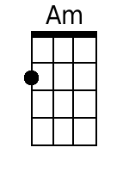 | 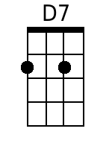 | 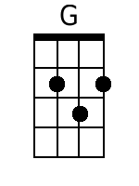 | 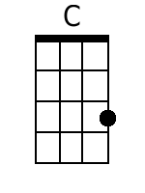 | 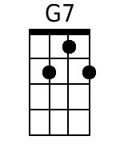 | 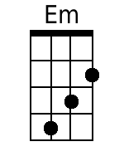 | 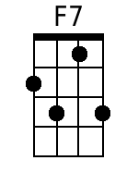 | 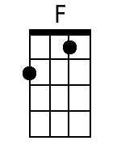
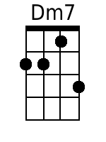 | 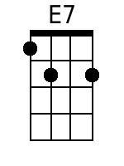 | 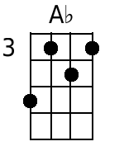 | 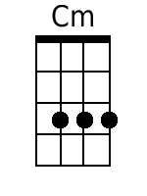 | 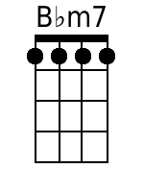 | 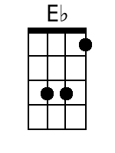 | 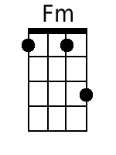 | 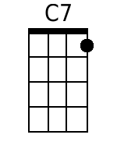

Count Your Blessings (Instead of Sheep) (Irving Berlin, 1954) (Am)
Second verse is the Ray Conniff Singers adaptation - DGBE

Introduction: Am D7 G C

G7 Am Em F7 C F Em Dm7 E7
When I'm worried, and I can't sleep, I count my blessings in-stead of sheep,
Am D7 G G7
And I fall a-sleep, counting my bless - ings.
Am Em F7 C F Em G7 E7
When my bankroll, is gettin' small, I think of when I had none at all.
Am D7 G7 C
And I fall a-sleep, counting my bless - ings.
Ab Cm Bbm7 Fm
I think about a nursery, and I picture curly heads,
Ab Eb G7 C Dm7 C C7
And one by one I count them, as they slumber in their beds
Am Em F7 C F Em Dm7 E7
If you’re worried, and you can't sleep, just count your blessings in-stead of sheep,
Am D7 G G7
And you’ll fall a-sleep, counting your bless – ings.

Am Em F7 C F Em Dm7 E7
So, if we’re worried, and we can't sleep, we’ll count our blessings in-stead of sheep,
Am D7 G7 C
And we’ll fall a-sleep, counting our bless – ings.
Ab Cm Bbm7 Fm
We’ll think about a Christmas Eve, and picture curly heads,
Ab Eb G7 C Dm7 C C7
With presents waiting ‘neath the tree, as they slumber in their beds.
Am Em F7 C F Em Dm7 E7
If you’re worried, and you can't sleep, just count your blessings in-stead of sheep,
Am D7 G7 C
And you’ll fall a-sleep, counting your bless - ings.

DGBE
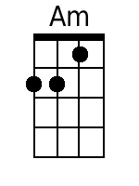 | 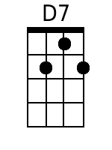 | 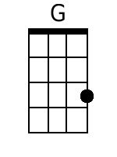 | 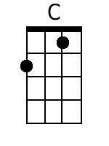 | 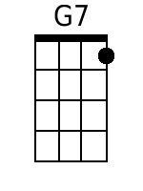 | 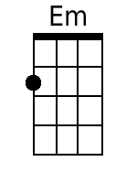 | 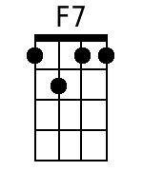 | 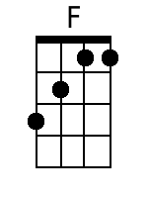
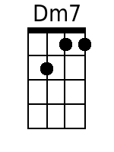 | 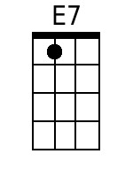 | 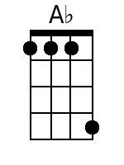 | 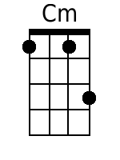 | 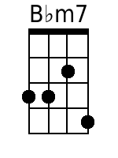 | 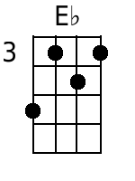 | 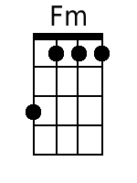 | 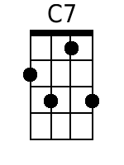

Count Your Blessings (Instead of Sheep) (Irving Berlin, 1954) (Dm)
Second verse is the Ray Conniff Singers adaptation - GCEA

Introduction: Dm G7 C F

C7 Dm Am Bb F Bb Am Gm7 A7
When I'm worried, and I can't sleep, I count my blessings in-stead of sheep,
Dm G7 C C7
And I fall asleep, counting my blessings.
C7 Dm Am Bb F Bb Am C7 A7
When my bankroll, is gettin' small, I think of when I had none at all.
Dm G7 C7 F
And I fall a-sleep, counting my blessings.
Db Fm D#m7 Bbm
I think about a nursery, and I picture curly heads,
Db Ab C7 F Gm7 F F7
And one by one I count them, as they slumber in their beds
Dm Am Bb F Bb Am Gm7 A7
If you're worried, and you can't sleep, just count your blessings in-stead of sheep,
Dm G7 C7 F
And you'll fall a-sleep, counting your blessings

Dm Am Bb F Bb Am Gm7 A7
So, if we're worried, and we can't sleep, we'll count our blessings in-stead of sheep,
Dm G7 C7 F
And we'll fall asleep, counting our blessings.
Db Fm D#m7 Bbm
We'll think about a Christmas Eve, and picture curly heads,
Db Ab C7 F Gm7 F F7
With presents waiting 'neath the tree, as they slumber in their beds.
Dm Am Bb F Bb Am Gm7 A7
If you're worried, and you can't sleep, just count your blessings in-stead of sheep,
Dm G7 C C7 F
And you'llI fall asleep, counting your ble- ess- ings.

GCEA
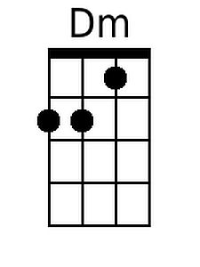 |  |  |  |  |  | 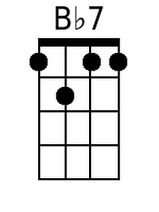 | 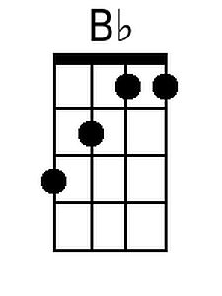
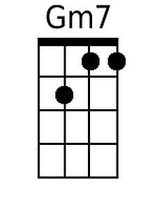 | 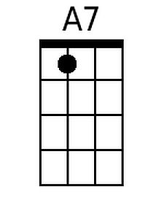 | 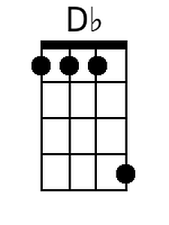 |  | 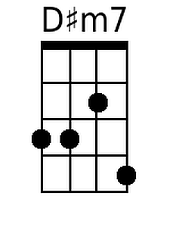 | 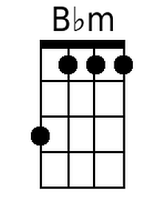 | 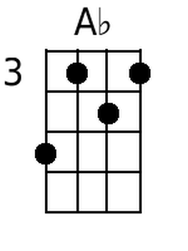

Count Your Blessings (Instead of Sheep) (Irving Berlin, 1954) (Dm)
Second verse is the Ray Conniff Singers adaptation - DGBE

Introduction: Dm G7 C F

C7 Dm Am Bb F Bb Am Gm7 A7
When I'm worried, and I can't sleep, I count my blessings in-stead of sheep,
Dm G7 C C7
And I fall asleep, counting my blessings.
C7 Dm Am Bb F Bb Am C7 A7
When my bankroll, is gettin' small, I think of when I had none at all.
Dm G7 C7 F
And I fall a-sleep, counting my blessings.
Db Fm D#m7 Bbm
I think about a nursery, and I picture curly heads,
Db Ab C7 F Gm7 F F7
And one by one I count them, as they slumber in their beds
Dm Am Bb F Bb Am Gm7 A7
If you're worried, and you can't sleep, just count your blessings in-stead of sheep,
Dm G7 C7 F
And you'll fall a-sleep, counting your blessings

Dm Am Bb F Bb Am Gm7 A7
So, if we're worried, and we can't sleep, we'll count our blessings in-stead of sheep,
Dm G7 C7 F
And we'll fall asleep, counting our blessings.
Db Fm D#m7 Bbm
We'll think about a Christmas Eve, and picture curly heads,
Db Ab C7 F Gm7 F F7
With presents waiting 'neath the tree, as they slumber in their beds.
Dm Am Bb F Bb Am Gm7 A7
If you're worried, and you can't sleep, just count your blessings in-stead of sheep,
Dm G7 C C7 F
And you'llI fall asleep, counting your ble- ess- ings.

DGBE
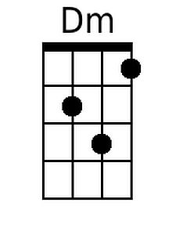 | 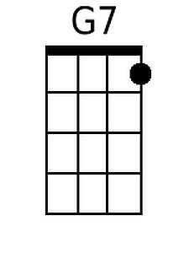 |  |  |  |  | 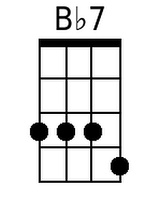 | 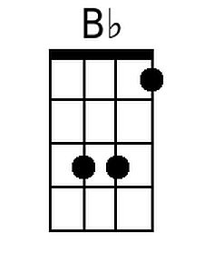
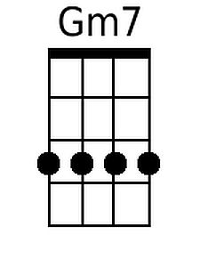 | 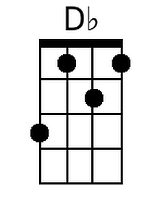 | 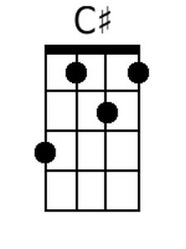 |  | 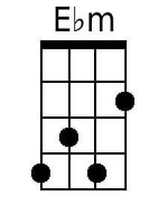 | 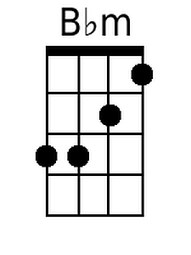

Count Your Blessings (Instead of Sheep) (Irving Berlin, 1954) (Em)
Second verse is the Ray Conniff Singers adaptation - GCEA

Introduction: Em A7 D G

D7 Em Bm C G C Bm Am7 B7
When I'm worried, and I can't sleep, I count my blessings in-stead of sheep,
Em A7 D D7
And I fall a-sleep, counting my bless-ings.
D7 Em Bm C G C Bm D7 B7
When my bankroll, is gettin' small, I think of when I had none at all.
Em A7 D7 G
And I fall a-sleep, counting my bless-ings.
Eb Gm Fm6 Cm
I think about a nursery, and I picture curly heads,
Eb Bb D7 G Am7 G G7
And one by one I count them, as they slumber in their beds
Em Bm C G C Bm Am7 B7
If you're worried, and you can't sleep, just count your blessings in-stead of sheep,
Em A7 D D7
And you'llI fall a-sleep, counting your bless-ings.

Em Bm C G C Bm Am7 B7
So, if we're worried, and we can't sleep, we'll count our blessings in-stead of sheep,
Em A7 D7 G
And we'll fall a-sleep, counting our bless-ings.
Eb Gm Fm6 Cm
We'll think about a Christmas Eve, and picture curly heads,
Eb Bb D7 G Am7 G G7
With presents waiting 'neath the tree, as they slumber in their beds.
Em Bm C G C Bm Am7 B7
If you're worried, and you can't sleep, just count your blessings in-stead of sheep,
Em A7 D D7 G
And you'llI fall a-sleep, counting your ble - ess-ings.

GCEA
 |  | 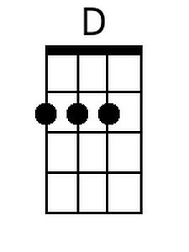 |  |  | 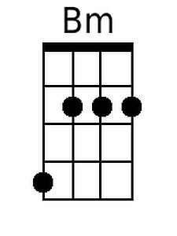
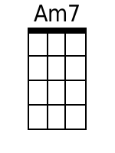 | 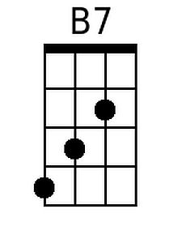 |  | 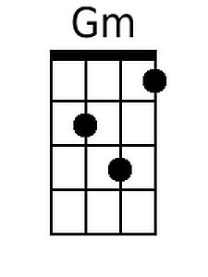 | 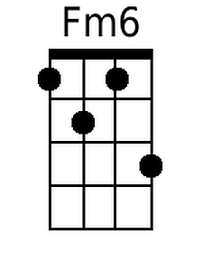 |  |  | 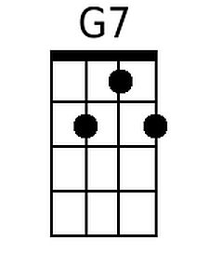

Count Your Blessings (Instead of Sheep) (Irving Berlin, 1954) (Em)
Second verse is the Ray Conniff Singers adaptation - DGBE

Introduction: Em A7 D G

D7 Em Bm C G C Bm Am7 B7
When I'm worried, and I can't sleep, I count my blessings in-stead of sheep,
Em A7 D D7
And I fall a-sleep, counting my bless-ings.
D7 Em Bm C G C Bm D7 B7
When my bankroll, is gettin' small, I think of when I had none at all.
Em A7 D7 G
And I fall a-sleep, counting my bless-ings.
Eb Gm Fm6 Cm
I think about a nursery, and I picture curly heads,
Eb Bb D7 G Am7 G G7
And one by one I count them, as they slumber in their beds
Em Bm C G C Bm Am7 B7
If you're worried, and you can't sleep, just count your blessings in-stead of sheep,
Em A7 D D7
And you'llI fall a-sleep, counting your bless-ings.

Em Bm C G C Bm Am7 B7
So, if we're worried, and we can't sleep, we'll count our blessings in-stead of sheep,
Em A7 D7 G
And we'll fall a-sleep, counting our bless-ings.
Eb Gm Fm6 Cm
We'll think about a Christmas Eve, and picture curly heads,
Eb Bb D7 G Am7 G G7
With presents waiting 'neath the tree, as they slumber in their beds.
Em Bm C G C Bm Am7 B7
If you're worried, and you can't sleep, just count your blessings in-stead of sheep,
Em A7 D D7 G
And you'llI fall a-sleep, counting your ble - ess-ings.

DGBE
 | 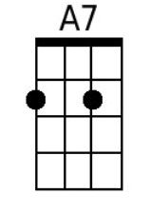 | 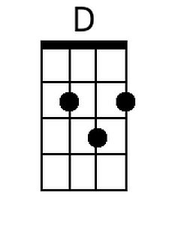 |  | 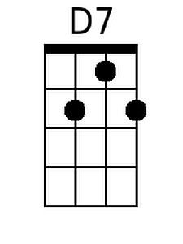 | 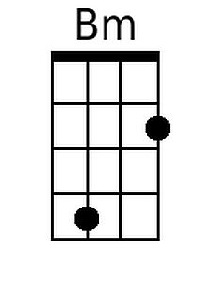 | 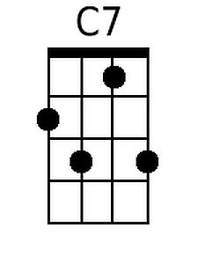
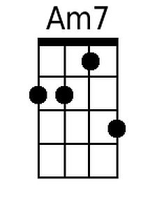 | 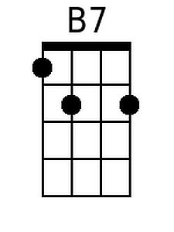 |  | 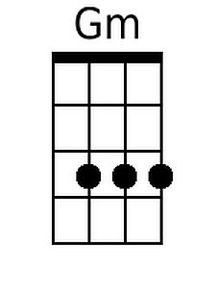 | 