**Counting Flowers on The Wall (De Witt Lewis)**

**Intro Am**

**C Am**



C

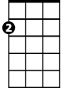

Am

I keep hearing your concern about my happiness

**Dm G**

All that thought you’ve given me is conscience I guess

**C Am**

If I were walking in y our shoes I wouldn’t worry none

**Dm G**



G

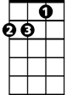

Dm

You and your friends are worried about me I’m having lots of fun

**Chorus:**

**Am**

Counting flowers on the wall. That don’t bother me at all

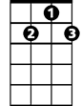

G7

F



Playing solitaire till dawn with a deck of fifty one

**F**

Smoking cigarettes and watching Captain Kangaroo.

**G G7 G**

Now don’t tell me I have nothing to do.

**C Am**

Last night I dressed in tails --- pretended I was on the town

**Dm G**

**BARITONE**



Am

As long as I can dream it’s hard to slow this swinger down

C



**C Am**

So please don’t give a thought to me I’m really doing fine

**Dm G**

You can always find me here -- having quite a time

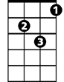

Dm

**(Chorus)**



G

**C Am**

Well it’s good to see you. I must go. I know I look affright.

**Dm G**

Anyway my eyes are not accustomed to this light

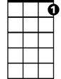

G7



F

**C Am**

And my shoes are not accustomed to this hard concrete

**Dm G**

I must go back to my room and make my day complete.

**(Chorus)**