Crazy (Willie Nelson, 1961)
Crazy by Patsy Cline (1961) – Key: C

Intro: Chords for last two lines  C A7 Dm A7 Dm  Crazy, crazy for feeling' so lonely  G7 C Fdim7 Dm7 G7  I'm crazy, crazy for feelin' so blue,  C A7 Dm A7 Dm  I knew, you'd love me as long as you wanted,  G7 C F C C7  And then someday, you'd leave me for somebody new  Refrain:  F C F C C7  Worry, why do I let myself worry  D7 G7 Dm7 G7  Wond'rin’, what in the world did I do  C A7 Dm A7 Dm  Crazy, for thinking that my love could hold you  F Em7 Dm7 Cmaj7  I'm crazy for tryin', crazy for cryin'  Dm7 G7 C F C  And I'm crazy for lovin' you.  (Repeat from Refrain)  F Em7 Dm7 Cmaj7  I'm crazy for tryin', crazy for cryin'  Dm7 G7 C F C  And I'm crazy for lovin' you. (2x) |  |  |  |  |  |  |  | 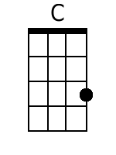 |  | 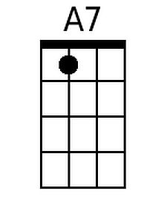
 |  |  |  |  |  |  |  | 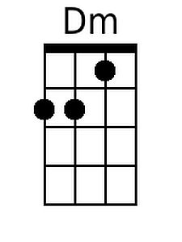 |  | 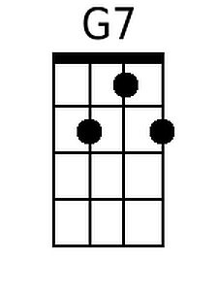
 |  |  |  |  |  |  |  | 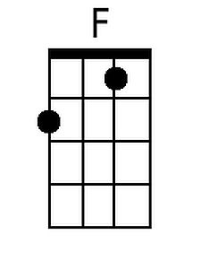 |  | 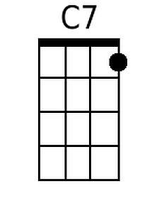
 |  |  |  |  |  |  |  | 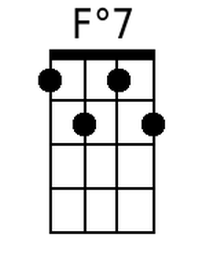 |  | 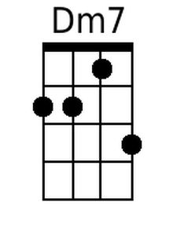
 |  |  |  |  |  |  |  | 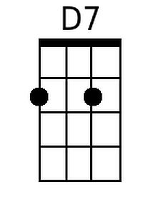 |  | 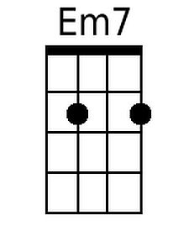
 |  |  |  |  |  |  |  | 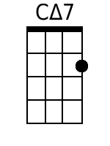
 |  | Bari | 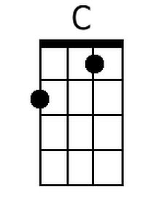 | 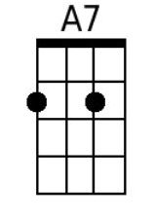 | 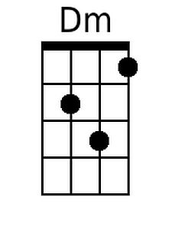 | 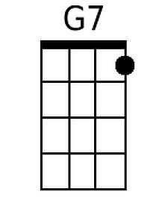 | 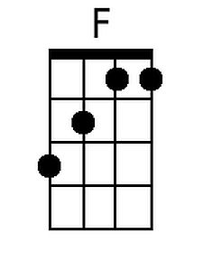 |  | 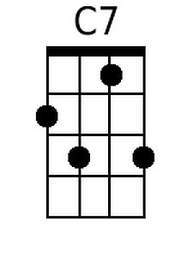
 |  |  | 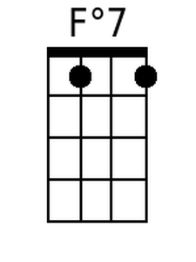 | 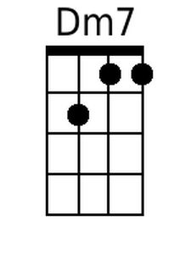 | 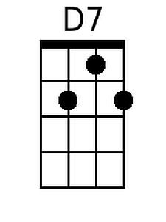 | 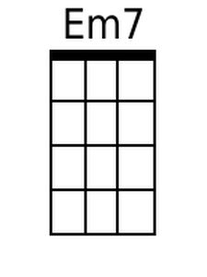 | 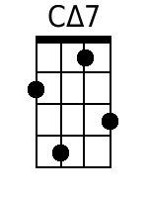 |  | 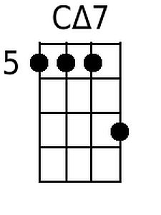

Crazy (Willie Nelson, 1961)
Crazy by Patsy Cline (1961) – Key: G

Intro: Chords for last two lines  G E7 Am E7 Am  Crazy, crazy for feeling' so lonely  D7 G Cdim7 Am7 D7  I'm crazy, crazy for feelin' so blue,  G E7 Am E7 Am  I knew, you'd love me as long as you wanted,  D7 G C G G7  And then someday, you'd leave me for somebody new  Refrain:  C G C G G7  Worry, why do I let myself worry  A7 D7 Am7 D7  Wond'rin', what in the world did I do.  G E7 Am E7 Am  Crazy, for thinking that my love could hold you  C Bm7 Am7 Gmaj7  I'm crazy for tryin', crazy for cryin'  Am7 D7 G C G  And I'm crazy for lovin' you.  (Repeat from Refrain)  C Bm7 Am7 Gmaj7  I'm crazy for tryin', crazy for cryin'  Am7 D7 G C G  And I'm crazy for lovin' you. (2x) |  |  |  |  |  |  |  | 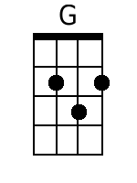 |  | 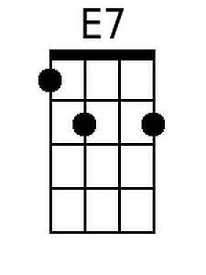
 |  |  |  |  |  |  |  | 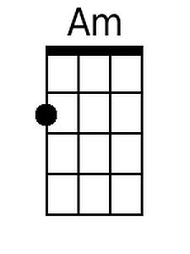
 |  |  |  |  |  |  |  | 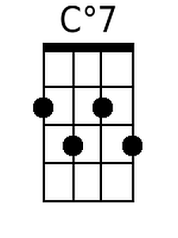 |  | 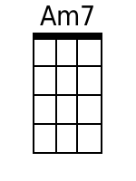
 |  |  |  |  |  |  |  |  |  | 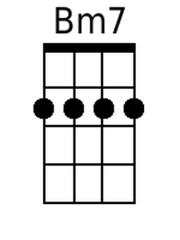
 |  |  |  |  |  |  |  | 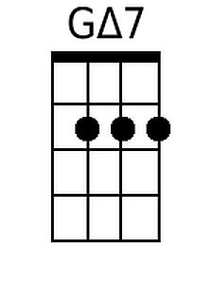
 |  | Bari | 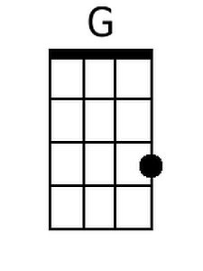 | 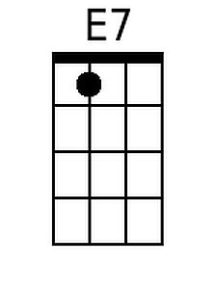 | 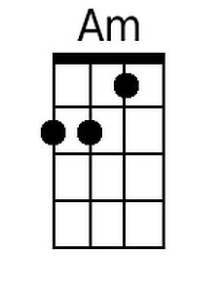
 |  |  | 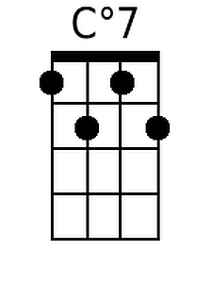 | 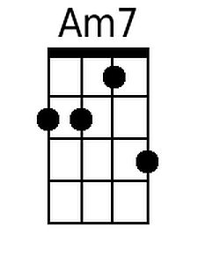 |  | 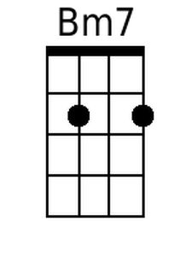 | 