**Crazy (Willie Nelson, 1961)**

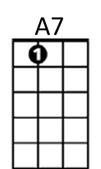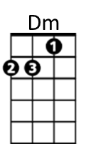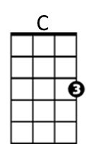**Key: C**

**Intro: Chords for last two lines**

**C A7 Dm A7 Dm**

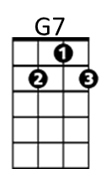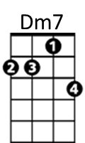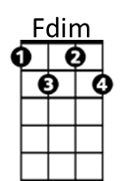Crazy, crazy for feeling' so lonely

**G7 C Fdim Dm7 G7**

I'm crazy, crazy for feelin' so blue,

**C A7 Dm A7 Dm**

I knew, you'd love me as long as you wanted,

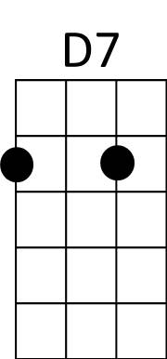 **G7 C F C C7**

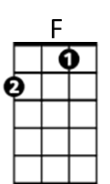And then someday, you'd leave me for somebody new

**Refrain:**

**F C F C C7**

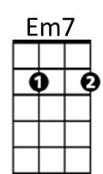Worry, why do I let myself worry

**D7 G7 Dm7 G**7

Wond'rin’, what in the world did I do

**C A7 Dm A7 Dm**

Crazy, for thinking that my love could hold you

**F Em7 Dm7 Cmaj7**

I'm crazy for tryin', crazy for cryin'

**Dm7 G7 C F C**

And I'm crazy for lovin' you.

**BARITONE**

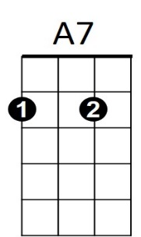**(Repeat from Refrain)**

C

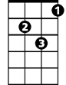

Dm

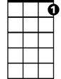

G7

**F Em7 Dm7 Cmaj7**

I'm crazy for tryin', crazy for cryin'

**Dm7 G7 C F C**

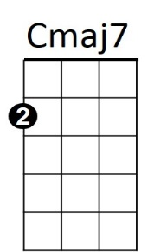And I'm crazy for lovin' you.

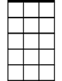

Em7



F

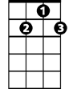

D7

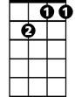

Dm7

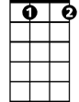

Fdim