**Crazy Love (Van Morrison) Key C**

**Intro: C Em F C 2x**

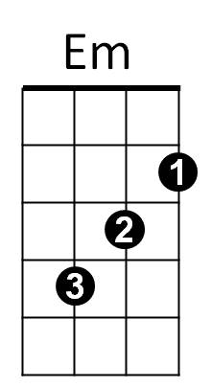

F



C

**C Em F C**

I can feel her heartbeat, from a thousand miles

**Em F C**

And the heavens open, every time she smiles

**Em F C**

And when I come to her, that's where I belong

**Em F C**

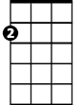

Am

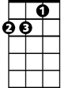

Dm



G

Yeah, I'm running to her, like a river's song

**Chorus:**

**G Am G F G**

She gives me love love, love, love, crazy love

**C G Am G F C**

She gives me love love, love, love, crazy love

**Em F C**

She's got a fine sense of humor when I'm feeling low down

**Em F C**

And when I come to her when the sun goes down

**Em F C**

She takes away my trouble take away my grief

**Em F C**

**BARITONE**

Take away my heartache, in the night like a thief



F



Em

C



**(Chorus)**

**Reprise:**

**G F C**

Yes, I need her in the daytime,

**G F C**

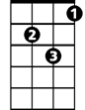

Dm



Am



G

Yes, I need her in the night

**G F C**

And I want to throw my arms around her,

**Am Dm G**

Kiss and hug her, kiss and hug her tight

**C Em F C**

And when I'm returning from so far away

**Em F C**

She gives me some sweet lovin, brightens up my day

**Em F C**

Yeh, it makes me righteous, yes it makes me whole

**Em F C**

Yeh, it makes me mellow down into my soul

**(Chorus) 2x repeat to fade**

**Crazy Love (Van Morrison) Key F**

**Intro: F Am Bb F 2x**

F



Am



Bb

**F Am Bb F**

I can feel her heartbeat, from a thousand miles

**Am Bb F**

And the heavens open, every time she smiles

**Am Bb F**

And when I come to her, that's where I be-long

**Am Bb F**



Gm



Dm



C

Yeah, I'm running to her, like a river's song

**Chorus:**

**C Dm C Bb C**

She gives me love love, love, love, crazy love

**F C Dm C Bb F**

She gives me love love, love, love, crazy love

**F Am Bb F**

She's got a fine sense of humor when I'm feeling low down

**Am Bb F**

And when I come to her when the sun goes down

**Am Bb F**

**BARITONE**

She takes away my trouble take away my grief

**Am Bb F**

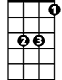

Bb



Am



F

Take away my heartache, in the night like a thief

**(Chorus)**

**Reprise:**

**C Bb F**



Dm

C



Yes, I need her in the daytime,

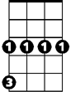

Gm

**C Bb F**

Yes, I need her in the night

**C Bb F**

And I want to throw my arms around her,

**Dm Gm C**

Kiss and hug her, kiss and hug her tight

**F Am Bb F**

And when I'm returning from so far a-way

**Am Bb F**

She gives me some sweet lovin, brightens up my day

**Am Bb F**

Yeh, it makes me righteous, yes it makes me whole

**Am Bb F**

Yeh, it makes me mellow down into my soul

**(Chorus) 2x repeat to fade**

**Crazy Love (Van Morrison) Key G**

**Intro: G Bm C G 2x**



C

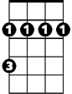

Bm



G

**G Bm C G**

I can feel her heartbeat, from a thousand miles

**Bm C G**

And the heavens open, every time she smiles

**Bm C G**

And when I come to her, that's where I belong

 **Bm C G**



Am

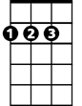

D

Yeah, I'm running to her, like a river's song

**Chorus:**

**D Em D C D**

She gives me love love, love, love, crazy love

**G D Em D C G**

She gives me love love, love, love, crazy love

**Bm C G**

She's got a fine sense of humor when I'm feeling low down

**Bm C G**

And when I come to her when the sun goes down

**Bm C G**

She takes away my trouble take away my grief

**Bm C G**

**BARITONE**

Take away my heartache, in the night like a thief

C



Bm

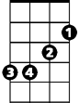

G

**(Chorus)**

**Reprise:**

**D C G**

Yes, I need her in the daytime,

**D C G**



Em



Am



D

Yes, I need her in the night

**D C G**

And I want to throw my arms around her,

**Em Am D**

Kiss and hug her, kiss and hug her tight

**G Bm C G**

And when I'm returning from so far away

**Bm C G**

She gives me some sweet lovin, brightens up my day

**Bm C G**

Yeh, it makes me righteous, yes it makes me whole

**Bm C G**

Yeh, it makes me mellow down into my soul

**(Chorus) 2x repeat to fade**