**Crazy Love (Rusty Young, 1978) (recorded by Poco) Key G**

**Cmaj7 G**

**G Cmaj7**

Tonight I'm gonna break away

**D Cmaj7 G**

Just you wait and see.

**Cmaj7**

I'll never be imprisoned by

**D Cmaj7 G**

A faded mem - ory.

**Cmaj7**

Just when I think I'm over her,

**D Cmaj7 G**

this broken heart will mend.

**Cmaj7**

I hear her name and I have to cry,

**D Cmaj7 G**

The tears come down again.

**Chorus:**

**Cmaj7**

It happens all the time.

**D G**

This crazy love of mine,

**Cmaj7**

Wraps around my heart

**D G**

Refusing to unwind.

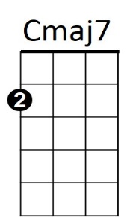**Cmaj7 D Cmaj7 G**

**BARITONE**



D

Ooo Ooo Crazy Love

**Cmaj7 D Cmaj7 G**

Ahh ha

**G Cmaj7**

Count the stars in a summer sky,

**D Cmaj7 G**

That fall without a sound.

**G Cmaj7**

And then pretend that you can't hear

**D Cmaj7 G**

These tear drops coming down.

**(Chorus)**

**REPEAT 1st verse**

**(Chorus)**

**G Cmaj7**

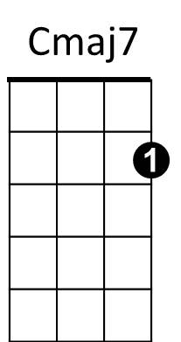Tonight I'm gonna break away.

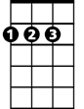

D



G



G