Crocodile Rock (Elton John, Bernie Taupin, 1972) (C)
Crocodile Rock by Elton John (G) – C-Tuned Chords
 - 𐛠 = 140

Intro (10 ½ Measures) Pattern: 𐛀 | 𐛀 | 𐛀 | then ||: ♪♪♪♪ ♪♩_ ♪♪♪♪ ♩_ :||
C_ F_ Bb_ | C | C | Am | Am | F | F | G | G

C Em
I re-member when rock was young. Me and Suzie had so much fun
F G
Holding hands and skimming stones, had an old gold Chevy and a place of my own.
C Em
But the biggest kick I ever got was doing a thing called the Crocodile Rock.
F
While the other kids were rocking round the clock,
G
We were hopping and bopping to the Crocodile Rock, well,

Chorus
Am D7
Croc Rocking is something shocking when your feet just can't keep still.
G7 C
_ I never knew me a better time and I guess I never will.
A7 D7
Oh lawdy, mama, those Friday nights when Suzie wore her dresses tight and
G7 | Bb F | Bb F | Bb F |
_ The Croc Rocking was out__ of sight__.
C | C . . | Am | Am . . | F | F . . | G | G
Laaa, la, la, la, la, laaa. La, la, la, la, laaa. La, la, la, la, laaa.

C Em
But the years went by and the rock just died. Suzie went and left us for some foreign guy.
F G
Long nights cryin’ by the record machine, Dreamin’ of my Chevy and my old blue jeans.
C Em
But they'll never kill the thrills we've got burning up to the Crocodile Rock.
F G
Learning fast as the weeks went past, we really thought the Crocodile Rock would last, well . . .
Chorus
Repeat First Verse and Chorus

Outro:
C | C . . | Am | Am . . | F | F . . | G | G . . Bb B C
Laaa, la, la, la, la, laaa. La, la, la, la, laaa. La, la, la, la, laaa.
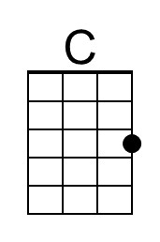 | 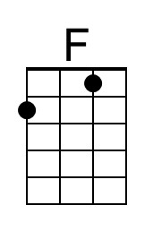 | 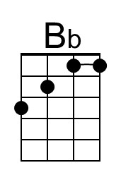 | 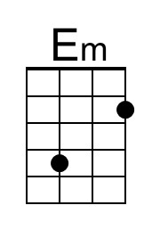 | 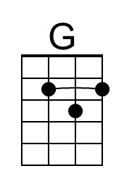 | 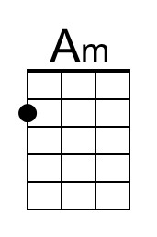 | 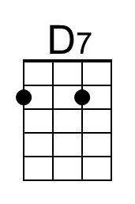 | 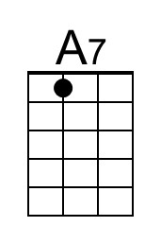

Crocodile Rock (Elton John, Bernie Taupin, 1972) (C)
Crocodile Rock by Elton John (G) – G-Tuned Chords
 - 𐛠 = 140

Intro (10 ½ Measures) Pattern: 𐛀 | 𐛀 | 𐛀 | then ||: ♪♪♪♪ ♪♩_ ♪♪♪♪ ♩_ :||
C_ F_ A#_ | C | C | Am | Am | F | F | G | G

C Em
I re-member when rock was young. Me and Suzie had so much fun
F G
Holding hands and skimming stones, had an old gold Chevy and a place of my own.
C Em
But the biggest kick I ever got was doing a thing called the Crocodile Rock.
F
While the other kids were rocking round the clock,
G
We were hopping and bopping to the Crocodile Rock, well,

Chorus
Am D7
Croc Rocking is something shocking when your feet just can't keep still.
G7 C
_ I never knew me a better time and I guess I never will.
A7 D7
Oh lawdy, mama, those Friday nights when Suzie wore her dresses tight and
G7 | Bb F | Bb F | Bb F |
_ The Croc Rocking was out__ of sight__.
C | C . . | Am | Am . . | F | F . . | G | G
Laaa, la, la, la, la, laaa. La, la, la, la, laaa. La, la, la, la, laaa.

C Em
But the years went by and the rock just died. Suzie went and left us for some foreign guy.
F G
Long nights cryin’ by the record machine, Dreamin’ of my Chevy and my old blue jeans.
C Em
But they'll never kill the thrills we've got burning up to the Crocodile Rock.
F G
Learning fast as the weeks went past, we really thought the Crocodile Rock would last, well . . .
Chorus
Repeat First Verse and Chorus

Outro:
C | C . . | Am | Am . . | F | F . . | G | G . . Bb B C
Laaa, la, la, la, la, laaa. La, la, la, la, laaa. La, la, la, la, laaa.
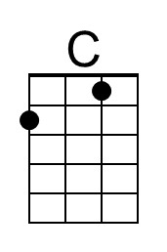 | 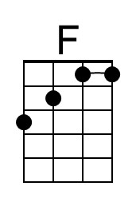 | 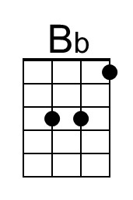 | 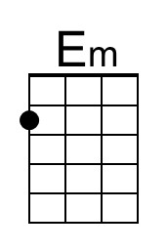 | 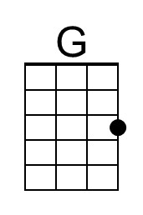 | 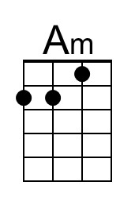 | 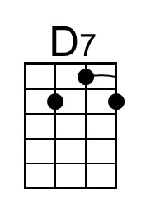 | 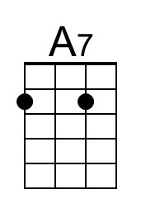
Crocodile Rock (Elton John, Bernie Taupin, 1972) (G)
Crocodile Rock by Elton John (G) – C-Tuned Chords
 - 𐛠 = 140

Intro (10 ½ Measures) Pattern: 𐛀 | 𐛀 | 𐛀 | then ||: ♪♪♪♪ ♪♩_ ♪♪♪♪ ♩_ :||
G_ | C_ F_ | G | G | Em | Em | C | C | D | D

G Bm
I re-member when rock was young. Me and Suzie had so much fun
C D
Holding hands and skimming stones, had an old gold Chevy and a place of my own.
G Bm
But the biggest kick I ever got was doing a thing called the Crocodile Rock.
C
While the other kids were rocking round the clock,
D
We were hopping and bopping to the Crocodile Rock, well,

Chorus
Em A7
Croc Rocking is something shocking when your feet just can't keep still.
D7 G
_ I never knew me a better time and I guess I never will.
E7 A7
Oh lawdy, mama, those Friday nights when Suzie wore her dresses tight and
D7 | F C | F C | F C |
_ The Croc Rocking was out__ of sight__.
G | G . . | Em | Em . . | C | C . . | D | D
Laaa, la, la, la, la, laaa. La, la, la, la, laaa. La, la, la, la, laaa.

G Bm
But the years went by and the rock just died. Suzie went and left us for some foreign guy.
C D
Long nights cryin’ by the record machine, Dreamin’ of my Chevy and my old blue jeans.
G Bm
But they'll never kill the thrills we've got burning up to the Crocodile Rock.
C D
Learning fast as the weeks went past, we really thought the Crocodile Rock would last, well . . .
Chorus
Repeat First Verse and Chorus

Outro
G | G . . | Em | Em . . | C | C . . | D | D . . F F# G
Laaa, la, la, la, la, laaa. La, la, la, la, laaa. La, la, la, la, laaa.

 |  |  | 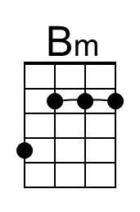 | 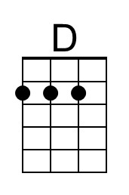 |  |  | 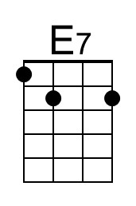

Crocodile Rock (Elton John, Bernie Taupin, 1972) (G)
Crocodile Rock by Elton John (G) – G-Tuned Chords
 - 𐛠 = 140

Intro (10 ½ Measures) Pattern: 𐛀 | 𐛀 | 𐛀 | then ||: ♪♪♪♪ ♪♩_ ♪♪♪♪ ♩_ :||
G_ | C_ F_ | G | G | Em | Em | C | C | D | D

G Bm
I re-member when rock was young. Me and Suzie had so much fun
C D
Holding hands and skimming stones, had an old gold Chevy and a place of my own.
G Bm
But the biggest kick I ever got was doing a thing called the Crocodile Rock.
C
While the other kids were rocking round the clock,
D
We were hopping and bopping to the Crocodile Rock, well,

Chorus
Em A7
Croc Rocking is something shocking when your feet just can't keep still.
D7 G
_ I never knew me a better time and I guess I never will.
E7 A7
Oh lawdy, mama, those Friday nights when Suzie wore her dresses tight and
D7 | F C | F C | F C |
_ The Croc Rocking was out__ of sight__.
G | G . . | Em | Em . . | C | C . . | D | D
Laaa, la, la, la, la, laaa. La, la, la, la, laaa. La, la, la, la, laaa.

G Bm
But the years went by and the rock just died. Suzie went and left us for some foreign guy.
C D
Long nights cryin’ by the record machine, Dreamin’ of my Chevy and my old blue jeans.
G Bm
But they'll never kill the thrills we've got burning up to the Crocodile Rock.
C D
Learning fast as the weeks went past, we really thought the Crocodile Rock would last, well . . .
Chorus
Repeat First Verse and Chorus

Outro
G | G . . | Em | Em . . | C | C . . | D | D . . F F# G
Laaa, la, la, la, la, laaa. La, la, la, la, laaa. La, la, la, la, laaa.

 |  |  | 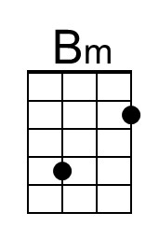 | 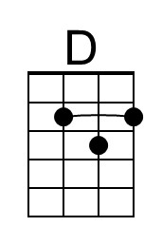 |  |  | 