Crocodile Rock (Elton John, Bernie Taupin, 1972) (C)
Crocodile Rock by Elton John (Originally in G)

Intro (8 Measures): C C Em Em F F G G  C Em  I re-member when rock was young me and Suzie had so much fun  F G  Holding hands and skimming stones, Had an old gold Chevy and a place of my own.  C Em  But the biggest kick I ever got was doing a thing called the Crocodile Rock  F  While the other kids were Rocking Round the Clock  G G G G  We were hopping and bopping to the Crocodile Rock, well,  Chorus  Am D7  Croc rocking is something shocking, when your feet just can't keep still  G C  I never knew me a better time and I guess I never will.  A7 D7  Oh lawdy mama those Friday nights, when Suzie wore her dresses tight and  G F  The Croc Rocking was ou . . .t of si . . .ght  C Am F G  Laaa la la la la, Laaa la la la la, Laaa la la la la, Laaa  C  But the years went by and the rock just died,  Em  Suzie went and left us for some foreign guy  F  Long nights crying by the record machine  G  Dreaming of my Chevy and my old blue jeans  C Em  But they'll never kill the thrills we've got, burning up to the Crocodile Rock  F  Learning fast as the weeks went past  G G  We really thought the Crocodile Rock would last, well ... Chorus  Repeat First Verse and Chorus  Outro:  C Am F G Bb B C  Laaa la la la la, Laaa la la la la, Laaa la la la la, Laaa |  |  |  |  |  |  | 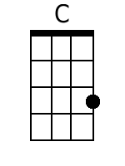
 |  |  |  |  |  |  | 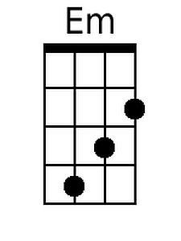
 |  |  |  |  |  |  | 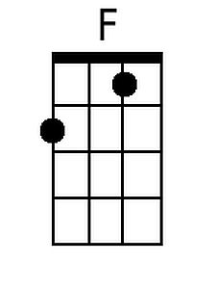
 |  |  |  |  |  |  | 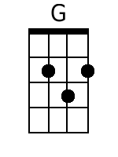
 |  |  |  |  |  |  | 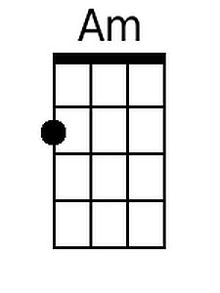
 |  |  |  |  |  |  | 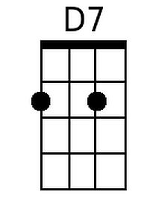
 |  |  |  |  |  |  | 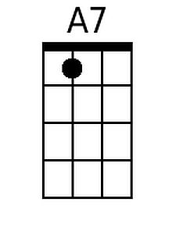
Baritone
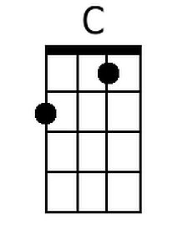 | 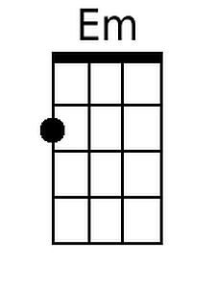 | 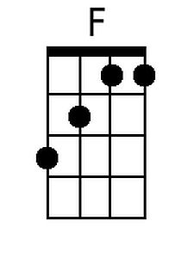 | 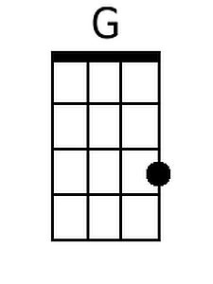 | 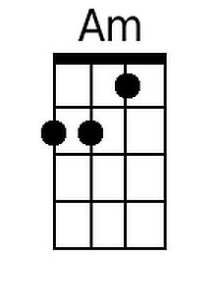 | 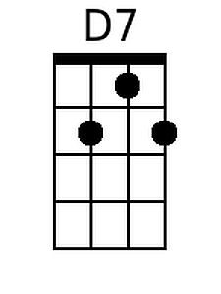 | 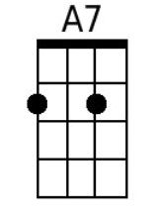

Crocodile Rock (Elton John, Bernie Taupin, 1972) (G)
Crocodile Rock by Elton John (Originally in G)

Intro (8 Measures): G G Bm Bm C C D7 D7

G Bm
I re-member when rock was young me and Suzie had so much fun
C D
Holding hands and skimming stones, Had an old gold Chevy and a place of my own.
G Bm
But the biggest kick I ever got was doing a thing called the Crocodile Rock
C
While the other kids were Rocking Round the Clock
D D
We were hopping and bopping to the Crocodile Rock, well,

Chorus
Em A7
Croc rocking is something shocking, when your feet just can't keep still
D G
I never knew me a better time and I guess I never will.
E7 A7
Oh lawdy mama those Friday nights, when Suzie wore her dresses tight and
D C
The Croc Rocking was ou . . .t of si . . .ght
G Em C D
Laaa la la la la, Laaa la la la la, Laaa la la la la, Laaa

G
But the years went by and the rock just died,
Bm
Suzie went and left us for some foreign guy
C
Long nights crying by the record machine
D
Dreaming of my Chevy and my old blue jeans
G Bm
But they'll never kill the thrills we've got, burning up to the Crocodile Rock
C
Learning fast as the weeks went past
D D
We really thought the Crocodile Rock would last, well ... Chorus

Repeat First Verse and Chorus

Outro:
G Em C D
Laaa la la la la, Laaa la la la la, Laaa la la la la, Laaa
 |  |  |  |  |  |  | 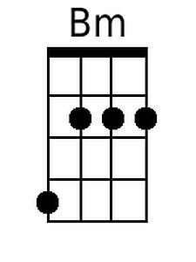
 |  |  |  |  |  |  | 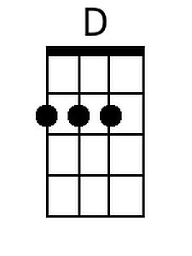
 |  |  |  |  |  |  | 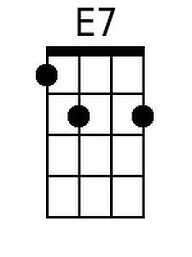
Baritone
 | 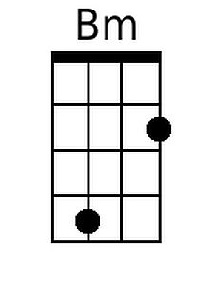 |  | 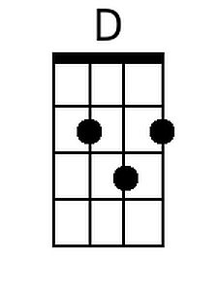 |  |  | 