**Cryin’ in the Rain (Howard Greenfield / Carole King)**

F

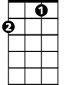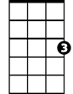

C

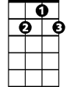

G7

**C F G7 C**I'll never let you see   
 **F G7 C** The way my broken heart is hurting me  
 **F E7 Am**I've got my pride and I know how to hide   
 **F G7**All my sorrow and pain   
 **Am G7 Am**I'll do my crying in the rain   
   
**C F G7 C**If I wait for cloudy skies   
 **F G7 C**You won't know the rain from the tears in my eyes   
 **F E7 Am**You'll never know that I still love you so   
 **F G7**Only heartaches remain   
 **Am G7 C**I'll do my crying in the rain   
   
**F Dm**Rain drops falling from heaven  
 **G7 C**Could never wash away my misery   
 **Dm**But since we're not together   
 **F** I look for stormy weather   
 **G7**To hide these tears I hope you'll never see   
   
**C F G7 C**Some day when my crying is done  
 **F G7 C**I'm gonna wear a smile and walk in the sun   
 **F E7 Am**I may be a fool but till then darling, you'll  
 **F G7**Never see me complain   
 **Am**I'll do my crying in the rain   
**G7 Am**I'll do my crying in the rain

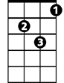

Dm

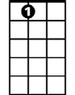

E7

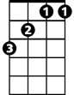

F

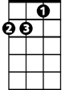

Am

C

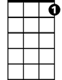

G7

**BARITONE**



Dm

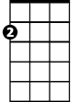

Am

E7

