**Crying (Roy Orbison / Joe Melson) Key C**

**C**

I was all right for a while,

I could smile for a while

But I saw you last night,

**Csus2**

You held my hand so tight,

**F Fm**

As you stopped to say hello

**C G**

Oh, you wished me well, you couldn't tell,

**G7**

That I'd been . .



C

**C Em**

Crying over you

**C Em**

Crying over you

**F G**

Then you said so long,



G

**F G**

Left me standing all alo ne

**C Csus2 F Fm**

Alone and crying, crying, crying, crying

**C**

It's hard to understa nd,

**G G7**

But the tou ch of your hand,

**C**

**BARITONE**

Can start me crying

C



**C**

I thought that I, was over you,

But it's true, so true

I love you even more,

**Csus2**



G

Than I did before

**F Fm**

But darling, what can I do?

**C**

Cause you don't love me,

**G G7**

And I'll always be

**C Em**

Crying over you

**C Em**

Crying over you

**F G**

Yes, now you're gone

**F G**

And from this moment on

**C Csus2 F Fm**

I'll be crying, crying, crying, crying

**C Am**

I'm crying, crying

**F G7 C G7 C F C**

Oh-oh-oh-over you

F

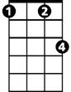

Fm

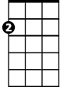

Am

Em

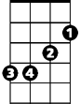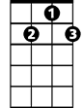

G7



F

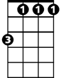

Fm

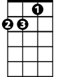

Am



Em

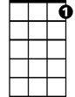

G7

**Crying (Roy Orbison / Joe Melson) Key D**

**D**

I was all right for a while,

I could smile for a while

But I saw you last night,

**Dsus2**

You held my hand so tight,

**G Gm**

As you stopped to say hello

**D A**

Oh, you wished me well, you couldn't tell,

**A7**

That I'd been . .

**D F#m**

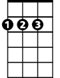

D

Crying over you

**D F#m**

Crying over you

**G A**

Then you said so long,

**G A**

Left me standing all alone

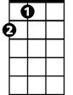

A

**D Dsus2 G Gm**

Alone and crying, crying, crying, crying

**D**

It's hard to understand,

**A A7**

But the touch of your hand,

**D**

Can start me crying

**BARITONE**

**D**



D

I thought that I, was over you,

But it's true, so true

I love you even more,

**Dsus2**

Than I did before



A

**G Gm**

But darling, what can I do?

**D**

Cause you don't love me,

**A A7**

And I'll always be

**D F#m**

Crying over you

**D F#m**

Crying over you

**G A**

Yes, now you're gone

**G A**

And from this moment on

**D Dsus2 G Gm**

I'll be crying, crying, crying, crying

**D Bm**

I'm crying, crying

**G A7 D A7 D G D**

Oh-oh-oh-over you

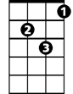

Gm



G

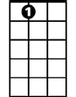

A7

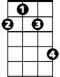

F#m

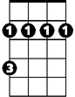

Bm

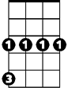

Gm



G

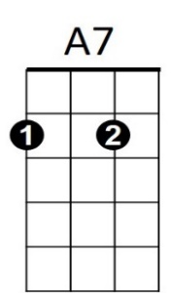

Bm



F#m

**Crying (Roy Orbison / Joe Melson) Key G**

**G**

I was all right for a while,

I could smile for a while

But I saw you last night,

**Gsus2**

You held my hand so tight,

**C Cm**

As you stopped to say hello

**G D**

Oh, you wished me well, you couldn't tell,

**D7**

That I'd been . .

**G Bm**

Crying over you

**G Bm**

Crying over you

**C D**

Then you said so long,

**C D**

Left me standing all alone

**G Gsus2 C Cm**

Alone and crying, crying, crying, crying

**G**

It's hard to understand,

**D D7**

But the touch of your hand,

**G**

**BARITONE**

Can start me crying

**G**

I thought that I, was over you,

But it's true, so true

I love you even more,

**Gsus2**

Than I did before

**C Cm**

But darling, what can I do?

**G**

Cause you don't love me,

**D D7**

And I'll always be

**G Bm**

Crying over you

**G Bm**

Crying over you

**C D**

Yes, now you're gone

**C D**

And from this moment on

**G Gsus2 C Cm**

I'll be crying, crying, crying, crying

**G Em**

I'm crying, crying

**C D7 G D7 G C G**

Oh-oh-oh-over you



C



G



Cm

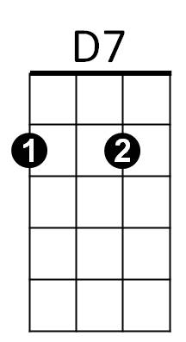

Em



Bm



D



Cm

C



G

Bm



Em



D7



D