**Cuando Calienta el Sol (Love Me With All of Your Heart) Key C**

**(Rafael Gaston Perez / Carlos Albert Martinoli / Carlos and Mario Rigual) (English lyrics by Maurice Vaughn / Sonny Skylar)**

**C Am Em**

*When the sun is hot here on the beach,*

*I feel your body tremble close to me;*

*It's your heartbeat, it's your face, it's your hair;*

*It's your kisses, I'm trembling, oh, oh, oh!*

*When the sun is hot here on the beach,*

Cuando calienta el sol aqui en la playa

**F G7 C A7**

Siento tu cuerpo vibrar cerca de mi

**Dm G7 C Am**

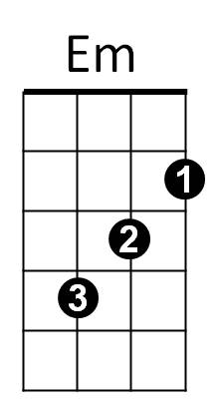Es tu palpitar, es tu cara, es tu pelo,

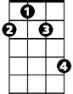

F#m

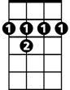

B7



G

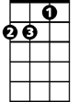

Dm

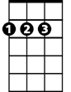

D

F

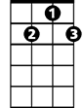

G7

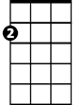

Am



C

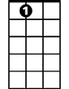

A7

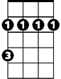

Bm

**Em F G7**

Son tus besos, me ester-mezco, oh, oh, oh

**C Am Dm**

Cuando calienta el sol,

**G7 C A7**

Cu ando cailenta el sol

**D Bm F#m**

Love me with all of your heart, that’s all I want, love

**G A7 D B7**

Love me with all of your heart, or not at all

**Em A7 D Bm**

Just promise me this, that you’ll give me all your kisses,

**F#m G A7**

Every winter, every summer, every fall

**D Bm F#m**

When we are far apart, or when you’re near me

**G A7 D B7**

Love me with all of your heart, as I love you

**Em A7 D Bm**

Don’t give me your love for a moment or an hour

**F#m G A7**

Love me always as you’ve loved me from the start

**BARITONE**

**D Bm Em**



F



Em



Am

C



With every beat of your heart

**A7 D Bm Em**

With every beat of your heart

**A7 D**

With every beat of your heart

B7

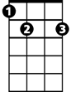

G



F#m

Bm

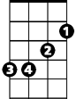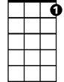

G7

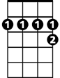

A7

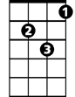

Dm



D