Da Doo Ron Ron
Phil Spector, Jeff Barry & Ellie Greenwich, 1963
Da Doo Ron Ron (Phil Spector, Jeff Barry & Ellie Greenwich, 1963) (C)
Da Doo Ron Ron by The Crystals (1963)

C F  I met him on a Monday and my heart stood still  G C  Da doo ron ron ron, da doo ron ron  C F  Somebody told me that his name was Bill  G C  Da doo ron ron ron, da doo ron ron  C F  Yes, my heart stood still,  C G  Yes, his name was Bill  C F  And when he walked me home  G C  Da doo ron ron ron, da doo ron ron  C  He knew what he was doin'  F  when he caught my eye  G C  Da doo ron ron ron, da doo ron ron  C F  He looks so quiet but my oh my  G C  Da doo ron ron ron, da doo ron ron |  |  |  | C F C G  Yes, he caught my eye, yes, my oh my  C F  And when he walked me home  G C  Da doo ron ron ron, da doo ron ron  C F  Picked me up at seven and he looked so fine  G C  Da doo ron ron ron, da doo ron ron  C F  Someday soon, I'm gonna make him mine  G C  Da doo ron ron ron, da doo ron ron  C F  Yes, he looked so fine,  C G  Yes, I'll make him mine  C F  And when he walked me home  G C  Da doo ron ron ron, da doo ron ron
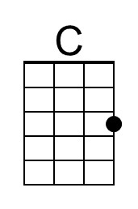 | 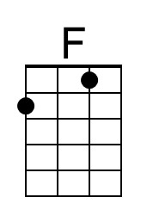 | 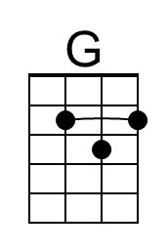 |  | Bari | 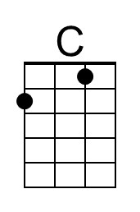 | 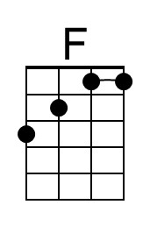 | 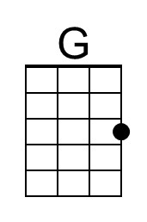

Da Doo Ron Ron (Phil Spector, Jeff Barry & Ellie Greenwich, 1963) (G)
Da Doo Ron Ron by The Crystals (1963)

G C  I met him on a Monday and my heart stood still  D G  Da doo ron ron ron, da doo ron ron  G C  Somebody told me that his name was Bill  D G  Da doo ron ron ron, da doo ron ron  G C  Yes, my heart stood still,  G D  Yes, his name was Bill  G C  And when he walked me home  D G  Da doo ron ron ron, da doo ron ron  G  He knew what he was doin'  C  when he caught my eye  D G  Da doo ron ron ron, da doo ron ron  G C  He looks so quiet but my oh my  D G  Da doo ron ron ron, da doo ron ron |  |  |  | G C G D  Yes, he caught my eye, yes, my oh my  G C  And when he walked me home  D G  Da doo ron ron ron, da doo ron ron  G C  Picked me up at seven and he looked so fine  D G  Da doo ron ron ron, da doo ron ron  G C  Someday soon, I'm gonna make him mine  D G  Da doo ron ron ron, da doo ron ron  G C  Yes, he looked so fine,  G D  Yes, I'll make him mine  G C  And when he walked me home  D G  Da doo ron ron ron, da doo ron ron
 |  | 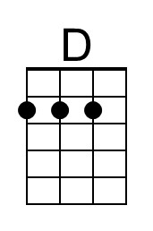 |  | Bari |  |  | 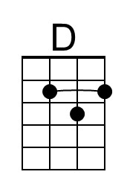

Da Doo Ron Ron (Phil Spector, Jeff Barry & Ellie Greenwich, 1963) (F)
Da Doo Ron Ron by The Crystals (1963)

F B♭  I met him on a Monday and my heart stood still  C F  Da doo ron ron ron, da doo ron ron  F B♭  Somebody told me that his name was Bill  C F  Da doo ron ron ron, da doo ron ron  F B♭  Yes, my heart stood still,  F C  Yes, his name was Bill  F B♭  And when he walked me home  C F  Da doo ron ron ron, da doo ron ron  F  He knew what he was doin'  B♭  when he caught my eye  C F  Da doo ron ron ron, da doo ron ron  F B♭  He looks so quiet but my oh my  C F  Da doo ron ron ron, da doo ron ron |  |  |  | F B♭ F C  Yes, he caught my eye, yes, my oh my  F B♭  And when he walked me home  C F  Da doo ron ron ron, da doo ron ron  F B♭  Picked me up at seven and he looked so fine  C F  Da doo ron ron ron, da doo ron ron  F B♭  Someday soon, I'm gonna make him mine  C F  Da doo ron ron ron, da doo ron ron  F B♭  Yes, he looked so fine,  F C  yes, I'll make him mine  F B♭  And when he walked me home  C F  Da doo ron ron ron, da doo ron ron
 | 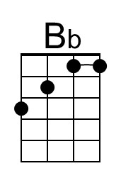 |  |  | Bari |  | 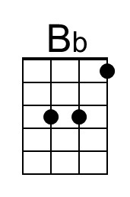

Da Doo Ron Ron (Phil Spector, Jeff Barry & Ellie Greenwich, 1963) (C)
Da Doo Ron Ron by The Crystals (1963)

C F  I met him on a Monday and my heart stood still  G C  Da doo ron ron ron, da doo ron ron  C F  Somebody told me that his name was Bill  G C  Da doo ron ron ron, da doo ron ron  C F  Yes, my heart stood still,  C G  Yes, his name was Bill  C F  And when he walked me home  G C  Da doo ron ron ron, da doo ron ron  C  He knew what he was doin'  F  when he caught my eye  G C  Da doo ron ron ron, da doo ron ron  C F  He looks so quiet but my oh my  G C  Da doo ron ron ron, da doo ron ron |  |  |  | C F C G  Yes, he caught my eye, yes, my oh my  C F  And when he walked me home  G C  Da doo ron ron ron, da doo ron ron  C F  Picked me up at seven and he looked so fine  G C  Da doo ron ron ron, da doo ron ron  C F  Someday soon, I'm gonna make him mine  G C  Da doo ron ron ron, da doo ron ron  C F  Yes, he looked so fine,  C G  Yes, I'll make him mine  C F  And when he walked me home  G C  Da doo ron ron ron, da doo ron ron
 |  |  |  | Bari

This page is intentionally blank.

