**Daisy Bell (On a Bicycle Built for Two) - Harry Dacre (1892)**

**C G7**

There is a flower within my heart

**C**

Daisy, Dai-sy

**C G7**

Planted one day by a glancing dart

**D7 C G7**

Planted by Dai-sy Bell

**Am Em7 Am**

Whether she loves me or loves me not

**Dm A7 Dm**

Sometimes it's hard to tell

**Am Em7 Am**

Yet I am longing to share the lot

**D7 G G7**

Of beautiful Daisy Bell

**Chorus:**

**C F C**

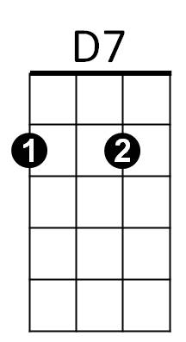Daisy, Daisy, give me your answer do

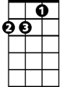

Dm

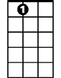

A7



C

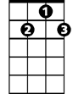

G7

**G7 C Am D7 G7**

I'm half cra - zy all for the love of you

**C**

It won't be a stylish marriage

**F C**

I can't afford a carriage

**G7 C G7**

But you'll look sweet upon the seat

**C G7 C**

Of a bicycle built for two

**C G7**

We will go tandem as man and wife

Em7

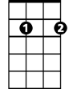

**C**

Daisy, Dai-sy

**C G7**

Pedalling away down the road of life

**D7 C G7**

I and my Daisy Bell



G



G

**Am Em7 Am**

When the road's dark, we can both despise

**Dm A7 Dm**

Policemen and lamps as well

**Am Em7 Am**

There are bright lights in the dazzling eyes

**D7 G G7**

Of beautiful Daisy Bell

**(Chorus)**

**C G7**

I will stand by you in “wheel” or woe,

**C**

Daisy, Dai-sy

**C G7**

You’ll be the belle which I will ring, you know

**D7 C G7**

Sweet little Daisy Bell

**Am Em7 Am**

You’ll take the lead in each trip we’ll take

**Dm A7 Dm**

Then if I don’t do well

**Am Em7 Am**

I will permit you to use the brake

**D7 G G7**

My beautiful Daisy Bell

**(Chorus)**

**BARITONE**

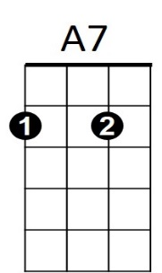



D7

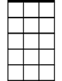

Em7

C

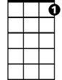

G7

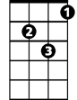

Dm



Am

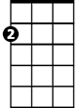

Am