**Dance, Dance, Dance (Brenda Cooper, Joseph Cooper & Steve Miller) Key of C**

**C F**

My grandpa he's ninety-five

**C G7**



C

F

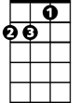

Dm

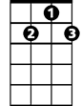

G7

He keeps on dancing he's still alive

**C F**

My grandma she's ninety-two

**C G7**

She loves to dance and sing some too

**C F**

I don't know but I've been told

**C G7**

If you keep on dancing you'll never grow old

**C F C G7 C**

Come on darlin' put a pretty dress on we're gonna go out tonight

**Chorus: F C Dm C**

Dance Dance Dance **x3**  - All night long

**C F**

I'm a hard workin man I'm a sun of a gun

**C G7**

I been workin all week in the noonday sun

**C F**

The wood's in the kitchen the cow's in the barn

**C G7**

I'm all cleaned up and my chores are all done

**C F C G7**

Take my hand - come along, let's go out and have some fun

**C F C G7 C**

Come on darlin' put a pretty dress on we're gonna go out tonight

**(Chorus)**

**BARITONE**

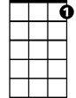

G7

C



F

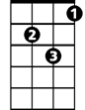

Dm

**C F**

Well come on darlin' don't you look that way

**C G7**

Don't know when you smile I've got to say

**C F**

You're my honey-pumpkin-lover you're my heart's delight

**C G7**

Don't you want to go out tonight

**C F**

You're such a pretty lady you're such a sweet girl

**C G7**

When you dance it brightens up my world

**C F C G7 C**

Come on darlin' put a pretty dress on we're gonna go out tonight

**(Chorus)**

**Dance, Dance, Dance (Brenda Cooper, Joseph Cooper & Steve Miller) Key of G**

**G C**

My grandpa he's ninety-five

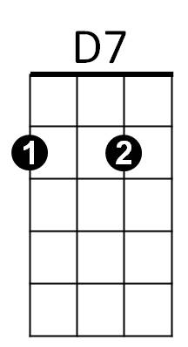 **G D7**



G

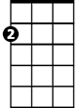

Am



C

He keeps on dancing he's still alive

**G C**

My grandma she's ninety-two

**G D7**

She loves to dance and sing some too

**G C**

I don't know but I've been told

**G D7**

If you keep on dancing you'll never grow old

**G C G D7 G**

Come on darlin' put a pretty dress on we're gonna go out tonight

**Chorus: C G Am G**

Dance Dance Dance **x3** (All night long)

**G C**

I'm a hard workin man I'm a sun of a gun

**G D7**

I been workin all week in the noonday sun

**G C**

The wood's in the kitchen the cow's in the barn

**G D7**

**BARITONE**

I'm all cleaned up and my chores are all done



G

C



**G C G D7**

Take my hand - come along, let's go out and have some fun

**G C G D7 G**

Come on darlin' put a pretty dress on we're gonna go out tonight

**(Chorus)**



D7



Am

**G C**

Well come on darlin' don't you look that way

**G D7**

Don't know when you smile I've got to say

**G C**

You're my honey-pumpkin-lover you're my heart's delight

**G D7**

Don't you want to go out tonight

**G C**

You're such a pretty lady you're such a sweet girl

**G D7**

When you dance it brightens up my world

**G C G D7 G**

Come on darlin' put a pretty dress on we're gonna go out tonight

**(Chorus)**

= = = = =

Notes:

Chords:

G 320003

C x30210

D7 xx0212

C/B x22010

Am7 x02010

Sometimes I find myself playing Am instead of Am7 and it still sounds good so if

it is easier for you go for it

Am x02210

Strum Pattern:

DDUUD

On the split measures I just do DD for each chord. The split measures are G D7 on

the last line of the verses and C C/B in the chorus.