Dance, Dance, Dance (Brenda Cooper, Joseph Cooper & Steve Miller)
Dance, Dance, Dance, Steve Miller Band, from the album "Fly Like An Eagle" (1976)
Key of C

G↓ C↓ G↓ D7↓  My grandpa, he's ninty-five, he keeps on dancing; he's still alive.  G↓ C↓ G↓ D7↓  My grandma, she's ninty-two; she loves to dance and sing some, too.  G C  I don't know, but I've been told  G D7  If you keep on dancing you'll never grow old.  G C  Come on darlin', put a pretty dress on;  G D7 G  We're gonna go out to-night.  Chorus:  C Cmaj7 Am7 D7 G  Dance, Dance, Dance [x3] All night long.  G C  I'm a hard workin man, I'm a son of a gun;  G D7  I been workin all week in the noonday sun.  G C  The wood's in the kitchen and the cow's in the barn;  G D7  I'm all cleaned up and my chores are all done.  G C G D7  Take my hand come along, let's go out and have some fun.  G C  Come on darlin', put a pretty dress on;  G D7 G  We're gonna go out to-night. Chorus | G C  Come on, darlin', don't look that way;  G D7  Don't you know when you smile I've got to say:  G C  You're my honey-pumpkin lover, you're my heart's delight;  G D7  Don't you want to go out tonight?  G C  You're such a pretty lady, you're such a sweet girl;  G D7  When you dance, it brightens up my world.  G C  Come on darlin', put a pretty dress on;  G D7 G  We're gonna go out to-night. Chorus
 | 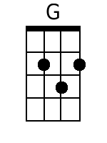 | 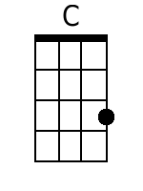 | 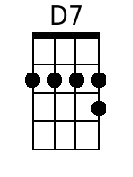 | 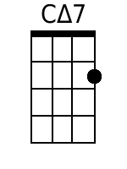 | 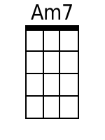
 | Bari
 | 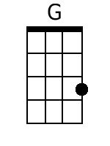 | 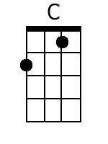 | 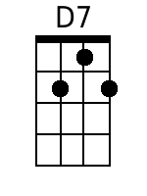 | 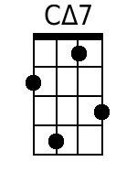 | 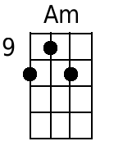

Dance, Dance, Dance (Brenda Cooper, Joseph Cooper & Steve Miller)
Dance, Dance, Dance, Steve Miller Band, from the album "Fly Like An Eagle" (1976)
Key of G

D↓ G↓ D↓ A7↓  My grandpa, he's ninty-five, he keeps on dancing; he's still alive.  D↓ G↓ D↓ A7↓  My grandma, she's ninty-two; she loves to dance and sing some, too.  D G  I don't know, but I've been told  D A7  If you keep on dancing you'll never grow old.  D G D A7 D  Come on darlin', put a pretty dress on; we're gonna go out to-night.  Chorus:  G Gmaj7 Em7 A7 D  Dance, Dance, Dance [x3] All night long.  D G  I'm a hard workin man, I'm a son of a gun;  D A7  I been workin all week in the noonday sun.  D G  The wood's in the kitchen and the cow's in the barn;  D A7  I'm all cleaned up and my chores are all done.  D G D A7  Take my hand come along, let's go out and have some fun.  D G D A7 D  Come on darlin', put a pretty dress on; we're gonna go out to-night. Chorus | D G  Come on, darlin', don't look that way;  D A7  Don't you know when you smile I've got to say:  D G  You're my honey-pumpkin lover, you're my heart's delight;  D A7  Don't you want to go out tonight?  D G  You're such a pretty lady, you're such a sweet girl;  D A7  When you dance, it brightens up my world.  D G D A7 D  Come on darlin', put a pretty dress on; we're gonna go out to-night. Chorus
 | 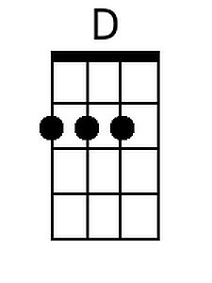 | 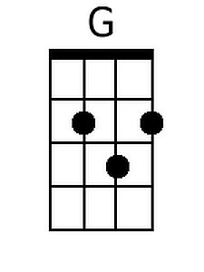 | 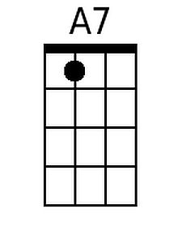 | 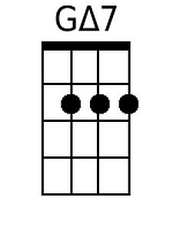 | 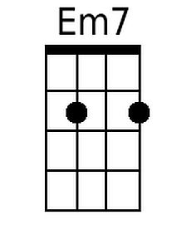
 | Bari
 | 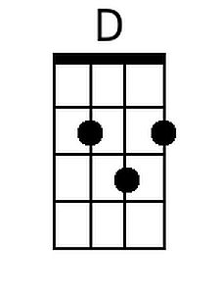 | 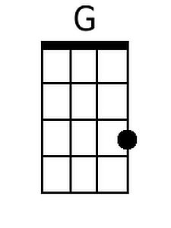 | 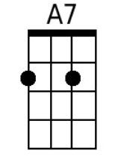 | 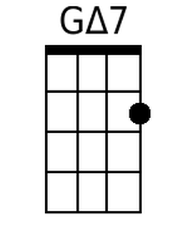 | 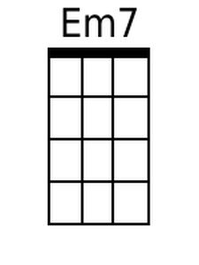

Dance, Dance, Dance (Brenda Cooper, Joseph Cooper & Steve Miller)
Dance, Dance, Dance, Steve Miller Band, from the album "Fly Like An Eagle" (1976)
Key of F

C↓ F↓ C↓ G7↓  My grandpa, he's ninty-five, he keeps on dancing; he's still alive.  C↓ F↓ C↓ G7↓  My grandma, she's ninty-two; she loves to dance and sing some, too.  C F  I don't know, but I've been told  C G7  If you keep on dancing you'll never grow old.  C F C G7 C  Come on darlin', put a pretty dress on; we're gonna go out to-night.  Chorus:  F Fmaj7 Dm7 G7 C  Dance, Dance, Dance [x3] All night long.  C F  I'm a hard workin man, I'm a son of a gun;  C G7  I been workin all week in the noonday sun.  C F  The wood's in the kitchen and the cow's in the barn;  C G7  I'm all cleaned up and my chores are all done.  C F C G7  Take my hand come along, let's go out and have some fun.  C F C G7 C  Come on darlin', put a pretty dress on; we're gonna go out to-night. Chorus | C F  Come on, darlin', don't look that way;  C G7  Don't you know when you smile I've got to say:  C F  You're my honey-pumpkin lover, you're my heart's delight;  C G7  Don't you want to go out tonight?  C F  You're such a pretty lady, you're such a sweet girl;  C G7  When you dance, it brightens up my world.  C F C G7 C  Come on darlin', put a pretty dress on; we're gonna go out to-night. Chorus
 | 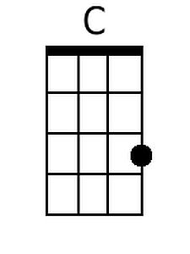 | 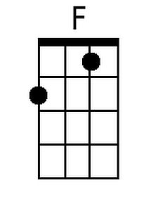 | 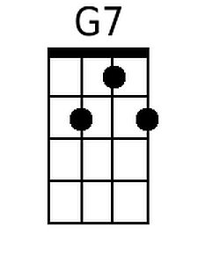 | 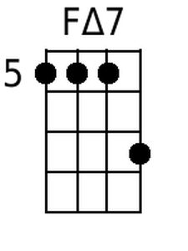 | 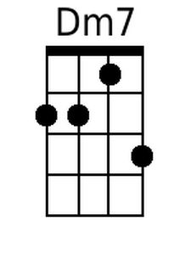
 | Bari
 | 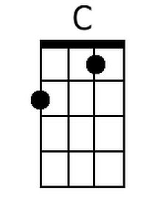 | 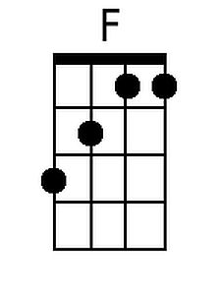 | 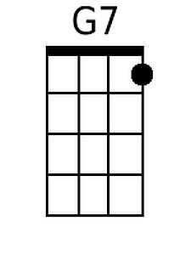 | 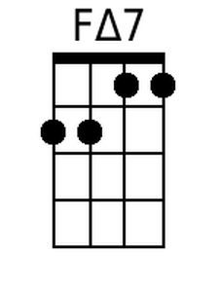 | 