Dancing Queen (Benny Andersson, Björn Ulvaeus & Stig Anderson, 1975)
Dancing Queen by Abba – Key of C
First Note: C
Intro (4 Measures): C F C Am  G7 E7 Am D7  You can dance, you can jive, Having the time of your life, Oh  F Dm G7 C | F | C | F  See that girl, watch that scene. Diggin' the Dancing Queen.  C F C Am  Friday night and the lights are low. Looking out for a place to go  G7 C G7 C  Where they play the right music, getting in the swing  G7 Am | G7 |  You come to look for a king.  C F C Am  Anybody could be that guy, night is young and the music's high  G7 C G7 C G7 Am | G7  With a bit of rock music, everything is fine. You're in the mood for a dance.  Am Dm G7  And when you get that chance, you are the . . .  Chorus  C F C | F |  Dancing Queen, Young and sweet only seventeen.  C F C G7 Am C  Dancing Queen, feel the beat from the tambourine.  G7 E7 Am D7  You can dance, you can jive, having the time of your life.  F Dm G7 C | F | C | F |  Oh, see that girl, watch that scene, diggin' the Dancing Queen  C F C Am  You're a teaser, you turn 'em on. Leave 'em burning and then you're gone  G7 C G7 C G7 Am | G7  Looking out for an-other. Anyone will do, you're in the mood for a dance  Am Dm G7  And when you get that chance, you are the . . . Chorus  Outro  F C | F | C | F | C | C  _ _ _ Diggin' the Dancing Queen. Hold |  |  |  |  |  |  |  | 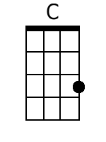
 |  |  |  |  |  |  |  | 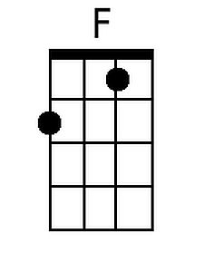
 |  |  |  |  |  |  |  | 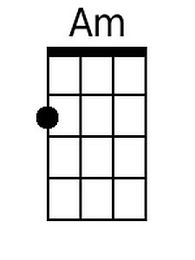
 |  |  |  |  |  |  |  | 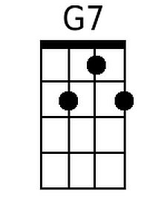
 |  |  |  |  |  |  |  | 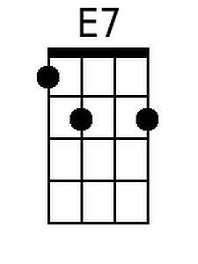
 |  |  |  |  |  |  |  | 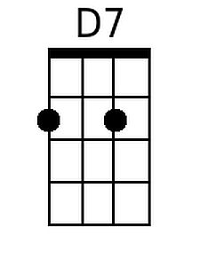
 |  |  |  |  |  |  |  | 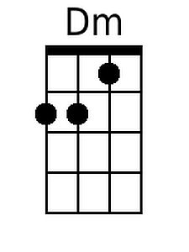
Bari | 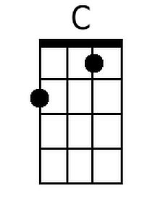 | 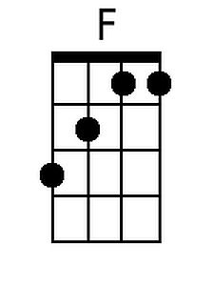 | 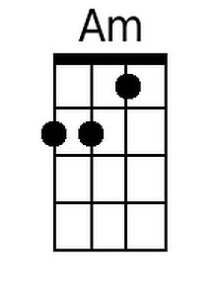 | 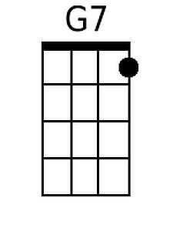 | 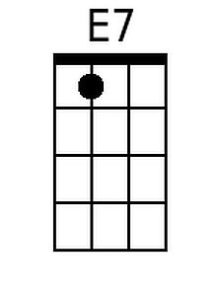 | 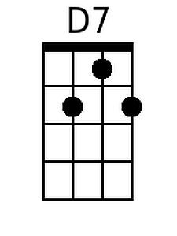 | 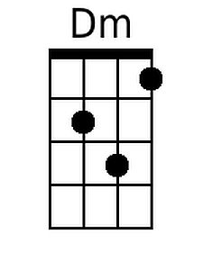

Dancing Queen (Benny Andersson, Björn Ulvaeus & Stig Anderson, 1975)
Dancing Queen by Abba – Key of G
First Note: G
Intro (4 Measures): G C G Em  D7 B7 Em A7  You can dance, you can jive, Having the time of your life, Oh  C Am D7 G | C | G | C  See that girl, watch that scene. Diggin' the Dancing Queen.  G C G Em  Friday night and the lights are low. Looking out for a place to go  D7 G D7 G  Where they play the right music, getting in the swing  D7 Em | D7 |  You come to look for a king.  G C G Em  Anybody could be that guy, night is young and the music's high  D7 G D7 G D7 Em | D7  With a bit of rock music, everything is fine. You're in the mood for a dance.  Em Am D7  And when you get that chance, you are the . . .  Chorus  G C G | C |  Dancing Queen, Young and sweet only seventeen.  G C G D7 Em G  Dancing Queen, feel the beat from the tambourine.  D7 B7 Em A7  You can dance, you can jive, having the time of your life.  C Am D7 G | C | G | C |  Oh, see that girl, watch that scene, diggin' the Dancing Queen  G C G Em  You're a teaser, you turn 'em on. Leave 'em burning and then you're gone  D7 G D7 G D7 Em | D7  Looking out for an-other. Anyone will do, you're in the mood for a dance  Em Am D7  And when you get that chance, you are the . . . Chorus  Outro  C G | C | G | C | G | G  _ _ _ Diggin' the Dancing Queen. Hold |  |  |  |  |  |  |  | 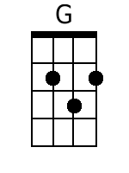
 |  |  |  |  |  |  |  | 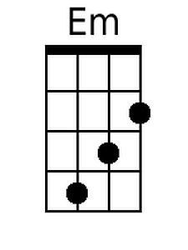
 |  |  |  |  |  |  |  | 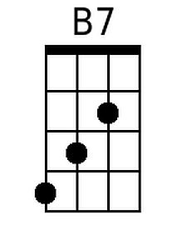
 |  |  |  |  |  |  |  | 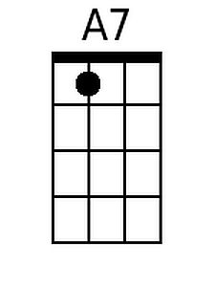
Bari | 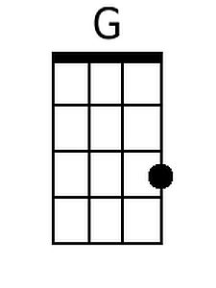 |  | 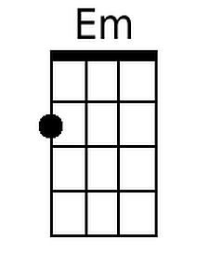 |  | 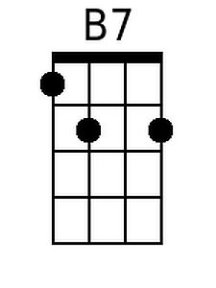 | 