**Danny Boy (Rory Dall O’Cahan)**

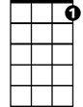

C7



C

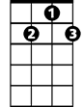

G7

**G7 C C7 F**

Oh Danny boy, the pipes, the pipes are calling

**C Em F G7**

From glen to glen and down the mountain side

**C C7 F**

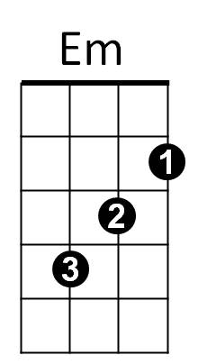The summer's gone and all the flowers are dying

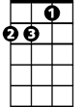

Dm

F



**C Dm G7 C G7**

'Tis you, 'tis you must go and I must bide

**Am F G7 C**

But come ye back when summer's in the meadow

**Am F Em D7 G7**

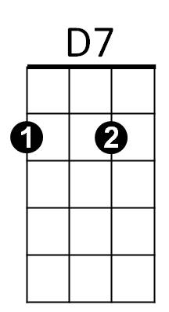Or when the valley's hushed and white with snow

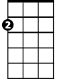

Am

**C F C Am**

And I'll be here in sunshine or in sha-dow

**C F G7 C G7**

Oh Danny boy, oh Danny boy, I love you so

**G7 C C7 F**

And if you come and all the flowers are dying

**C Em F G7**

And I am dead, as dead I well may be

**G7 C C7 F**

You'll come and find the place where I am lying

**C Dm G7 C G7**

And kneel and say an “Ave” there for me

**Am F G7 C**

And I shall hear, though soft you tread above me

**Am F Em D7 G7**

And all my dreams will warm and sweeter be

**C F C Am**

For you’ll not fail to tell me that you love me

**C F G7 C G7**

I’ll sleep in peace until you come to me

**BARITONE**

C



F

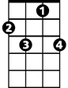

C7



G7

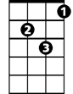

Dm



D7



Am



Em