**Daydream Believer (John Stewart)**

**Intro: C Dm (2x)**

**C Dm**

Oh, I could hide 'neath the wings

**Em F**

Of the bluebird as she sings.

**C Am D7 G7**

The six o'clock alarm would never ring.

**C Dm**

But it rings and I rise,

**Em F**

Wipe the sleep out of my eyes.

**C Am Dm G7 C**

My shavin' razor's cold and it stings.

**Chorus:**

**F G Em**

Cheer up, Sleepy Jean.

Em

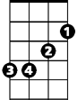

C

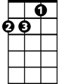

Dm

**F G Am**

Oh, what can it mean.

**F C F**

To a daydream believer

**C D7 G7**

And a homecoming queen.

**BARITONE**

C



G



Am

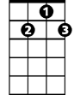

D7

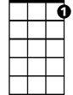

G7

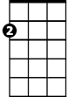

Em

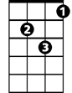

Dm

**C Dm**

You once thought of me

**Em F**

As a white knight on a steed.

**C Am D7 G7**

Now you know how happy I can be.

**C Dm**

Oh, and our good times start and end

**Em F**

Without dollar one to spend.

**C Am Dm G7 C**

But how much, baby, do we really need.

**(Chorus) 2X**

**(Repeat and fade)**

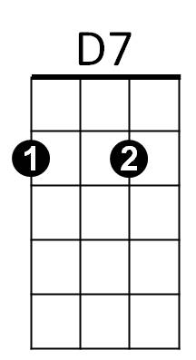



F

F



Am



G



G7