**Daydream (Lovin’ Spoonful)**

**Intro: C**

**C A7**

What a day for a daydream

**Dm G7**

What a day for a daydreamin' boy

**C A7**

And I'm lost in a daydream

**Dm G7**

Dreamin' bout my bundle of joy

**Chorus:**

**F D7 C A7**

And even if time ain't really on my side

**F D7 C A7**

It's one of those days for takin' a walk outside

**F D7 C A7**

I'm blowin' the day to take a walk in the sun

**D7**

And fall on my face on somebody's

**G7**

New-mowed lawn

**C A7**

I been havin' a sweet dream

**Dm G7**

I been dreamin' since I woke up today

**C A7**

It's starring me and my sweet dream

**Dm G7**

'Cause she's the one that makes me feel this way

**F D7 C A7**

And even if time is passin' me by a lot

**F D7 C**

I couldn't care less about the dues

**. A7**

You say I've got

**F D7 C A7**

Tomorrow I'll pay the dues for dropping my load

**D7 G7**

A pie in the face for bein' a sleepy bull toad

**Verse melody (whistled)**

**F D7 C A7**

And you can be sure that if you're feelin' right

**F D7 C A7**

A daydream will last 'til long into the night

**F D7**

Tomorrow at breakfast you may

**C A7**

Prick up your ears

**D7 G7**

Or you may be daydreamin' for a thousand years

**C A7**

What a day for a daydream

**Dm G7**

Custom-made for a daydreamin' boy

**C A7**

And I'm lost in a daydream

**Dm G7**

Dreamin' bout my bundle of joy

**Chorus melody to fade**

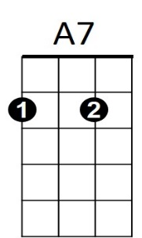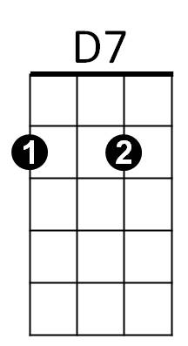

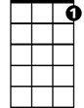

G7

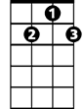

D7



F

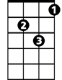

Dm

C



**BARITONE**

F

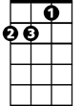

Dm



C

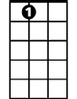

A7



G7

**Daydream (Lovin’ Spoonful) Key F**

**Intro: F**

**F D7**

What a day for a daydream

**Gm C7**

What a day for a daydreamin' boy

**F D7**

And I'm lost in a daydream

**Gm C7**

Dreamin' bout my bundle of joy

**Chorus:**

**Bb G7 F D7**

And even if time ain't really on my side

**Bb G7 F D7**

It's one of those days for takin' a walk outside

**Bb G7 F D7**

I'm blowin' the day to take a walk in the sun

**G7**

And fall on my face on somebody's

**C7**

New-mowed lawn

**F D7**

I been havin' a sweet dream

**Gm C7**

I been dreamin' since I woke up today

**F D7**

It's starring me and my sweet dream

**Gm C7**

'Cause she's the one that makes me feel this way

**Bb G7 F D7**

And even if time is passin' me by a lot

**Bb G7 F**

I couldn't care less about the dues

**. D7**

You say I've got

**Bb G7 F D7**

Tomorrow I'll pay the dues for dropping my load

**G7 C7**

A pie in the face for bein' a sleepy bull toad

**Verse melody (whistled)**

**Bb G7 F D7**

And you can be sure that if you're feelin' right

**Bb G7 F D7**

A daydream will last 'til long into the night

**Bb G7**

Tomorrow at breakfast you may

**F D7**

Prick up your ears

**G7 C7**

Or you may be daydreamin' for a thousand years

**F D7**

What a day for a daydream

**Gm C7**

Custom-made for a daydreamin' boy

**F D7**

And I'm lost in a daydream

**Gm C7**

Dreamin' bout my bundle of joy

**Chorus melody to fade**

**BARITONE**

F



D7



F



Gm



C7

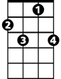

C7

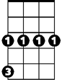

Gm



Bb

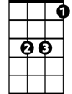

Bb



G7



G7

**Daydream (Lovin’ Spoonful) Key G**

**Intro: G**

**G E7**

What a day for a daydream

**Am D7**

What a day for a daydreamin' boy

**G E7**

And I'm lost in a daydream

**Am D7**

Dreamin' bout my bundle of joy

**Chorus:**

**C A7 G E7**

And even if time ain't really on my side

**C A7 G E7**

It's one of those days for takin' a walk outside

**C A7 G E7**

I'm blowin' the day to take a walk in the sun

**A7**

And fall on my face on somebody's

**D7**

New-mowed lawn

**G E7**

I been havin' a sweet dream

**Am D7**

I been dreamin' since I woke up today

**G E7**

It's starring me and my sweet dream

**Am D7**

'Cause she's the one that makes me feel this way

**C A7 G E7**

And even if time is passin' me by a lot

**C A7 G**

I couldn't care less about the dues

**. E7**

You say I've got

**C A7 G E7**

Tomorrow I'll pay the dues for dropping my load

**A7 D7**

A pie in the face for bein' a sleepy bull toad

**Verse melody (whistled)**

**C A7 G E7**

And you can be sure that if you're feelin' right

**C A7 G E7**

A daydream will last 'til long into the night

**C A7**

Tomorrow at breakfast you may

**G E7**

Prick up your ears

**A7 D7**

Or you may be daydreamin' for a thousand years

**G E7**

What a day for a daydream

**Am D7**

Custom-made for a daydreamin' boy

**G E7**

And I'm lost in a daydream

**Am D7**

Dreamin' bout my bundle of joy

**Chorus melody to fade**

E7

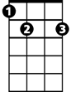

G

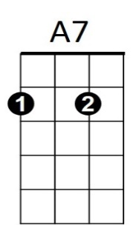

C



Am



D7



G



E7

**BARITONE**



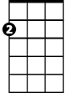

Am



A7



C