**December, 1963 (Oh, What a Night) (Bob Gaudio / Judy Parker)**

**Intro: C Am F G / C Am F G**

**C Am F G C Am**

Oh, what a night, late December back in sixty three,

**F G C Am F G C Am F G**

What a very special time for me, as I remember what a night!

**C Am F G C Am**

Oh, what a night, you know I didn't even know her name,

**F G C Am F G C Am F G**

But I was never gonna be the same, what a lady, what a night!

**Ch** **orus:**

**Dm F Am G**

Oh I, I got a funny feeling when she walked in the room,

**Dm F G G7**



G

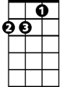

Dm

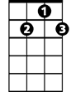

G7

Em

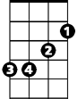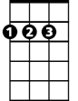

D



C

F

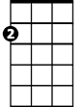

Am

And I, as I recall it ended much too soon.

**C Am F G C Am**

Oh what a night, hypnotizing, mesmerizing me,

**F G C Am**

She was everything I dreamed she'd be,

**F G C**  **Am F G**

Sweet surrender, what a night!

**Am D / Am D**

**Bridge:**

**F Em**

Oh, I felt a rush like a rolling bolt of thunder,

**F G G7**

**BARITONE**

Spinning my head around and taking my body under.



Am

C



F



G

**C Am F G / (C Am F G) 3x**

Oh what a night!

**(Chorus)**

**C Am F G C Am**

Oh what a night, why'd it take so long to see the light?



D

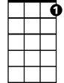

G7



Em

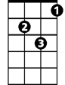

Dm

**F G C Am**

Seemed so wrong, but now it seems so right,

**F G C Am F G**

What a lady, what a night!

**Am D / Am D**

**(Bridge)**

**C Am F G to fade**

Oh what a night! Doo do doo do do, doo do doo)