Deck The Hall
C04 C
Welsh carol "Nos Galan" (16th Century) with English lyrics by Thomas Oliphant (1862); altered lyrics from the Pennsylvania School Journal (December, 1877).

Intro  F C G C  Fa la la la la, la la la la.  C G C G C  Deck the hall with boughs of holly, fa la la la la, la la la la,  C G C G C  'tis the season to be jolly, fa la la la la, la la la la.  G C D G  Don we now our gay apparel, fa la la, la la la, la la la.  C F C G C  Toll the ancient Yuletide carol, fa la la la la, la la la la.  C G C G C  See the blazing Yule before us, fa la la la la, la la la la,  C G C G C  strike the harp and join the chorus, fa la la la la, la la la la.  G C D G  Follow me in merry measure, fa la la, la la la, la la la.  C F C G C  While I tell of Yuletide treasure, fa la la la la, la la la la.  C G C G C  Fast away the old year passes, fa la la la la, la la la la,  C G C G C  hail the new, ye lads and lasses, fa la la la la, la la la la.  G C D G  Sing we joyous all together, fa la la, la la la, la la la.  C F C G C  Heedless of the wind and weather, fa la la la la, la la la la.  Outro (Slowly)  F C G C  Fa la la la la, la la la la. |  |  |  |  |  | 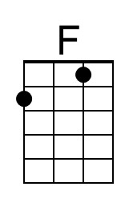
 |  |  |  |  |  | 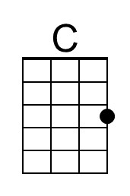
 |  |  |  |  |  | 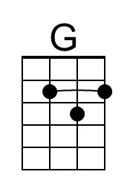
 |  |  |  |  |  | 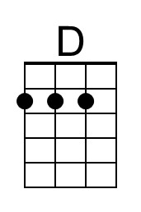
Baritone | 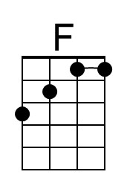 | 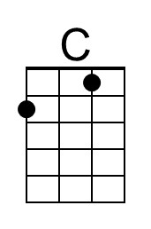 | 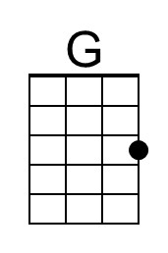 | 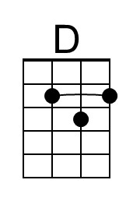

Deck The Hall
C04 F
Welsh carol "Nos Galan" (16th Century) with English lyrics by Thomas Oliphant (1862); altered lyrics from the Pennsylvania School Journal (December, 1877).

Bb F C F  Intro Fa la la la la, la la la la.  F C F C F  Deck the hall with boughs of holly, fa la la la la, la la la la,  F C F C F  'tis the season to be jolly, fa la la la la, la la la la.  C F G C  Don we now our gay apparel, fa la la, la la la, la la la.  F Bb F C F  Toll the ancient Yuletide carol, fa la la la la, la la la la.  F C F C F  See the blazing Yule before us, fa la la la la, la la la la,  F C F C F  strike the harp and join the chorus, fa la la la la, la la la la.  C F G C  Follow me in merry measure, fa la la, la la la, la la la.  F Bb F C F  While I tell of Yuletide treasure, fa la la la la, la la la la.  F C F C F  Fast away the old year passes, fa la la la la, la la la la,  F C F C F  hail the new, ye lads and lasses, fa la la la la, la la la la.  C F G C  Sing we joyous all together, fa la la, la la la, la la la.  F Bb F C F  Heedless of the wind and weather, fa la la la la, la la la la.  Outro (Slowly)  Bb F C F  Fa la la la la, la la la la. |  |  |  |  |  | 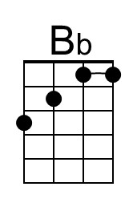
Baritone | 