Deep Purple - C
Deep Purple - C
Nino Tempo And April Stevens, 1963

 |  |  |  | 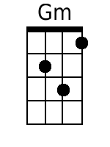 |  | 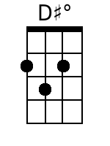 | 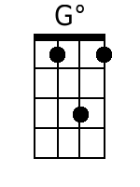

Verse 1.
G7 C A7 Dm G7
When the deep purple falls, over sleepy garden walls.
C Gm A7 A7
And the stars begin to twinkle in the sky-eye-eye-eye.
A7 Dm Fm C D#dim
Through the mist of a memory, you wander back to me,
Dm G7 C G7
breath..ing my name with a sigh-eye-eye-eye.

Verse 2.
G7 C Gdim Dm G7
In the still of the night, once a..gain I hold you tight.
C Gm A7
Though you're gone, your love lives on when moonlight beams.
A7 Dm Fm C D#dim
And as long as my heart will beat, sweet lover, we'll always meet,
D G7 C G7
Here in my deep pur..ple dreams.

Repeat Verses 1 & 2.

Coda:
A7 Dm Fm C D#dim
And as long as my heart will beat, sweet lover, we'll always meet,
Dm G7 Fm C
Here in my deep pur..ple dreams.
Deep Purple – C
(Simplified Version)
Nino Tempo And April Stevens, 1963

 |  |  |  |  |  | 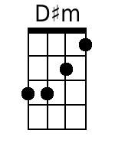

Verse 1.
G C A Dm G
When the deep purple falls, over sleepy garden walls.
C Gm A
And the stars begin to twinkle in the sky-eye-eye-eye.
A Dm Fm C D#m
Through the mist of a memory, you wander back to me,
Dm G C G
breath..ing my name with a sigh-eye-eye-eye.

Verse 2.
G C Gm Dm G
In the still of the night, once a..gain I hold you tight.
C Gm A
Though you're gone, your love lives on when moonlight beams.
A Dm Fm C D#m
And as long as my heart will beat, sweet lover, we'll always meet,
D G C G
Here in my deep pur..ple dreams.

Repeat Verses 1 & 2.

Coda:
A Dm Fm C D#m
And as long as my heart will beat, sweet lover, we'll always meet,
Dm G Fm C
Here in my deep pur..ple dreams.

