Deep Purple - G
Deep Purple - G
Nino Tempo And April Stevens, 1963

 |  |  |  |  | 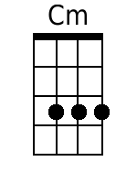 | 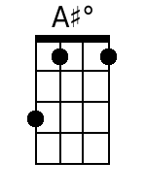 | 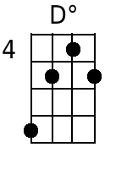

Verse 1.
D7 G E7 Am D7
When the deep purple falls, over sleepy garden walls.
G Dm E7 E7
And the stars begin to twinkle in the sky-eye-eye-eye.
E7 Am Cm G A#dim
Through the mist of a memory, you wander back to me,
Am D7 G D7
breath..ing my name with a sigh-eye-eye-eye.

Verse 2.
D7 G Ddim Am D7
In the still of the night, once a..gain I hold you tight.
G Dm E7
Though you're gone, your love lives on when moonlight beams.
E7 Am Cm G A#dim
And as long as my heart will beat, sweet lover, we'll always meet,
A D7 G D7
Here in my deep pur..ple dreams.

Repeat Verses 1 & 2.

Coda:
E7 Am Cm G A#dim
And as long as my heart will beat, sweet lover, we'll always meet,
Am D7 Cm G
Here in my deep pur..ple dreams.
Deep Purple - G
(Simplified Version)
Nino Tempo And April Stevens, 1963

 |  | 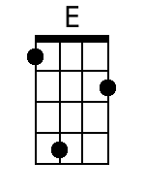 |  |  |  | 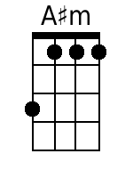

Verse 1.
D G E Am D
When the deep purple falls, over sleepy garden walls.
G Dm E
And the stars begin to twinkle in the sky-eye-eye-eye.
E Am Cm G A#m
Through the mist of a memory, you wander back to me,
Am D G D
breath..ing my name with a sigh-eye-eye-eye.

Verse 2.
D G Dm Am D
In the still of the night, once a..gain I hold you tight.
G Dm E
Though you're gone, your love lives on when moonlight beams.
E Am Cm G A#m
And as long as my heart will beat, sweet lover, we'll always meet,
A D G D
Here in my deep pur..ple dreams.

Repeat Verses 1 & 2.

Coda:
E Am Cm G A#m
And as long as my heart will beat, sweet lover, we'll always meet,
Am D Cm G
Here in my deep pur..ple dreams.

