Deep Purple (Peter DeRose & Mitchell Parish, 1938) (C)

Intro: Last 2 lines of verse.  C A7 Dm G7  When the deep purple falls, over sleepy garden walls.  C Gm A7  And the stars begin to twinkle in the sky-eye-eye-eye.  Dm Fm C Aº7  Through the mist of a memory, you wander back to me,  Dm G7 C G7  Breathe..ing my name with a sigh- eye-eye-eye.  C Gº7 Dm G7  In the still of the night, once a-gain I hold you tight.  C Gm  Though you're gone, your love lives on  A7  when moonlight beams.  Dm Fm  And as long as my heart will beat,  C Aº7  sweet lover, we'll always meet,  Dm G7 C G7  Here in my deep purple dreams.  To Outro: C A7  (Repeat From Top)  Outro  Dm Fm  And as long as my heart will beat,  C Aº7  sweet lover, we'll always meet,  Dm G7 Fm C  Here in my deep purple dreams. |  |  |  |  |  |  | 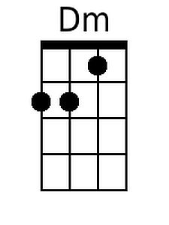 | 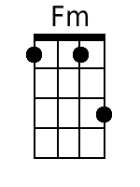
 |  |  |  |  |  |  | 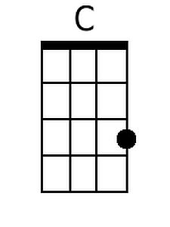 | 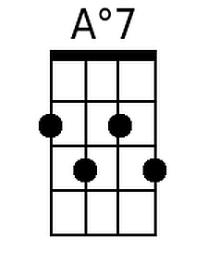
 |  |  |  |  |  |  | 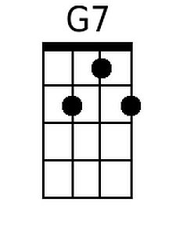 | 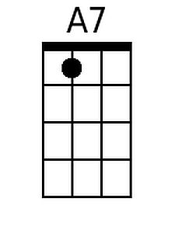
 |  |  |  |  |  |  | 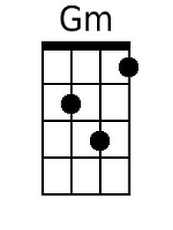 | 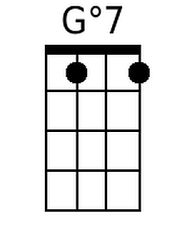
Bari | 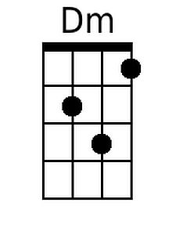 | 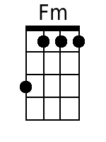 | 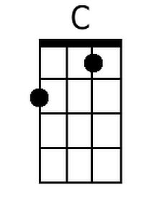 | 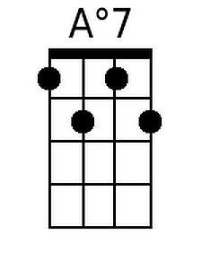 | 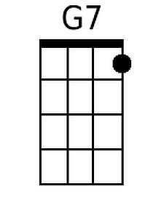 | 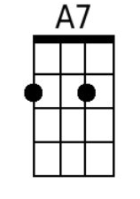 | 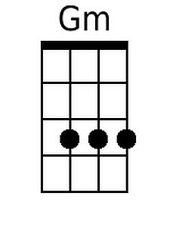 | 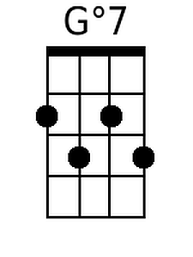

Deep Purple (Peter DeRose & Mitchell Parish, 1938) (G)

Intro: Last 2 lines of verse.  G E7 Am D7  When the deep purple falls, over sleepy garden walls.  G Dm E7  And the stars begin to twinkle in the sky-eye-eye-eye.  Am Cm G Eº7  Through the mist of a memory, you wander back to me,  Am D7 G D7  Breathe..ing my name with a sigh- eye-eye-eye.  G Dº7 Am D7  In the still of the night, once a-gain I hold you tight.  G Dm  Though you're gone, your love lives on  E7  when moonlight beams.  Am Cm  And as long as my heart will beat,  G Eº7  sweet lover, we'll always meet,  Am D7 G D7  Here in my deep purple dreams.  To Outro: C A7  (Repeat From Top)  Outro  Am Cm  And as long as my heart will beat,  G Eº7  sweet lover, we'll always meet,  Am D7 Cm G  Here in my deep purple dreams. |  |  |  |  |  |  | 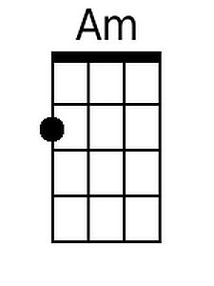 | 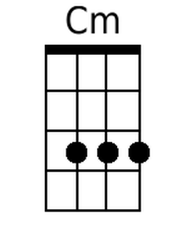
 |  |  |  |  |  |  | 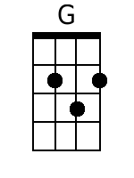 | 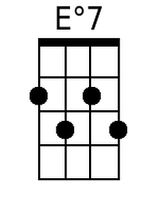
 |  |  |  |  |  |  | 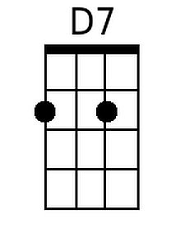 | 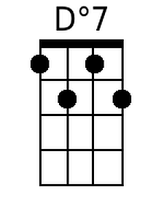
 |  |  |  |  |  |  |  | 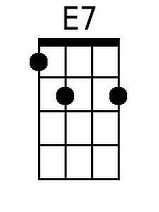
Bari | 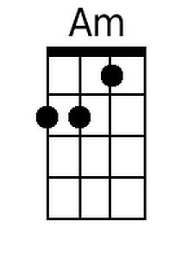 | 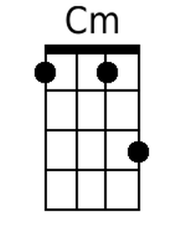 | 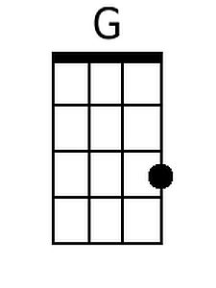 |  | 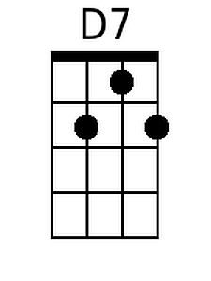 | 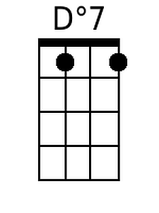 |  | 