Deep Purple (Peter DeRose & Mitchell Parrish, 1938) (C)

Intro: C | C7 | Dm7 | G7 |  C Gº7 Dm G7  When the Deep Purple falls over sleepy garden walls,  C Gm6 A7  and the stars begin to flicker in the sky,  Dm Fm Fm6  Thru the mist of a mem - o - ry  Em7 Aº7  you wander back to me,  Dm7 G7 C A7 | G9  breathing my name with a sigh,  C Gº7 Dm G7  In the still of the night once a-gain you hold me tight,  C Gm6  Tho you're gone your love lives on  A7  when moonlight beams.  Dm Fm Fm6  And as long as my heart will beat,  Em7 Gº7  Lover, we'll always meet,  F6 G7 Dm C – C#º7 | Dm7 G7 |  here in my Deep Purple Dreams.  Outro: C  Repeat from Top |  |  |  |  |  |  | 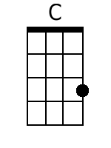 |  | 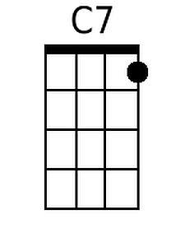 |  | 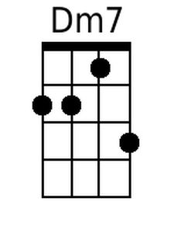
 |  |  |  |  |  |  | 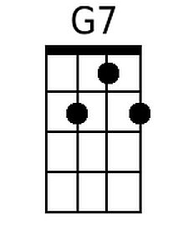 |  | 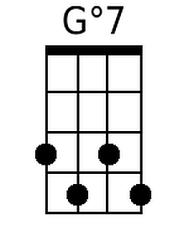 |  | 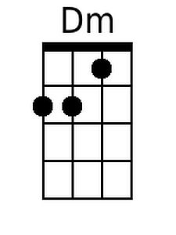
 |  |  |  |  |  |  | 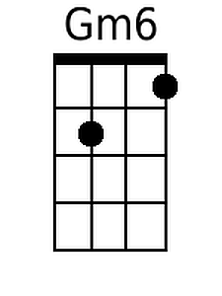 |  | 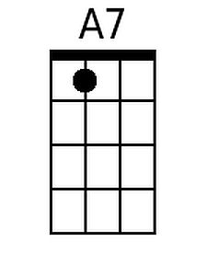 |  | 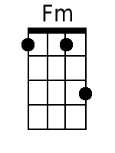
 |  |  |  |  |  |  | 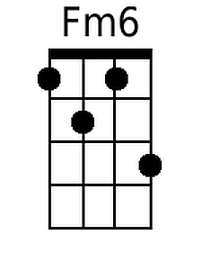 |  | 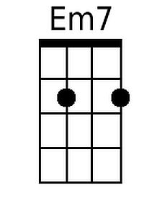 |  | 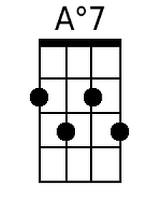
 |  |  |  |  |  |  | 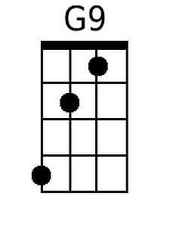 |  | 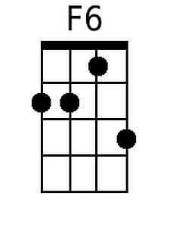 |  | 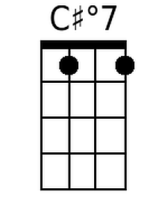
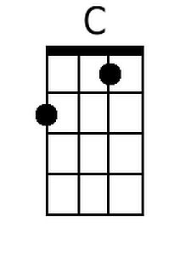 | 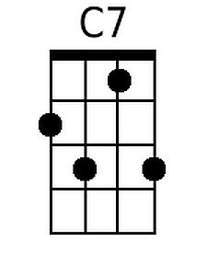 | 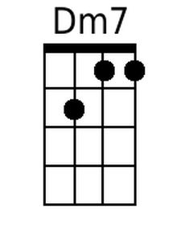 | 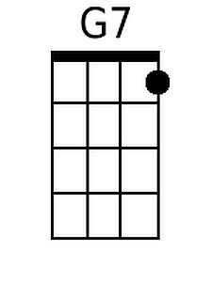 | 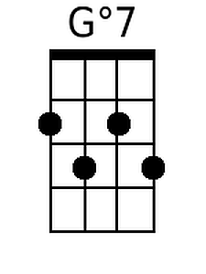 | 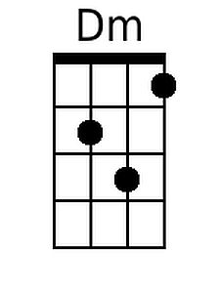 | 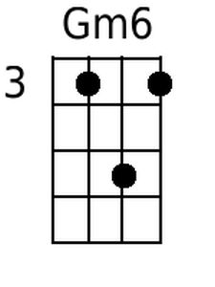 |  | 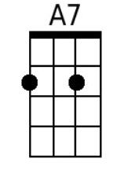 |  | 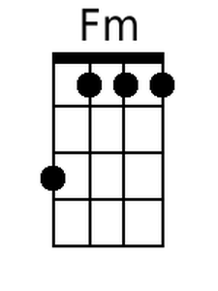
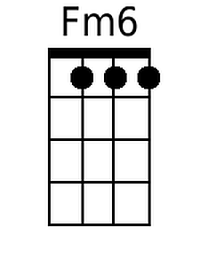 | 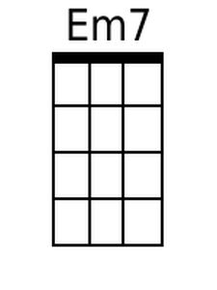 | 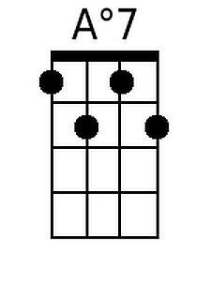 | 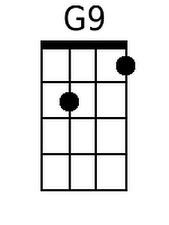 | 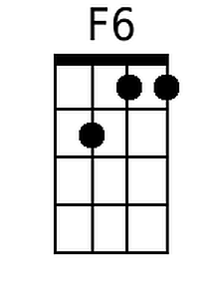 | 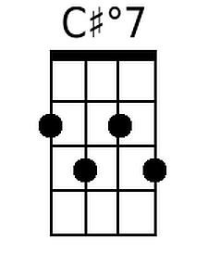 | Alt.  Chords |  | 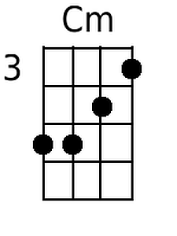 |  | 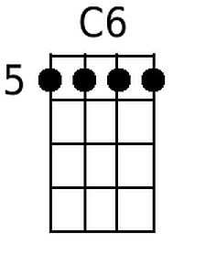

Deep Purple (Peter DeRose & Mitchell Parrish, 1938) (G)

Intro G | G7 | Am7 | D7 |  G Dº7 Am D7  When the Deep Purple falls over sleepy garden walls,  G Dm6 E7  and the stars begin to flicker in the sky,  Am Cm Cm6  Thru the mist of a mem - o - ry  Bm7 Eº7  you wander back to me,  Am7 D7 G E7 | D9  breathing my name with a sigh,  G Dº7 Am D7  In the still of the night once a-gain you hold me tight,  G Dm6  Tho you're gone your love lives on  E7  when moonlight beams.  Am Cm Cm6  And as long as my heart will beat,  Bm7 Dº7  Lover, we'll always meet,  C6 D7 Am G - G#º7 | Am7 D7 |  here in my Deep Purple Dreams.  Outro: C  Repeat from Top |  |  |  |  |  | 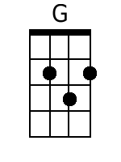 |  | 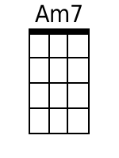
 |  |  |  |  |  | 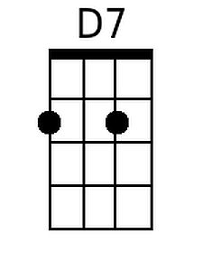 | 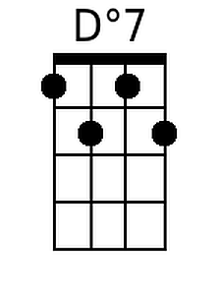 | 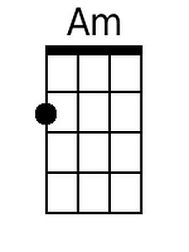
 |  |  |  |  |  | 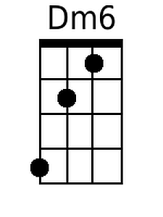 | 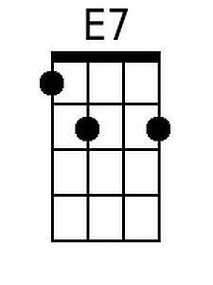 | 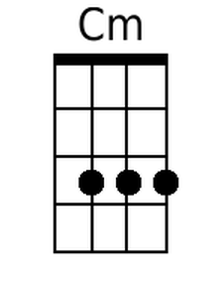
 |  |  |  |  |  | 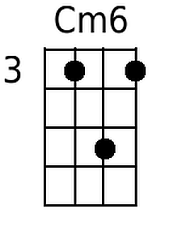 | 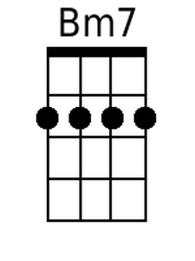 | 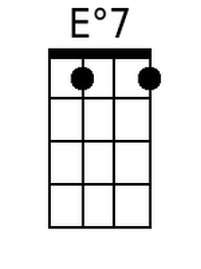
 |  |  |  |  |  | 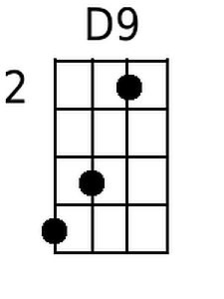 | 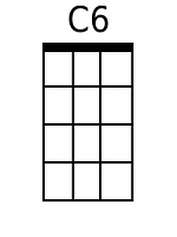 | 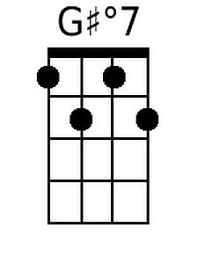
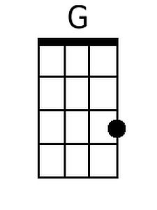 |  | 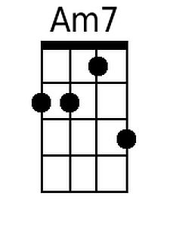 | 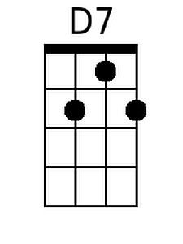 | 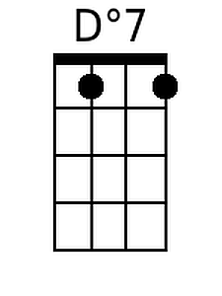 | 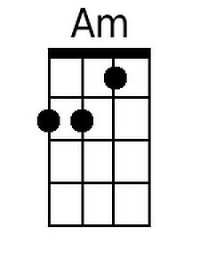 | 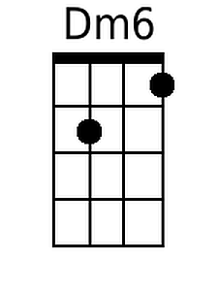 | 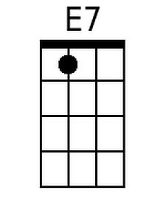 | 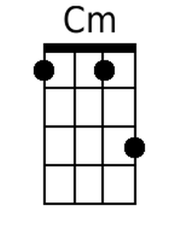
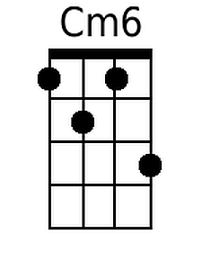 | 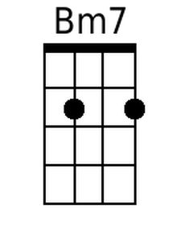 | 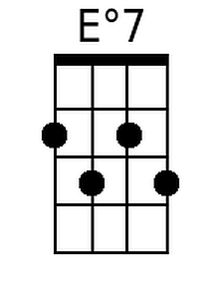 | 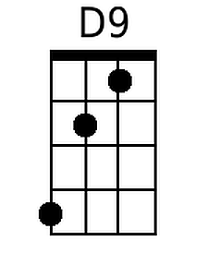 | 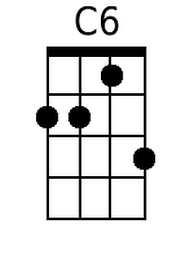 | 