**Deep Purple (Peter DeRose / Mitchell Parish)**

**D7 G E7 Am D7**

When the deep p urple falls, over sleepy garden walls.

**G Dm E7**

And the stars begin to twinkle in the sky-eye-eye-eye.

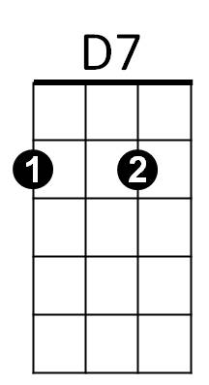**E7 Am Cm G Bbdim**



G

E7

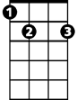

Through the mist of a memory, you wander back to me,

**Am D7 G D7**

Breathe..ing my name with a sigh- eye-eye-eye.

**D7 G Ddim Am D7**

In the still of the night, once a..gain I hold you tight.

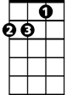

Dm

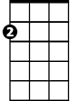

Am

**G Dm E7**

Though you're gone, your love lives on when moonlight beams.

**E7 Am Cm G Bbdim**

And as long as my heart will beat, sweet lover, we'll always meet,

**Am D7 G D7**

Here in my deep pur..ple dreams.

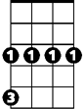

Cm

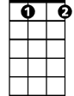

Bbdim

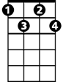

Ddim

**D7 G E7 Am D7**

When the deep purple falls, over sleepy garden walls.

**G Dm E7**

And the stars begin to twinkle in the sky-eye-eye-eye.

**E7 Am Cm G Bbdim**

Through the mist of a memory, you wander back to me,

**Am D7 G D7**

Breathe..ing my name with a sigh-eye-eye-eye.

**D7 G Ddim Am D7**

In the still of the night, once a..gain I hold you tight.

**G Dm E7**

Though you're gone, your love lives on when moonlight beams

**E7 Am Cm G Bbdim**

And as long as my heart will beat, sweet lover, we'll always meet,

**Am D7 G E7**

Here in my deep pur..ple dreams.

**E7 Am Cm G Bbdim**

And as long as my heart will beat, sweet lover, we'll always meet,

**Am D7 Cm G**

Here in my deep pur..ple dreams.

**BARITONE**

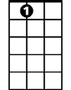

E7



Am

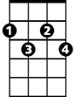

Bbdim



Ddim

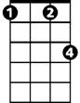

Cm

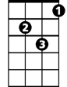

Dm



G

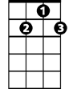

D7