Deep In the Heart of 'Bama (June Hershey & Don Swander, 1941) (C)
Lyrics Alt. By Theresa Miller & Doug Anderson, 2021
4/4 Time – Tempo 120 BPM
Intro (3 measures) C | G7 | C  C  The New Year's sky: a big Moon Pie! ( ↓ ↓ ↓ ↓ )  G7  That's what it's like in 'Bama.  G7  The meteor showers fall many hours ( ↓ ↓ ↓ ↓ )  C | C  Over the skies of 'Bama.  C  Mag-nolia blooms are like perfume ( ↓ ↓ ↓ ↓ )  G7  It sure is sweet in 'Bama;  G7  Re-minds me of the place I love ( ↓ ↓ ↓ ↓ )  C | C  My heart’s in A-la-bama.  C  The football teams! The fans all scream! ( ↓ ↓ ↓ ↓ )  G7  All over A-la-bama.  G7  And eat a peach at old Orange Beach ( ↓ ↓ ↓ ↓ )  C | C  Gulf shores of sweet old 'Bama.  C  The gators splash, and crash, and thrash ( ↓ ↓ ↓ ↓ )  G7  From North to South in 'Bama.  G7  And our Uke Fest is Just The Best ! ( ↓ ↓ ↓ ↓ )  C | G7  Next to a lake in 'Bama. (3x - Retard last time  End with C_C_C_C | G7_G7_G7_G7 | C [Hold] ) | 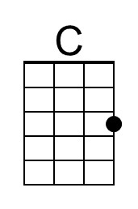
 | 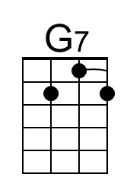
 | Bari
 | 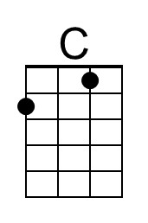
 | 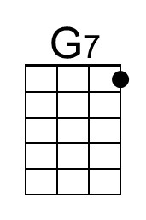

Deep In the Heart of 'Bama (June Hershey & Don Swander, 1941) (F)
Lyrics Alt. By Theresa Miller & Doug Anderson, 2021
4/4 Time – Tempo 120 BPM
Intro (3 measures) F | C7 | F  F  The New Year's sky: a big Moon Pie! ( ↓ ↓ ↓ ↓ )  C7  That's what it's like in 'Bama.  C7  The meteor showers fall many hours ( ↓ ↓ ↓ ↓ )  F | F  Over the skies of 'Bama.  F  Mag-nolia blooms are like perfume ( ↓ ↓ ↓ ↓ )  C7  It sure is sweet in 'Bama;  C7  Re-minds me of the place I love ( ↓ ↓ ↓ ↓ )  F | F  My heart’s in A-la-bama.  F  The football teams! The fans all scream! ( ↓ ↓ ↓ ↓ )  C7  All over A-la-bama.  C7  And eat a peach at old Orange Beach ( ↓ ↓ ↓ ↓ )  F | F  Gulf shores of sweet old 'Bama.  F  The gators splash, and crash, and thrash ( ↓ ↓ ↓ ↓ )  C7  From North to South in 'Bama.  C7  And our Uke Fest is Just The Best ! ( ↓ ↓ ↓ ↓ )  F | C7  Next to a lake in 'Bama. (3x - Retard last time  End with F_F_F_F | C7_C7_C7_C7 | F [Hold] ) | 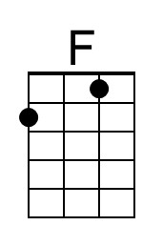
 | 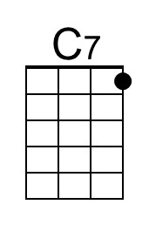
 | Bari
 | 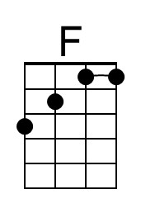
 | 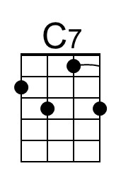

Deep In the Heart of 'Bama (June Hershey & Don Swander, 1941) (G)
Lyrics Alt. By Theresa Miller & Doug Anderson, 2021
4/4 Time – Tempo 120 BPM
Intro (3 measures) G | D7 | G  G  The New Year's sky: a big Moon Pie! ( ↓ ↓ ↓ ↓ )  D7  That's what it's like in 'Bama.  D7  The meteor showers fall many hours ( ↓ ↓ ↓ ↓ )  G | G  Over the skies of 'Bama.  G  Mag-nolia blooms are like perfume ( ↓ ↓ ↓ ↓ )  D7  It sure is sweet in 'Bama;  D7  Re-minds me of the place I love ( ↓ ↓ ↓ ↓ )  G | G  My heart’s in A-la-bama.  G  The football teams! The fans all scream! ( ↓ ↓ ↓ ↓ )  D7  All over A-la-bama.  D7  And eat a peach at old Orange Beach ( ↓ ↓ ↓ ↓ )  G | G  Gulf shores of sweet old 'Bama.  G  The gators splash, and crash, and thrash ( ↓ ↓ ↓ ↓ )  D7  From North to South in 'Bama.  D7  And our Uke Fest is Just The Best ! ( ↓ ↓ ↓ ↓ )  G | D7  Next to a lake in 'Bama. (3x - Retard last time  End with G_G_G_G | D7_D7_D7_D7 | C [Hold] ) | 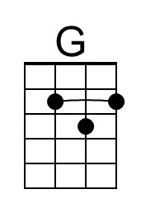
 | 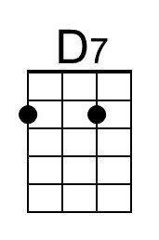
 | Bari
 | 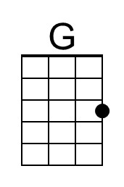
 | 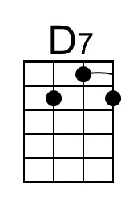

A reference to the Leonid meteor shower of Nov. 12-13, 1833, the night that the "Stars Fell On Alabama."
Peach - the state fruit of Alabama (2006).
A reference to the 1979 transplant of 56 alligators in north Alabama’s Wheeler National Wildlife Refuge.
Lake Guntersville – the site of the annual Alabama Ukulele Festival.

