Deep In the Heart of 'Bama (June Hershey & Don Swander, 1941) (C)
Lyrics Alt. By Theresa Miller & Doug Anderson, 2021
4/4 Time – Tempo 120 BPM
Intro (4 measures) C | G7 | C | G7  C  The New Year's sky: a big Moon Pie! ( ↓ ↓ ↓ ↓ )  G7  In Mobile, Ala-bama.  G7  The meteor showers fall many hours ( ↓ ↓ ↓ ↓ )  C | C  Over the skies of 'Bama.  C  Mag-nolia blooms are like perfume ( ↓ ↓ ↓ ↓ )  G7  It sure is sweet in 'Bama;  G7  Re-minds me of the place I love ( ↓ ↓ ↓ ↓ )  C | C  My heart’s in Ala-bama.  C  The football teams! The fans all scream! ( ↓ ↓ ↓ ↓ )  G7  All over Ala-bama.  G7  And eat a peach at old Orange Beach ( ↓ ↓ ↓ ↓ )  C | C  Gulf shores of sweet old 'Bama.  C  The gators splash, and crash, and thrash ( ↓ ↓ ↓ ↓ )  G7  From North to South in 'Bama.  G7  And our Uke Fest is Just The Best ! ( ↓ ↓ ↓ ↓ )  C | G7 C (Tremolo)  Next to a lake in 'Bama. (Retard) Deep in the heart of ‘Bama. | 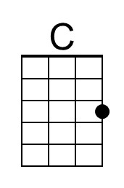
 | 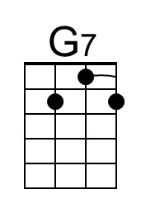
 | Bari
 | 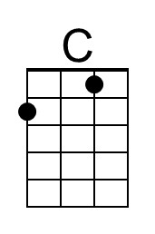
 | 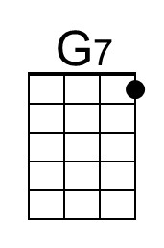

Deep In the Heart of 'Bama (June Hershey & Don Swander, 1941) (F)
Lyrics Alt. By Theresa Miller & Doug Anderson, 2021
4/4 Time – Tempo 120 BPM
Intro (4 measures) F | C7 | F | C7  F  The New Year's sky: a big Moon Pie! ( ↓ ↓ ↓ ↓ )  C7  In Mobile, Ala-bama.  C7  The meteor showers fall many hours ( ↓ ↓ ↓ ↓ )  F | F  Over the skies of 'Bama.  F  Mag-nolia blooms are like perfume ( ↓ ↓ ↓ ↓ )  C7  It sure is sweet in 'Bama;  C7  Re-minds me of the place I love ( ↓ ↓ ↓ ↓ )  F | F  My heart’s in Ala-bama.  F  The football teams! The fans all scream! ( ↓ ↓ ↓ ↓ )  C7  All over Ala-bama.  C7  And eat a peach at old Orange Beach ( ↓ ↓ ↓ ↓ )  F | F  Gulf shores of sweet old 'Bama.  F  The gators splash, and crash, and thrash ( ↓ ↓ ↓ ↓ )  C7  From North to South in 'Bama.  C7  And our Uke Fest is Just The Best ! ( ↓ ↓ ↓ ↓ )  F | C7 F (Tremolo)  Next to a lake in 'Bama. (Retard) Deep in the heart of ‘Bama. | 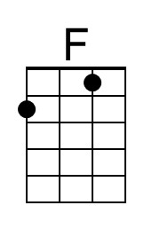
 | 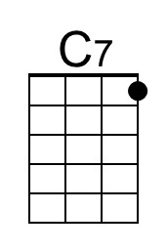
 | Bari
 | 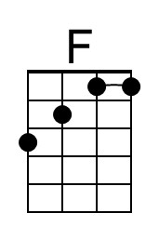
 | 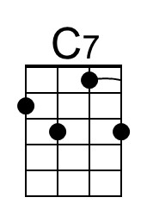

Deep In the Heart of 'Bama (June Hershey & Don Swander, 1941) (G)
Lyrics Alt. By Theresa Miller & Doug Anderson, 2021
4/4 Time – Tempo 120 BPM
Intro (4 measures) G | D7 | G | D7  G  The New Year's sky: a big Moon Pie! ( ↓ ↓ ↓ ↓ )  D7  In Mobile, Ala-bama.  D7  The meteor showers fall many hours ( ↓ ↓ ↓ ↓ )  G | G  Over the skies of 'Bama.  G  Mag-nolia blooms are like perfume ( ↓ ↓ ↓ ↓ )  D7  It sure is sweet in 'Bama;  D7  Re-minds me of the place I love ( ↓ ↓ ↓ ↓ )  G | G  My heart’s in Ala-bama.  G  The football teams! The fans all scream! ( ↓ ↓ ↓ ↓ )  D7  All over Ala-bama.  D7  And eat a peach at old Orange Beach ( ↓ ↓ ↓ ↓ )  G | G  Gulf shores of sweet old 'Bama.  G  The gators splash, and crash, and thrash ( ↓ ↓ ↓ ↓ )  D7  From North to South in 'Bama.  D7  And our Uke Fest is Just The Best ! ( ↓ ↓ ↓ ↓ )  G | D7 G (Tremolo)  Next to a lake in 'Bama. (Retard) Deep in the heart of ‘Bama. | 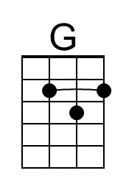
 | 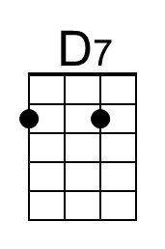
 | Bari
 | 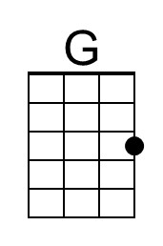
 | 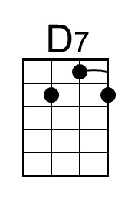

A 12’ tall “Moon Pie” is dropped from the 34th floor of the RSA BankTrust Building, St. Francis St. at Royal, in Mobile annually since Dec. 31, 2008 – except for 2020 when the drop was canceled due to COVID.
A reference to the Leonid meteor shower of Nov. 12-13, 1833, the night that the "Stars Fell On Alabama."
Peach - the state fruit of Alabama (2006).
A reference to the 1979 transplant of 56 alligators in north Alabama’s Wheeler National Wildlife Refuge.
Lake Guntersville – the site of the annual Alabama Ukulele Festival.

