Deep In the Heart of Texas
June Hershey & Don Swander, 1941
Deep In the Heart of Texas (June Hershey & Don Swander, 1941) (C)

Intro C F G7 C  C  The stars at night - are big and bright  G  Deep in the heart of Texas  C  The prairie sky - is wide and high  C  Deep in the heart of Texas.  C  The Sage in bloom - is like perfume  G  Deep in the heart of Texas  C  Re-minds me of - the one I love  C  Deep in the heart of Texas.  C  The cowboys cry - ki-yip-pie-yi  G  Deep in the heart of Texas  C  The rabbits rush - around the brush  C  Deep in the heart of Texas.  C  The coyotes wail - along the trail  G  Deep in the heart of Texas  C  The doggies bawl - and bawl and bawl  C  Deep in the heart of Texas. | 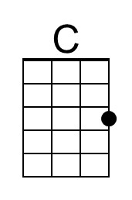
 | 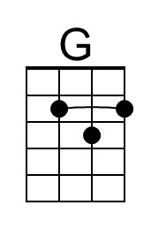
 | Bari
 | 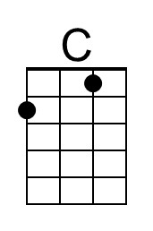
 | 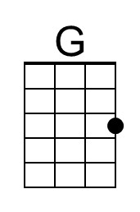

Deep In the Heart of Texas (June Hershey & Don Swander, 1941) (G)

Intro G | D | G |

G
The stars at night - are big and bright
D
Deep in the heart of Texas
G
The prairie sky - is wide and high
G
Deep in the heart of Texas.

G
The Sage in bloom - is like perfume
D
Deep in the heart of Texas
G
Re-minds me of - the one I love
G
Deep in the heart of Texas.

G
The cowboys cry - ki-yip-pie-yi
D
Deep in the heart of Texas
G
The rabbits rush - around the brush
G
Deep in the heart of Texas.

G
The coyotes wail - along the trail
D
Deep in the heart of Texas
G
The doggies bawl - and bawl and bawl
G
Deep in the heart of Texas.
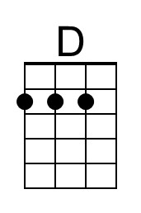
Bari
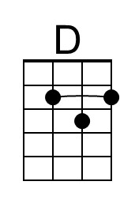

Deep In the Heart of Texas (June Hershey & Don Swander, 1941) (F)

Intro F | C | F  F  The stars at night - are big and bright  C  Deep in the heart of Texas.  F  The prairie sky - is wide and high  F  Deep in the heart of Texas.  F  The Sage in bloom - is like perfume  C  Deep in the heart of Texas  F  Re-minds me of - the one I love  F  Deep in the heart of Texas.  F  The cowboys cry - ki-yip-pie-yi  C  Deep in the heart of Texas  F  The rabbits rush - around the brush  F  Deep in the heart of Texas.  F  The coyotes wail - along the trail  C  Deep in the heart of Texas  F  The doggies bawl - and bawl and bawl  F  Deep in the heart of Texas. | 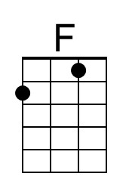
 | Bari
 | 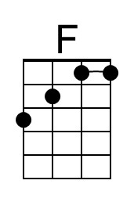

Deep In the Heart of Texas (June Hershey & Don Swander, 1941) (C)

Intro C F G7 C

C
The stars at night - are big and bright
G
Deep in the heart of Texas
C
The prairie sky - is wide and high
C
Deep in the heart of Texas.

C
The Sage in bloom - is like perfume
G
Deep in the heart of Texas
C
Re-minds me of - the one I love
C
Deep in the heart of Texas.

C
The cowboys cry - ki-yip-pie-yi
G
Deep in the heart of Texas
C
The rabbits rush - around the brush
C
Deep in the heart of Texas.

C
The coyotes wail - along the trail
G
Deep in the heart of Texas
C
The doggies bawl - and bawl and bawl
C
Deep in the heart of Texas.
Bari

This page is intentionally blank.

