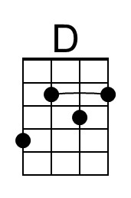
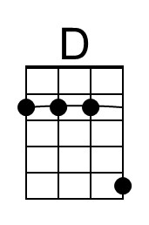
Dem Bones (“Dry Bones”) (D)
James Weldon Johnson & John Rosamond Johnson, before 1928
The lyrics were inspired by Ezekiel 37:1–14
Dem Bones by Fred Waring and the Pennsylvanians (1947) (Video)
Dem Dry Bones by the Delta Rhythm Boys (1950)
Dry Bones by The Four Lads (1968) -- Dem Bones by Gospel Harmony Quartet (1981)

This is a good song for using Barre Chords.
Optional chord voicing for C-Tuning: 333x – G Tuning: x232

Instrumental Intro D A7 D
Oh, hear the word of the Lord.

D A7 D
E-ze-kiel cried “Dem Dry Bones!” E-ze-kiel cried, “Dem Dry Bones!”
D G D A7 D
E-ze-kiel cried, “Dem Dry Bones!” Oh, hear the word of the Lord.

D D#
The foot bone connected to the leg bone. The leg bone connected to the knee bone.
E F
The knee bone connected to the thigh bone. The thigh bone connected to the back bone.
F# G
The back bone connected to the neck bone. The neck bone connected to the head bone.
G D7 G
Oh, hear the word of the lord.

G D7 G
Dem bones, dem bones, gonna walk aroun’. Dem bones, dem bones, gonna walk aroun’
G C G D7 G
Dem bones, dem bones, gonna walk aroun’, Oh, hear the word of the Lord

G Gb
The head bone connected to the neck bone. The neck bone connected to the back bone.
F E
The back bone connected to the thigh bone. The thigh bone connected to the knee bone.
Eb D
The knee bone connected to the leg bone. The leg bone connected to the foot bone.
D A7 D
Oh, hear the word of the Lord.

D A7 D
Dem bones, dem bones, gonna walk aroun’. Dem bones, dem bones, gonna walk aroun’ .
D G D A7 D
Dem bones, dem bones, gonna walk aroun’, Oh, hear the word of the Lord

D D A7 G | D D D A7 ↓ | D ↓
Oh, hear _ the word of the Lord.
______________________
“Dry Bones” is a separate although similar folk song.

