Desperado (Glen Frey / Don Henley) (C)

C C7 F Fm  Desperado, why don't you come to your senses ?  C Am7 D7 G7  You been out ridin' fences for so long now  C C7 F Fm  Oh, you're a hard one, I know that you got your reasons,  C E7 Am7 D7 G7 C G  These things that are pleasin' you can hurt you somehow  Am Em  Don't you draw the queen of diamonds boy,  F C  She'll beat you if she's able,  Am7 F C G  You know the queen of hearts is always your best bet  Am Em  Now it seems to me some fine things  F C  Have been laid upon your table  Am D7 Dm7 G  But you only want the ones you can't get  G G7 C C7 F Fm  Des – per - ado, oh you ain't gettin' no younger,  C Am7 D7 G7  Your pain and your hunger, they're drivin' you home  C C7 F Fm  And freedom, well, that's just some people talkin'  C E7 Am7 D7 G7 C G  Your prison is walkin' through this world all a – lone. |  |  |  |  |  | 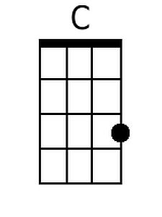 |  | 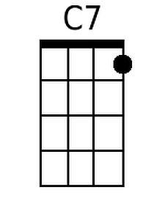
 |  |  |  |  |  | 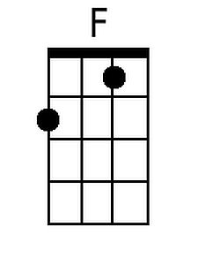 | 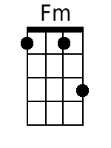
 |  |  |  |  |  | 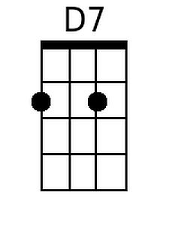 | 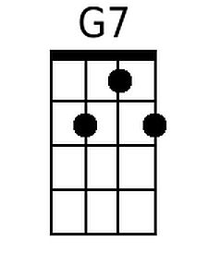
 |  |  |  |  |  | 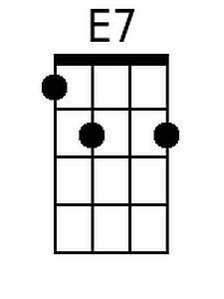 | 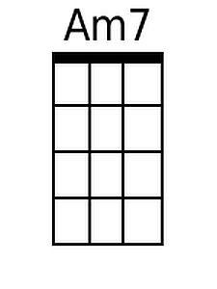
 |  |  |  |  |  | 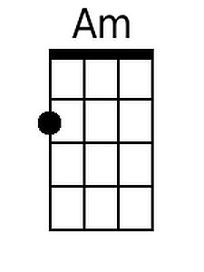 | 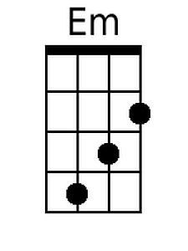
 |  |  |  |  |  | 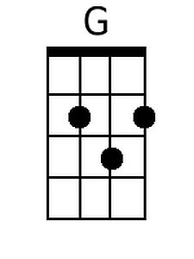 | 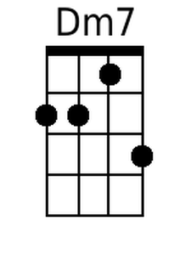
Bari
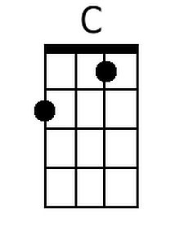 | 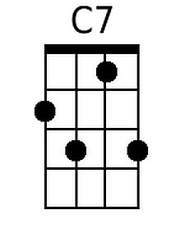 | 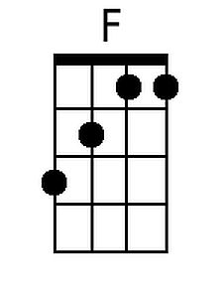 | 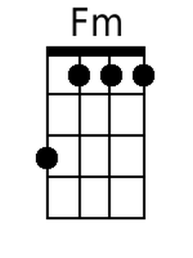 | 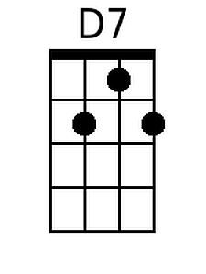 | 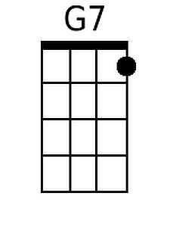
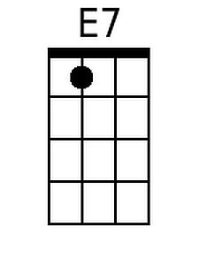 | 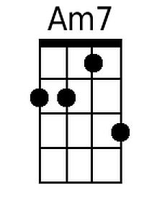 | 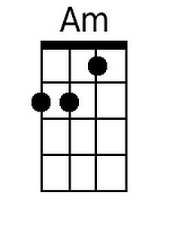 | 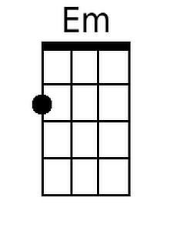 | 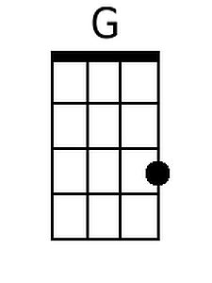 | 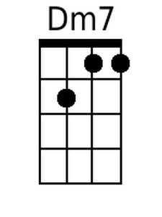

Desperado (C) - Page 2

Am Em
Don't your feet get cold in the winter time?
F C
The sky won't snow and the sun won't shine
Am7 F C G
It's hard to tell the night time from the day
Am Em
You're losin' all your highs and lows
F C Dm7 G
Ain't it funny how the feelin' goes away

G7 C C7 F Fm
Des - perado, why don't you come to your senses
C Am D7 G7
Come down from your fences, open the gate
C C7 F Fm
It may be rainin', but there's a rainbow above you
C E7 Am F C Dm7
You better let somebody love you,
C E7 Am Dm7 G7 C C C7 F Fm C
You better let somebody love you before it's too-oo late
Desperado (Glen Frey / Don Henley) (G)

G G7 C Cm
Desperado, why don't you come to your senses ?
G Em7 A7 D7
You been out ridin' fences for so long now
G G7 C Cm
Oh, you're a hard one, I know that you got your reasons,
G B7 Em7 A7 D7 G D
These things that are pleasin' you can hurt you somehow

Em Bm
Don't you draw the queen of diamonds boy,
C G
She'll beat you if she's able,
Em7 C G D
You know the queen of hearts is always your best bet
Em Bm
Now it seems to me some fine things
C G
Have been laid upon your table
Em A7 Am7 D
But you only want the ones you can't get

D7 G G7 C Cm
Des – perado, oh you ain't gettin' no younger,
G Em7 A7 D7
Your pain and your hunger, they're drivin' you home
G G7 C Cm
And freedom, well, that's just some people talkin'
G B7 Em7 A7 D7 G D
Your prison is walkin' through this world all a- lone

 |  |  |  |  |  |  | 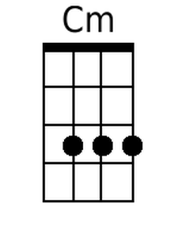
 |  |  |  |  |  | 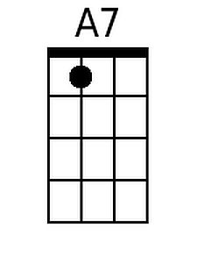
 |  |  |  |  |  | 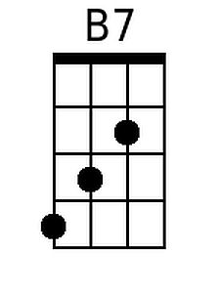 | 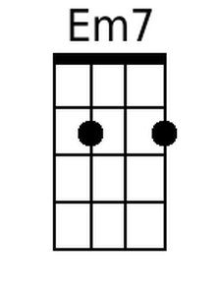
 |  |  |  |  |  |  | 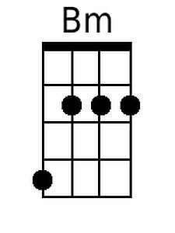
 |  |  |  |  |  | 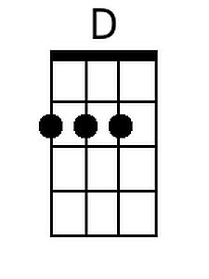 | 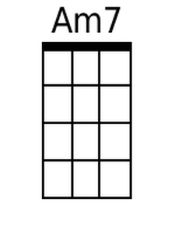
Bari
 |  |  | 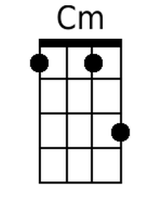 | 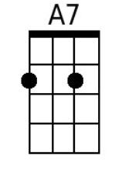
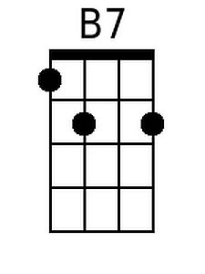 | 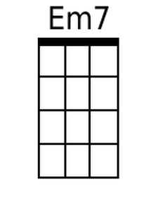 |  | 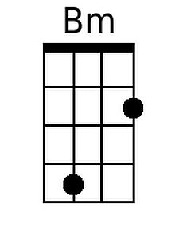 | 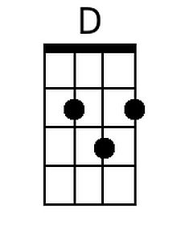

Desperado (G) - Page 2
Em Bm
Don't your feet get cold in the winter time ?
C G
The sky won't snow and the sun won't shine
Em7 C G D
It's hard to tell the night time from the day
Em Bm
You're losin' all your highs and lows
C G Am7 D
Ain't it funny how the feelin' goes away

D7 G G7 C Cm
Des - perado, why don't you come to your senses
G Em A7 D7
Come down from your fences, open the gate
G G7 C Cm
It may be rainin', but there's a rainbow a-bove you
G B7 Em C G Am7
You better let somebody love you,
G B7 Em Am7 D7 G G G7 C Cm G
You better let somebody love you before it's too-oo late

