Desperado (Glen Frey / Don Henley) (C & G)

This was the lead single from the 1973 album of the same name, the second studio album by the American band the Eagles. It was recorded at Island Studios in London, England, with musicians from the London Philharmonic Orchestra. It ranked No. 494 on Rolling Stone's 2004 list of "The 500 Greatest Songs of All Time". It was voted the No. 2 favorite Eagles song in a poll of Rolling Stone readers (July 29, 2015; #1 was "Hotel California"). It was never released as a single but was covered by Linda Ronstadt in 1973, which helped to boost its popularity. It was covered by several other artists including Kenny Rogers and Johnny Cash.
According to Don Henley, "Desperado" was based on a song he started in 1968, written in the style of old songs by Stephen Foster. In 1972, after they had recorded their first album "Eagles" in London, Glenn Frey and Henley decided that they should write songs together. In their first songwriting session after returning from London, Henley played Frey the unfinished version of the song, and said: "When I play it and sing it, I think of Ray Charles and Stephen Foster. It's really a Southern Gothic thing, but we can easily make it more Western." According to Henley, Frey "leapt right on it – filled in the blanks and brought structure", and the song became "Desperado". Henley added: "And that was the beginning of our songwriting partnership ... that's when we became a team."
"Desperado" features some interesting chord progressions. The five verses alternate between the major keys of C or G and their relative minor keys, Am & Em, a not uncommon practice.

In Verses 1, 3, & 5:
Roman Numeral Notation |  |  |  |  | Nashville Notation
I | I7 | IV | iv |  | 1 | 1(7) | 4 | 4m
I | vi7 | II7 | V7 |  | 1 | 6m7 | 2(7) | 5(7)
I | I7 | IV | iv |  | 1 | 1(7) | 4 | 4m
I | vi7 | II7 | V7 |  | 1 | 6m7 | 2(7) | 5(7)
with an I V transition to the following verses.

Verses 2 & 4 (analyzed from the viewpoint of the key of C/G):
Roman Numeral Notation |  |  |  |  | Nashville Notation
vi | iii | IV | I |  | 6m | 3m | 4 | 1
vi7 | IV | I | V |  | 6m7 | 4 | 1 | 5
vi | iii | IV | I |  | 6m | 3m | 4 | 1
vi | II7 | ii7 | V |  | 6m | 2(7) | 2m7 | 5

Verses 2 & 4 (analyzed from the viewpoint of the key of Am/Em):
Roman Numeral Notation |  |  |  |  | Nashville Notation
i | v | VI | III |  | 1m | 5m | 6 | 3
i7 | VI | I | VII |  | 1m7 | 6 | 1 | 7
i | v | VI | III |  | 1m | 5m | 6 | 3
i | IV7 | iv7 | VII |  | 1m | 4(7) | 4m7 | 7

Desperado (Don Henley & Glenn Frey, 1972) (C)

Pickup chord: G7  C C7 F Fm  Desperado, why don't you come to your senses ?  C Am7 D7 G7  You been out ridin' fences for so long now  C C7 F Fm  Oh, you're a hard one, I know that you got your reasons,  C E7 Am7 D7 G7 C G  These things that are pleasin' you can hurt you somehow  Am Em  Don't you draw the queen of diamonds boy,  F C  She'll beat you if she's able,  Am7 F C G  You know the queen of hearts is always your best bet  Am Em  Now it seems to me some fine things  F C  Have been laid upon your table  Am D7 Dm7 G  But you only want the ones you can't get  G G7 C C7 F Fm  Des – per - ado, oh you ain't gettin' no younger,  C Am7 D7 G7  Your pain and your hunger, they're drivin' you home  C C7 F Fm  And freedom, well, that's just some people talkin'  C E7 Am7 D7 G7 C G  Your prison is walkin' through this world all a – lone. |  |  |  |  |  | 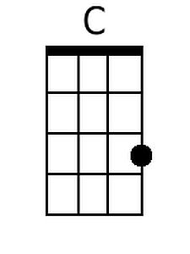 | 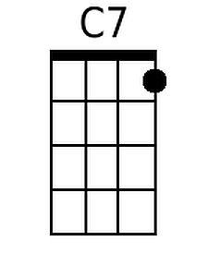
 |  |  |  |  |  | 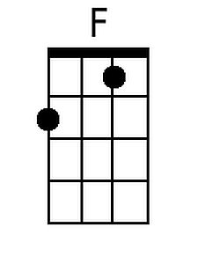 | 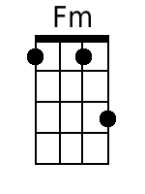
 |  |  |  |  |  | 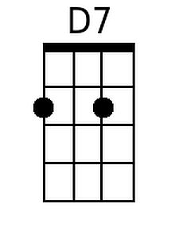 | 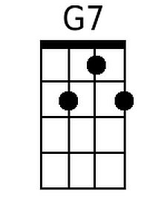
 |  |  |  |  |  | 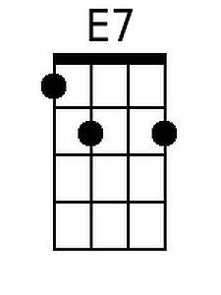 | 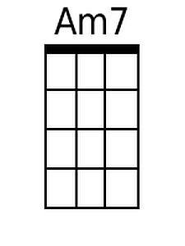
 |  |  |  |  |  | 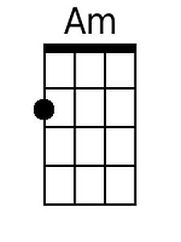 | 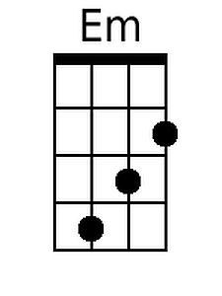
 |  |  |  |  |  | 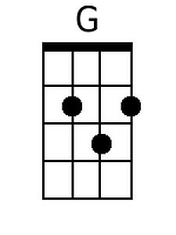 | 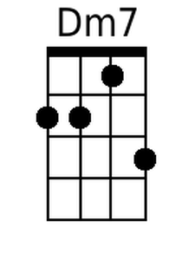
Bari
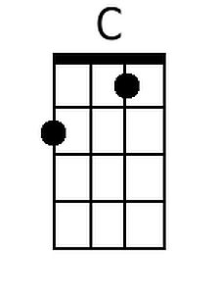 | 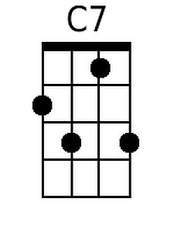 | 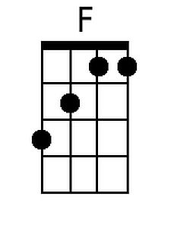 | 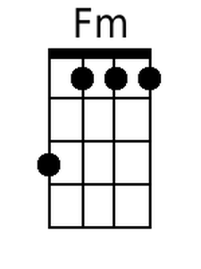 | 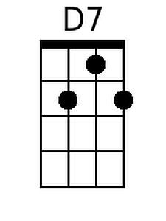 | 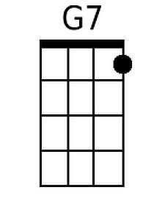
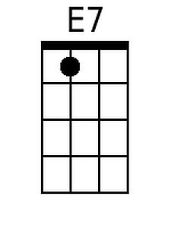 | 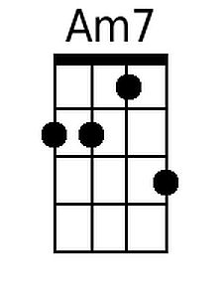 | 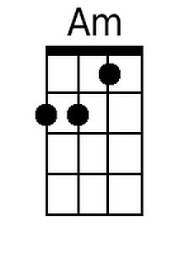 | 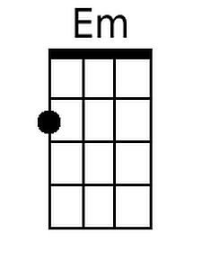 | 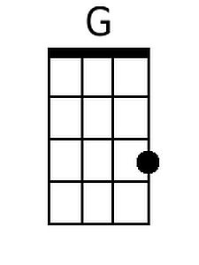 | 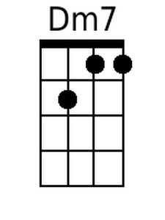

Desperado (C) - Page 2

Am Em
Don't your feet get cold in the winter time?
F C
The sky won't snow and the sun won't shine
Am7 F C G
It's hard to tell the night time from the day
Am Em
You're losin' all your highs and lows
F C Dm7 G
Ain't it funny how the feelin' goes away

G7 C C7 F Fm
Des - perado, why don't you come to your senses
C Am D7 G7
Come down from your fences, open the gate
C C7 F Fm
It may be rainin', but there's a rainbow above you
C E7 Am F C Dm7
You better let somebody love you,
C E7 Am Dm7 G7 C C C7 F Fm C
You better let somebody love you before it's too-oo late
Desperado (Don Henley & Glenn Frey, 1972) (G)

Pickup chord: D7
G G7 C Cm
Desperado, why don't you come to your senses ?
G Em7 A7 D7
You been out ridin' fences for so long now
G G7 C Cm
Oh, you're a hard one, I know that you got your reasons,
G B7 Em7 A7 D7 G D
These things that are pleasin' you can hurt you somehow

Em Bm
Don't you draw the queen of diamonds boy,
C G
She'll beat you if she's able,
Em7 C G D
You know the queen of hearts is always your best bet
Em Bm
Now it seems to me some fine things
C G
Have been laid upon your table
Em A7 Am7 D
But you only want the ones you can't get

D7 G G7 C Cm
Des – perado, oh you ain't gettin' no younger,
G Em7 A7 D7
Your pain and your hunger, they're drivin' you home
G G7 C Cm
And freedom, well, that's just some people talkin'
G B7 Em7 A7 D7 G D
Your prison is walkin' through this world all a- lone

 |  |  |  |  |  |  | 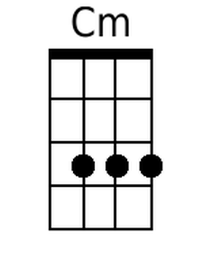
 |  |  |  |  |  | 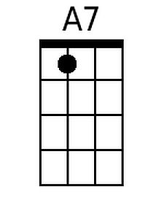
 |  |  |  |  |  | 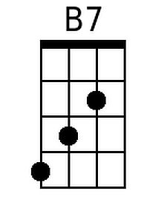 | 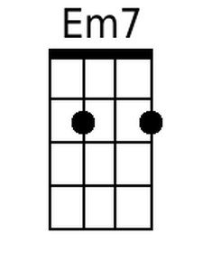
 |  |  |  |  |  |  | 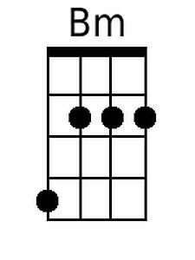
 |  |  |  |  |  | 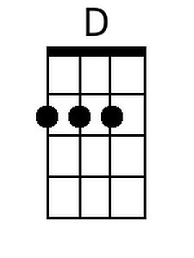 | 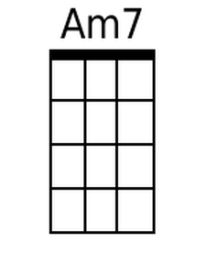
Bari
 |  |  | 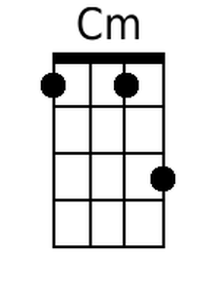 | 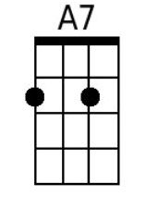
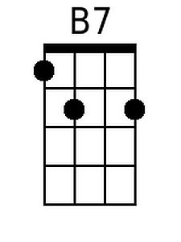 | 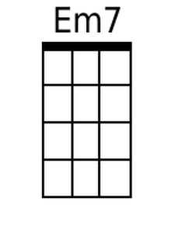 |  | 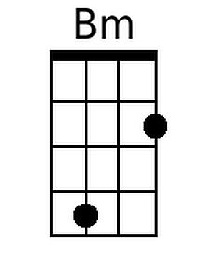 | 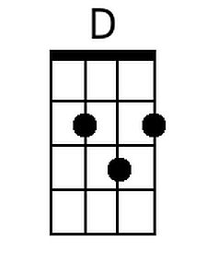

Desperado (G) - Page 2
Em Bm
Don't your feet get cold in the winter time ?
C G
The sky won't snow and the sun won't shine
Em7 C G D
It's hard to tell the night time from the day
Em Bm
You're losin' all your highs and lows
C G Am7 D
Ain't it funny how the feelin' goes away

D7 G G7 C Cm
Des - perado, why don't you come to your senses
G Em A7 D7
Come down from your fences, open the gate
G G7 C Cm
It may be rainin', but there's a rainbow a-bove you
G B7 Em C G Am7
You better let somebody love you,
G B7 Em Am7 D7 G G G7 C Cm G
You better let somebody love you before it's too-oo late

