**Desperado (Glen Frey / Don Henley) Key C**

**C C7 F Fm**

F

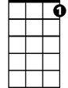

C7

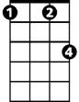

Fm



C

Desperado, why don't you come to your senses ?

**C Am7 D7 G7**

You been out ridin' fences for so long now

**C C7 F Fm**

Oh, you're a hard one, I know that you got your reasons,

**C E7 Am7 D7 G7 C G**

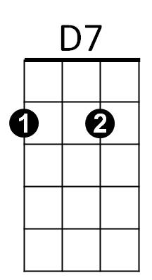These things that are pleasin' you can hurt you somehow

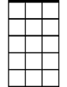

Am7



G

E7

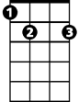

Em

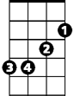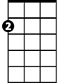

Am

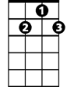

G7

**Am Em**

Don't you draw the queen of diamonds boy,

**F C**

She'll beat you if she's able,

**Am7 F C G**

You know the queen of hearts is always your best bet

**Am Em**

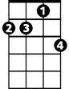

Dm7

Now it seems to me some fine things

**F C**

Have been laid upon your table

**Am D7 Dm7 G**

But you only want the ones you can't get

**G G7 C C7 F Fm**

Des – per - ado, oh you ain't gettin' no younger,

**C Am7 D7 G7**

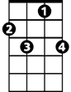

C7

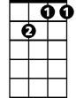

Dm7



D7

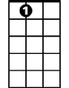

E7



Em



F

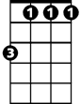

Fm



G



G7



Am7

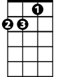

Am

**BARITONE**

C



Your pain and your hunger, they're drivin' you home

**C C7 F Fm**

And freedom, well, that's just some people talkin'

**C E7 Am7 D7 G7 C G**

Your prison is walkin' through this world all a - lone

**Am Em**

Don't your feet get cold in the winter time?

**F C**

The sky won't snow and the sun won't shine

**Am7 F C G**

It's hard to tell the night time from the day

**Am Em**

You're losin' all your highs and lows

**F C Dm7 G**

Ain't it funny how the feelin' goes away

**G7 C C7 F Fm**

Des - perado, why don't you come to your senses

**C Am D7 G7**

Come down from your fences, open the gate

**C C7 F Fm**

It may be rainin', but there's a rainbow above you

**C E7 Am F C Dm7**

You better let somebody love you,

**C E7 Am Dm7 G7 C C C7 F Fm C**

You better let somebody love you before it's too-oo late

**Desperado (Glen Frey / Don Henley) Key G**



C



Fm

F



C7

**G G7 C Cm**

Desperado, why don't you come to your senses ?

**G Em7 A7 D7**

You been out ridin' fences for so long now

**G G7 C Cm**

Oh, you're a hard one, I know that you got your reasons,

 **G B7 Em7 A7 D7 G D**



G7

E7



Am7

These things that are pleasin' you can hurt you somehow

**Em Bm**

Don't you draw the queen of diamonds boy,

**C G**

She'll beat you if she's able,

**Em7 C G D**

You know the queen of hearts is always your best bet



Dm7



G



Am

Em



**Em Bm**

Now it seems to me some fine things

**C G**

Have been laid upon your table

**Em A7 Am7 D**

But you only want the ones you can't get

**D7 G G7 C Cm**

Des - perado, oh you ain't gettin' no younger,

**G Em7 A7 D7**



Am



Em



Dm7



D7



G7



E7



Fm



F



C7

C



**BARITONE**

Your pain and your hunger, they're drivin' you home

**G G7 C Cm**

And freedom, well, that's just some people talkin'

**G B7 Em7 A7 D7 G D**

Your prison is walkin' through this world all a- lone

**Em Bm**

Don't your feet get cold in the winter time ?



Am7

**C G**

The sky won't snow and the sun won't shine

**Em7 C G D**

It's hard to tell the night time from the day

**Em Bm**

You're losin' all your highs and lows

**C G Am7 D**

Ain't it funny how the feelin' goes away



G

**D7 G G7 C Cm**

Des - perado, why don't you come to your senses

**G Em A7 D7**

Come down from your fences, open the gate

**G G7 C Cm**

It may be rainin', but there's a rainbow above you

**G B7 Em C G Am7**

You better let somebody love you,

**G B7 Em Am7 D7 G G G7 C Cm G**

You better let somebody love you before it's too-oo late