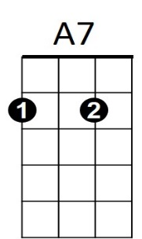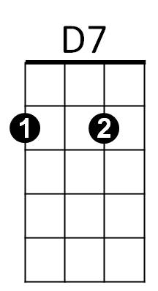



D



G

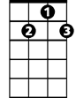

D7

**BARITONE**



G

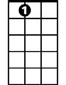

A7

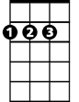

D

**Devil Woman (Marty Robbins)**

**G D7**



G



G7

I told Mary about it, I told her about a great sin

**G**

Mary cried and forgave me, then Mary took me back again

**G7 C**

Said if I wanted my freedom, I could be free ever more

**G D7 G**

But I don't want to be, and I don't want to see, Mary cry anymore

**Chorus:**



C

**D7 G**

Oh Devil woman, Devil woman let go of me

**D7 G**

Devil woman let me be, and leave me alone, I wanna go home

**G D7**

Mary is waiting and weeping, down in our shack by the sea

**G**

Even after I hurt her, Mary's still in love with me

**G7 C**

Devil woman it's over, trapped no more by your charm

**G D7 G**

‘Cause I don't want to stay, I want to get away, woman let go of my arm

**(CHORUS)**

**BARITONE**



D7

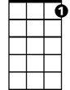

G7

**G D7**



G

Devil woman you’re evil, like the dark coral reef

**G**

Like the winds that bring high tides, you bring sorrow and grief

**G7 C**

You made me ashamed to face Mary, Mary had the strength to tell

**G D7 G**

Skies are not so black, Mary took me back, Mary has broken your spell

C



**(CHORUS)**

**G D7**

Running along by the seashore, running as fast as I can

**G**

Even the seagulls are happy, glad I’m coming home again

**G7 C**

Never again will I ever, cause another tear to fall

**G D7 G**

Down the beach I see, what belongs to me, the one I want most of all

**(CHORUS)**

**D7 G**

Oh Devil woman, Devil woman let go of me

**D7 G D7 G**

Devil woman don't follow me, and leave me alone, I wanna go home