
Do You Hear What I Hear?
C28 C
Noël Regney & Gloria Shayne, 1962
Do You Hear What I Hear? by the Harry Simeone Chorale

Intro (Chords for last line)  | F | G7 | C – Bb | C |  C Bb C  Said the night wind to the little lamb,  Am C Am C  Do you see what I see? (Echo)  C Bb C  Way up in the sky, little lamb,  Am C Am C  Do you see what I see? (Echo)  Am Em  A star, a star, dancing in the night  F G E7  With a tail as big as a kite  F G7 C G7  With a tail as big as a kite  C Bb C  Said the little lamb to the shepherd boy,  Am C Am C  Do you hear what I hear? (Echo)  C Bb C  Ringing through the sky, shepherd boy,  Am C Am C  Do you hear what I hear? (Echo)  Am Em  A song, a song, high above the trees  F G E7  With a voice as big as the sea  F G7 C G7  With a voice as big as the sea |  |  |  |  | C Bb C  Said the shepherd boy to the mighty king,  Am C Am C  Do you know what I know? (Echo)  C Bb C  In your palace warm, mighty king,  Am C Am C  Do you know what I know? (Echo)  Am Em  A Child, a Child shivers in the cold  F G E7  Let us bring Him silver and gold  F G7 C G7  Let us bring Him silver and gold.  C Bb C  Said the king to the people everywhere,  Am C Am C  Listen to what I say (Echo)  C Bb C  Pray for peace, people everywhere!  Am C Am C  Listen to what I say (Echo)  Am Em  The Child, the Child, sleeping in the night  F G E7  He will bring us goodness and light  F G7 C Bb C  He will bring us goodness and light.
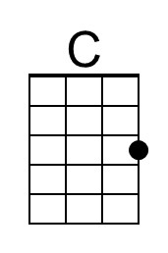 | 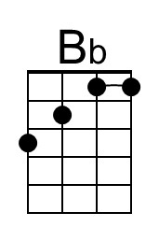 | 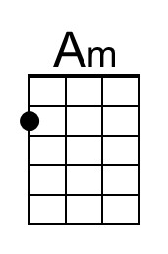 | 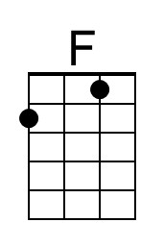 | 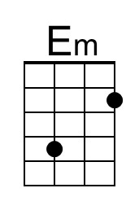 |  | 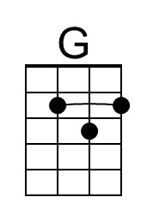 | 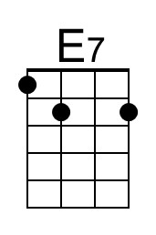 | 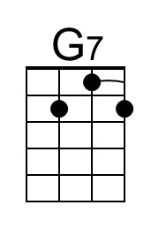
Baritone | 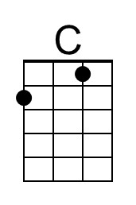 | 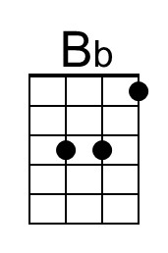 | 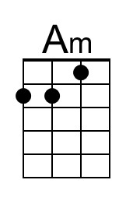 | 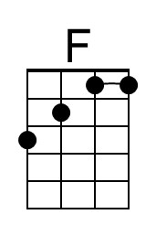 |  | 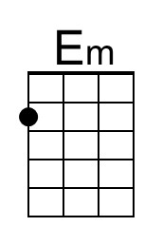 | 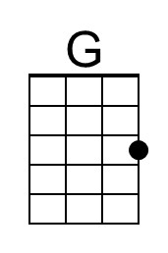 | 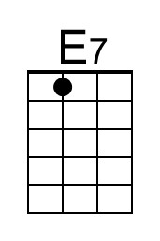 | 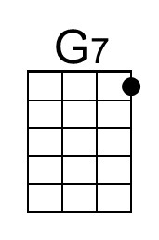

Do You Hear What I Hear?
C28 G
Noël Regney & Gloria Shayne, 1962
Do You Hear What I Hear? by the Harry Simeone Chorale

Intro (Chords for last line)  | C | D7 | G – F | G |  G F G  Said the night wind to the little lamb,  Em G Em G  Do you see what I see? (Echo)  G F G  Way up in the sky, little lamb,  Em G Em G  Do you see what I see? (Echo)  Em Bm  A star, a star, dancing in the night  C D B7  With a tail as big as a kite  C D7 G D7  With a tail as big as a kite  G F G  Said the little lamb to the shepherd boy,  Em G Em G  Do you hear what I hear? (Echo)  G F G  Ringing through the sky, shepherd boy,  Em G Em G  Do you hear what I hear? (Echo)  Em Bm  A song, a song, high above the trees  C D B7  With a voice as big as the sea  C D7 G D7  With a voice as big as the sea |  |  |  |  | G F G  Said the shepherd boy to the mighty king,  Em G Em G  Do you know what I know? (Echo)  G F G  In your palace warm, mighty king,  Em G Em G  Do you know what I know? (Echo)  Em Bm  A Child, a Child shivers in the cold  C D B7  Let us bring Him silver and gold  C D7 G D7  Let us bring Him silver and gold.  G F G  Said the king to the people everywhere,  Em G Em G  Listen to what I say (Echo)  G F G  Pray for peace, people everywhere!  Em G Em G  Listen to what I say (Echo)  Em Bm  The Child, the Child, sleeping in the night  C D B7  He will bring us goodness and light  C D7 G F G  He will bring us goodness and light.
 |  |  |  | 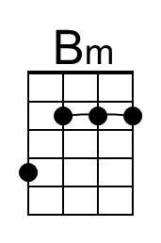 |  | 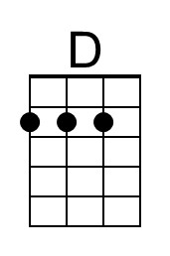 | 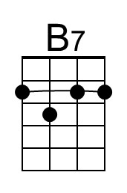 | 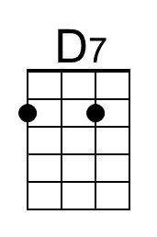
Baritone |  |  |  |  |  | 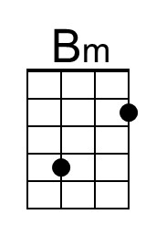 | 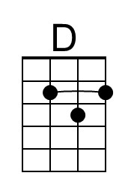 | 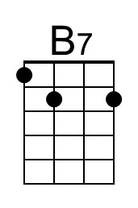 | 