**Do You Hear What I Hear?**

C 28

**Intro (Chords for last line): F G7 C – Bb C**

**C Bb C**

Said the night wind to the little lamb,

**Am C Am C**

Do you see what I see?

**C Bb C**

Way up in the sky, little lamb,

**Am C Am C**

Do you see what I see?

**Am Em**

A star, a star, dancing in the night

**F G E7**

With a tail as big as a kite

**F G7 C**

With a tail as big as a kite

**C Bb C**

Said the little lamb to the shepherd boy,

**Am C Am C**

Do you hear what I hear?

**C Bb C**

Ringing through the sky, shepherd boy,

**Am C Am C**

Do you hear what I hear?

**Am Em**

A song, a song, high above the trees

**F G E7**

With a voice as big as the sea

**F G7 C**

With a voice as big as the sea

**C Bb C**

Said the shepherd boy to the mighty king,



F

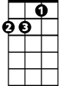

Am

**BARITONE**

**Am C Am C**

C

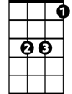

Bb

Do you know what I know?

**C Bb C**

In your palace warm, mighty king,

**Am C Am C**

Do you know what I know?

**Am Em**

A Child, a Child shivers in the cold

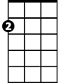

Em

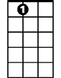

E7

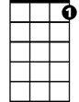

G7



G

**F G E7**

Let us bring Him silver and gold

**F G7 C**

Let us bring Him silver and gold

**C Bb C**

Said the king to the people everywhere,

**Am C Am C**

Listen to what I say

**C Bb C**

Pray for peace, people everywhere!

**Am C Am C**

Listen to what I say

**Am Em**

The Child, the Child, sleeping in the night

**F G E7**

He will bring us goodness and light

**F G7 C Bb C**

He will bring us goodness and light

F



Am



Bb



C

E7

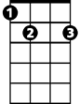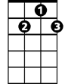

G7

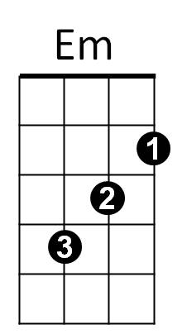



G