Do-Re-Mi (Rogers and Hammerstein) (C)
Do-Re-Mi by Julie Andrews and the Children from “The Sound Of Music” (1959)

Intro: (4 Measures) G  G  Let's start at the very beginning  G  A very good place to start  G7 C  When you read you begin with A B C.  G7 C G  When you sing you be-gin with  C G C C G C  do-re-mi. Do-re-mi.  G G7  The first three notes just  C G7 C  happen to be  C G C C G C  Do-re-mi, do-re-mi  C G7 | C G7 |  Do-re-mi-fa-so-la-ti  [Verse]  C  Doe, a deer, a female deer  G7 G9 - G7  Ray, a drop of golden sun  C  Me, a name I call myself  G7 G9  Far, a long, long way to run  C G7 F  Sew, a needle pulling thread  D7 G  La, a note to follow Sew  E7 Am C7  Tea, a drink with jam and bread  F Dm7 G7 C  That will bring us back to Do  ___________________________________  |1 G  | oh-oh-oh. [Repeat verse]  ___________________________________  |2 C F C G C  | Do-re-mi-fa-so-la-ti-do-so-do! | Transition – 2 Measures of G  [Intervals]  C | F | C | G  So Do La Fa Mi Do Re  C | F | C | G  So Do La Fa Mi Do Re  [Bridge]  C F C G  When you know the notes to sing  C F C G C  You can sing most anything  [Repeat Verse; use 2nd ending]  C | G | C | F | C | F | G | C  Do Re Mi Fa So La Ti Do  C | G | C | F | C | F | G  Do Re Mi Fa So La Ti  [Intervals 2] (2x)  C  Do Mi Mi  C  Mi So So  G  Re Fa Fa  G  La Ti Ti  [Repeat Bridge & Verse; use 2nd ending]
 | 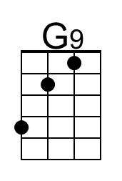 | 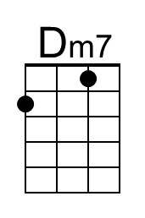 | 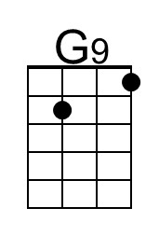 | 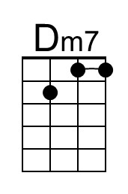

Do-Re-Mi (Rogers and Hammerstein) (G)
Do-Re-Mi by Julie Andrews and the Children from “The Sound Of Music” (1959)

Intro: (4 Measures) D  D  Let's start at the very beginning  D  A very good place to start  D7 G  When you read you begin with A B C.  D7 G D  When you sing you be-gin with  G D G G D G  do-re-mi. Do-re-mi.  D D7  The first three notes just  G D7 G  happen to be  G D G G D G  Do-re-mi, do-re-mi  G D7 | G | D7 |  Do-re-mi-fa-so-la-ti  [Verse]  G  Doe, a deer, a female deer  D7 D9 - D7  Ray, a drop of golden sun  G  Me, a name I call myself  D7 D9  Far, a long, long way to run  G D7 C  Sew, a needle pulling thread  A7 D  La, a note to follow Sew  B7 Em G7  Tea, a drink with jam and bread  C Am7 D7 G  That will bring us back to Do  ___________________________________  |1 D  | oh-oh-oh. [Repeat verse]  ___________________________________  |2 G C G D G  | Do-re-mi-fa-so-la-ti-do-so-do! | Transition – 2 Measures of G  [Intervals]  G | C | G | D  So Do La Fa Mi Do Re  G | C | G | D  So Do La Fa Mi Do Re  [Bridge]  C F C G  When you know the notes to sing  C F C G C  You can sing most anything  [Repeat Verse; use 2nd ending]  G | D | G | C | G | C | D | G  Do Re Mi Fa So La Ti Do  G | D | G | C | G | C | D  Do Re Mi Fa So La Ti  [Intervals 2] (2x)  G  Do Mi Mi  G  Mi So So  D  Re Fa Fa  D  La Ti Ti  [Repeat Bridge & Verse; use 2nd ending]
 | 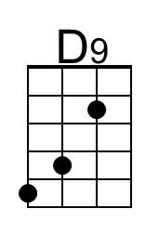 | 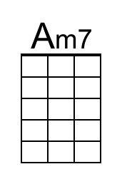 | 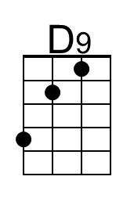 | 