**Dock of the Bay (Otis Redding)**

**G B7**

Sittin' in the morning sun

**C B Bb A**

I'll be sittin' in the eve-n- ing come

**G B7**

Watching the ships roll in,

**C B Bb A**

Then I watch them roll a-wa-ay a - gain, yeah

**CHORUS:**

**G E7**

I'm sittin' on the dock of the bay

**G E7**

Watching the tide roll away

**G A**

Ooh I'm just sittin' on the dock of the bay

**G E7**

Wasti ng ti---ime



G

**G B7**

I left my home in Georgia

**C B Bb A**

Headed for the Fris-co bay

**G B7**

'Cause I've had nothing to live for



Bb

**C B Bb A**

And look like nothing's gonna co-me my way

**(CHORUS)**

**G D C**

Look like nothing's gonna change

**G D C**

Everything still remains the same

**G D C**

I can't do what ten people tell me to do

**F D**

So I guess I'll remain the same

**BARITONE**

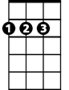

A

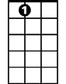

E7



D



F



G

C



B

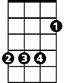

B7

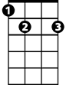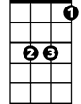

Bb

**G B7**

Sittin' here resting my bones

**C B Bb A**

And this loneliness won't leave me a - lone

**G B7**

These two thousand miles I roamed

**C B Bb A**

Just to make this do-ck my home

**G E7**

Now I'm just gonna sit at the dock of the bay

**G E7**

Watching the tide roll away, oooh

**G A**

Sittin' on the dock of the bay

**G E7**

Wasting ti---ime

**OUTRO: whistle and fade out (kazoos?)**

**G E7 / G E7**

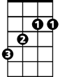

B



C

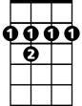

B7



D

E7

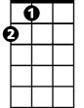

A

F

