**Don't Dream It's Over (Neil Finn)**

**Intro: Csus4**

**C Am**

There is freedom within, there is freedom without

**F E7**

Try to catch the deluge - in a paper cup

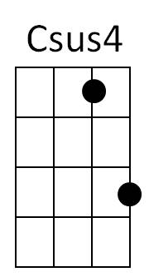**C Am**

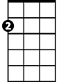

Am



C

There's a battle ahead, many battles are lost

**F**

But you'll never see the end of the road

**E7**

While you're traveling with me

**Chorus:**

**F G C Am**



G

E7

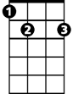

F



Hey now, hey now, Don't dream it's over

**F G C Am**

Hey now, hey now, When the world comes in

**F G C Am**

They come, they come - To build a wall between us

**F G**

We know they won't win

**C Am**

Now I'm towing my car, there's a hole in the roof

**F E7**

My possessions are causing me suspicion but there's no proof

**C Am**

In the paper today - tales of war and of waste

**F E7**

But you turn right over to the T.V. page

**(Chorus) C Am F E7 / C Am F E7 / F C F C Bb G**

**C Am**

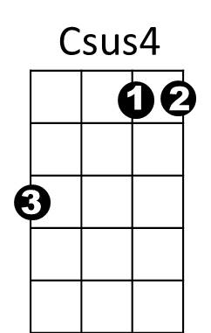Now I'm walking again - to the beat of a drum



F

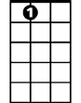

E7



G

C

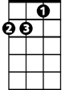

Am

**BARITONE**

**F E7**

And I'm counting the steps - to the door of your heart

**C Am**

Only shadows ahead - barely clearing the roof

**F E7**

Get to know the feeling of liberation and release

**(Chorus)**

**F G C Am F G C Am**

Don't let them win - Hey now, hey now

**F G C Am**

Hey now, hey now - Don't let them win

**F G C Am**

They come, they come - Don't let them win

**F G C Am / F G Am**

Hey now, hey now,

**Don't Dream It's Over (Neil Finn)**

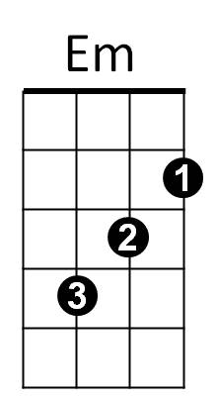**Intro: Gsus4**



G

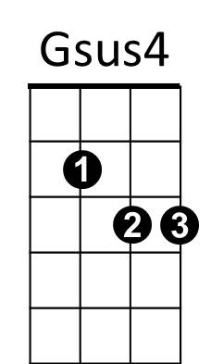**G Em**

There is freedom within, there is freedom without

**C B7**

Try to catch the deluge - in a paper cup

**G Em**

There's a battle ahead, many battles are lost

**C**

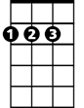

D

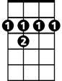

B7



C

But you'll never see the end of the road

**B7**

While you're traveling with me

**Chorus:**

**C D G Em**

Hey now, hey now, Don't dream it's over

**C D G Em**

Hey now, hey now, When the world comes in

**C D G Em**

They come, they come - To build a wall between us

**C D**

We know they won't win

**G Em**

Now I'm towing my car, there's a hole in the roof

**C B7**

My possessions are causing me suspicion but there's no proof

**G Em**

**BARITONE**

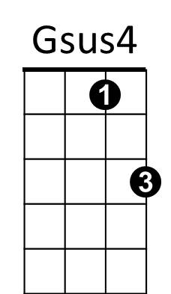In the paper today - tales of war and of waste



G



Em

**C B7**

But you turn right over to the T.V. page

**(Chorus)**

**G Em C B7 / G Em C B7 / C G C G Bb D**

**G Em**

C



B7



D

Now I'm walking again - to the beat of a drum

**C B7**

And I'm counting the steps - to the door of your heart

**G Em**

Only shadows ahead - barely clearing the roof

**C B7**

Get to know the feeling of liberation and release

**(Chorus)**

**C D G Em C D G Em**

Don't let them win - Hey now, hey now

**C D G Em**

Hey now, hey now - Don't let them win

**C D G Em**

**BARITONE**

They come, they come - Don't let them win

**C D G Em / C D Em**

Hey now, hey now,