**Don't It Make My Brown Eyes Blue (Richard C Leigh)**

**Intro: C Am Dm7 G7 / C Am Dm7 G7**

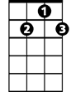

G7

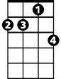

Dm7

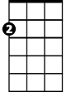

Am



C

**C Am Dm7 G7**

Don't know when I've been so blue

**C Am Dm E7**

Don't know what's come over you

**Am C Am D7**

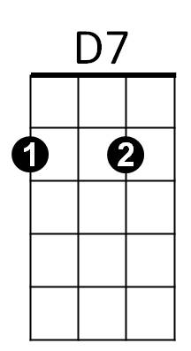You've found someone ne - w

Em

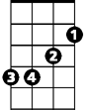

F



E7

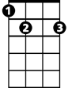

**F Em Dm7 G**

And don't it make my brown eyes blue

**C Am Dm7 G7**

I'll be fine when you're gone

**C Am Dm E7**



G

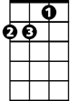

Dm

I'll just cry all night long

**Am C Am D7**

Say it isn't tru - e

**F G C**

And don't it make my brown eyes blue

**Am Em F C**

Tell me no secrets, tell me some lies

**BARITONE**

**Am Em F C**

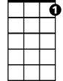

G7

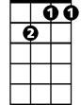

Dm7



Am

C



Give me no reasons, give me ali - bis

**Am Em F C**

Tell me you love me and don't let me cry

**Dm Em F G**

Say anything but don't say goodbye



Em



F



D7

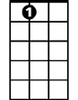

E7

**C Am Dm7 G7**

I didn't mean to treat you bad

**C Am Dm E7**

Didn't know just what I had

**Am C Am D7**

But honey now I do - o



G

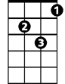

Dm

**F Em**

And don't it make my brown eyes,

**F Em**

Don't it make my brown eyes

**F G C**

Don't it make my brown eyes blue.

**C Am Dm7 G7 / C Am Dm7 G C**