Don't Let The Rain Come Down (Serendipity Singers) (C)
Chorus  C F  Ah, hah, Oh, no, don't let the rain come down.  G C  Ah, hah, Oh, no, don't let the rain come down.  C F  Ah, hah, Oh, no, don't let the rain come down.  G  My roof's got a hole in it and I might drown.  C  Oh, yes, my roof's got a hole in it and I might drown.  C F  There was a crooked man and he had a crooked smile,  G C  Had a crooked sixpence and he walked a crooked mile.  F  Had a crooked cat and he had a crooked mouse,  G C  They all lived together in a crooked little house. Chorus  C F  Well, this crooked little man and his crooked little smile,  G C  Took his crooked sixpence and he walked a crooked mile.  F  Bought some crooked nails and a crooked little bat,  G C  Tried to fix his roof with a rat-tat-tat-tat-tat. Chorus  C F  Now this crooked little man and his crooked cat and mouse,  G C  They all live together in a crooked little house.  F  Has a crooked door with a crooked little latch,  G C  Has a crooked roof with a crooked little patch. Chorus | (Note Chord Change)  D G  Ah, hah, Oh, no, don't let the rain come down.  A7 D  Ah, hah, Oh, no, don't let the rain come down.  D G  Ah, hah, Oh, no, don't let the rain come down.  A7  My roof's got a hole in it and I might drown  Oh, yes, my roof's got a hole in it..  My roof's got a hole in it..  D  My roof's got a hole in it.. and I..might..drown.
 | 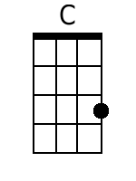 | 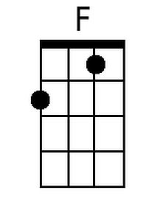 | 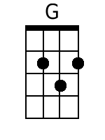
 | 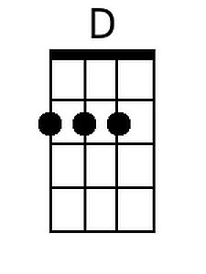 | 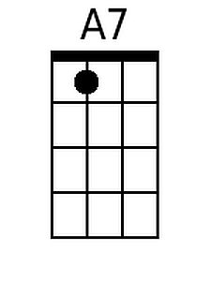
 | Bari
 | 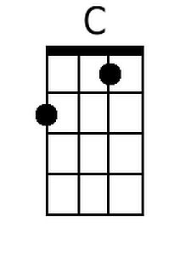 | 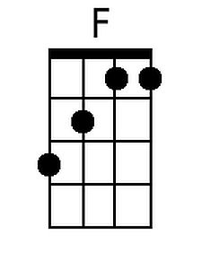 | 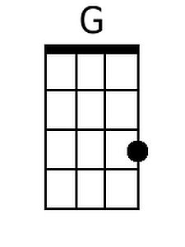
 | 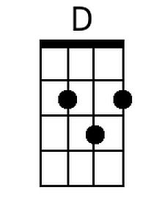 | 