Donna (Ritchie Valens, 1958) (C)
502C
Donna by Ritchie Valens (F – 100 BPM)
Donna by Los Lobos (1987) (F# – 115 BPM)

Chorus
C Am F G C Am F G
Oh, Donna, Oh, Donna, Oh, Donna, Oh, Donna.

C Am F G
I had a girl, Donna was her name
C Am F G
Since she left me I've never been the same
C Am F G C
'Cause I love my girl, Donna, where can you be?
F G
Where can you be?

C Am F G
Now that you're gone, I'm left all alone
C Am F G
All by my-self to wander and roam
C Am F G C
'Cause I love my girl, Donna, where can you be?
F C C7
Where can you be?

Bridge
F
Well, darlin', now that you're gone,
C
I don't know what I'll do.
F G
All the time and all my love for you.

Repeat Verse 1. Repeat Chorus.

Outro
C Am F G C Am F G C
Oh, Donna, Oh, Donna, Oh, Donna, Oh, Donna. Oh.

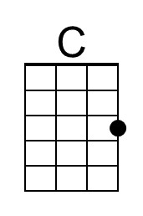 | 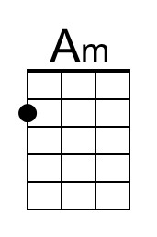 | 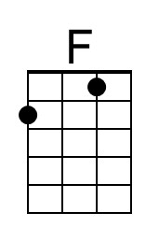 | 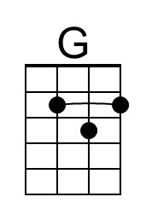 | Bari | 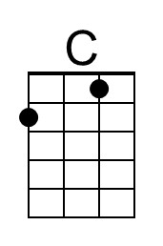 | 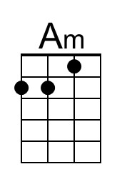 | 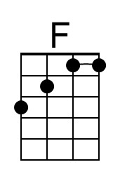 | 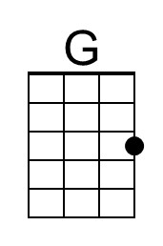

Donna (Ritchie Valens, 1958) (F)
502F
Donna by Ritchie Valens (F – 100 BPM)
Donna by Los Lobos (1987) (F# – 115 BPM)

Chorus
F Dm Bb C F Dm Bb C
Oh, Donna, Oh, Donna, Oh, Donna, Oh, Donna.

F Dm Bb C
I had a girl, Donna was her name
F Dm Bb C
Since she left me I've never been the same
F Dm Bb C F
'Cause I love my girl, Donna, where can you be?
Bb C
Where can you be?

F Dm Bb C
Now that you're gone, I'm left all alone
F Dm Bb C
All by my-self to wander and roam
F Dm Bb C F
'Cause I love my girl, Donna, where can you be?
Bb F F7
Where can you be?

Bridge
Bb
Well, darlin', now that you're gone,
F
I don't know what I'll do.
Bb C
All the time and all my love for you.

Repeat Verse 1. Repeat Chorus.

Outro
F Dm Bb C F Dm Bb C F
Oh, Donna, Oh, Donna, Oh, Donna, Oh, Donna. Oh.

 | 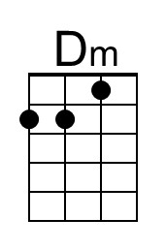 | 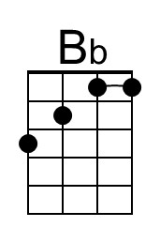 |  | Bari |  | 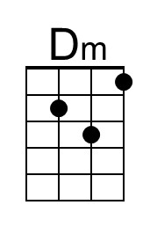 | 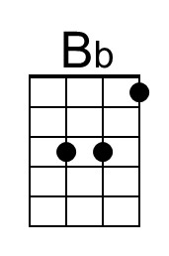

Donna (Ritchie Valens, 1958) (G)
502G
Donna by Ritchie Valens (F – 100 BPM)
Donna by Los Lobos (1987) (F# – 115 BPM)

Chorus
G C D G C D
Oh, Donna, Oh, Donna, Oh, Donna, Oh, Donna.

G C D
I had a girl, Donna was her name
G C D
Since she left me I've never been the same
G C D G
'Cause I love my girl, Donna, where can you be?
C D
Where can you be?

G C D
Now that you're gone, I'm left all alone
G C D
All by myself to wander and roam
G C D G
'Cause I love my girl, Donna, where can you be?
C G G7
Where can you be?

Bridge
C
Well, darlin', now that you're gone,
G
I don't know what I'll do.
C D
All the time and all my love for you.

Repeat Verse 1. Repeat Chorus.

Outro
G Em C D G Em C D G
Oh, Donna, Oh, Donna, Oh, Donna, Oh, Donna. Oh.

 | 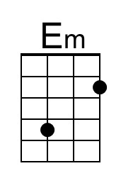 |  | 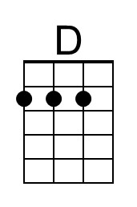 | Bari |  | 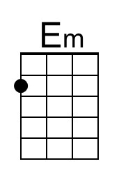 |  | 