**Don't Let the Rain Come Down (Serendipity Singers)**

**CHORUS:**

**G C**

Ah, hah, Oh, no, don't let the rain come down.

**D G**

Ah, hah, Oh, no, don't let the rain come down.

**G C**

Ah, hah, Oh, no, don't let the rain come down.

**D**

My roof's got a hole in it and I might drown.

Oh, yes, my roof's got a hole in it

**G**

and I might drown.

**G C**

There was a crooked man and he had a crooked smile,

**D G**

Had a crooked sixpence and he walked a crooked mile.

**C**

Had a crooked cat and he had a crooked mouse,

**D G**

They all lived together in a crooked little house.

**(CHORUS)**

**G C**

Well, this crooked little man and his crooked little smile,

**D G**

Took his crooked sixpence and he walked a crooked mile.

**C**

Bought some crooked nails and a crooked little bat,

**D G**

Tried to fix his roof with a rat-tat-tat-tat-tat.

**(CHORUS)**

**G C**

Now this crooked little man and his crooked cat and mouse,

**D G**

They all live together in a crooked little house.

**C**

Has a crooked door with a crooked little latch,

**D G**

Has a crooked roof with a crooked little patch.

**(CHORUS) (note chord change)**

**A D**

Ah, hah, Oh, no, don't let the rain come down.

**E7 A**

Ah, hah, Oh, no, don't let the rain come down.

**A D**

Ah, hah, Oh, no, don't let the rain come down.

**E7**

My roof's got a hole in it and I might drown

Oh, yes, my roof's got a hole in it..

My roof's got a hole in it..

**A**

My roof's got a hole in it.. and I..might..drown.

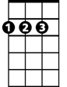

D

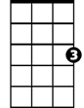

C



G

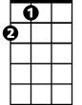

A

E7

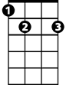

**BARITONE**

C

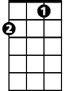

G



D



A

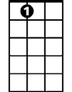

E7