**Don’t Let the Sun Catch You Crying**

**Cmaj7 F**

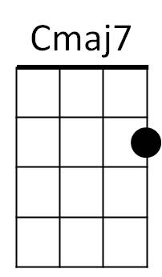**Cmaj7 F Cmaj7 F**

Em

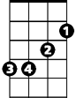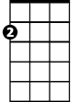

Am



G

F



Don't let the sun catch you cryin'

**Cmaj7 F G**

Tonight's the time for all your tears

**Am Em**

Your heart may be broken tonight

**Am Em**

But tomorrow in the mornin' light

**F G Cmaj7 F**

Don't let the sun catch you cryin'

**Cmaj7 F Cmaj7 F**

The night time shadows disappear

**Cmaj7 F G**

And with them go all your tears

**Am Em**

For sunshine will bring joy

**Am Em**

For every girl and boy so

**F G Cmaj7 F**

Don't let the sun catch you cryin'

**G Am**

We know that cryin's not a bad thing

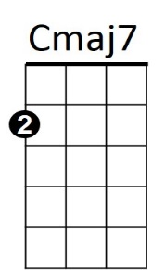**F G**



Em

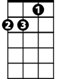

Am



G



F

**BARITONE**

But stop your cryin' when the birds sing

**Cmaj7 F Cmaj7 F**

It may be hard to discover

**Cmaj7 F G**

That you been left for another

**Am Em**

And don't forget that love's a game

**Am Em**

And it can always come again so

**F G Cmaj7 F**

Don't let the sun catch you cryin'

**Cmaj7 F**

Don't let the sun catch you cryin' oh no

**Cmaj7**

Oh, no, no

**Don’t Let the Sun Catch You Crying**

**Gmaj7 Bb**

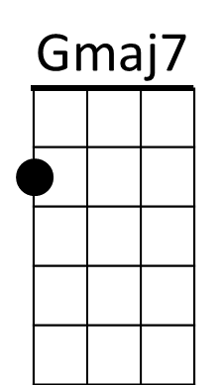**Gmaj7 Bb Gmaj7 Bb**



C



Dm



Am



Bb

Don't let the sun catch you cryin'

**Gmaj7 Bb C**

Tonight's the time for all your tears

**Dm Am**

Your heart may be broken tonight

**Dm Am**

But tomorrow in the mornin' light

**Bb C Gmaj7 Bb**

Don't let the sun catch you cryin'

**Gmaj7 Bb Gmaj7 Bb**

The night time shadows disappear

**Gmaj7 Bb C**

And with them go all your tears

**Dm Am**

For sunshine will bring joy

**Dm Am**

For every girl and boy so

**Bb C Gmaj7 Bb**

Don't let the sun catch you cryin'

**C Dm**

We know that cryin's not a bad thing

**Bb C**

But stop your cryin' when the birds sing

**Gmaj7 Bb Gmaj7 Bb**

It may be hard to discover

**Gmaj7 Bb C**

That you been left for another

**Dm Am**

And don't forget that love's a game

**Dm Am**

And it can always come again so

**Bb C Gmaj7 Bb**

Don't let the sun catch you cryin'

**Gmaj7 Bb Gmaj7**

Don't let the sun catch you cryin' oh no - Oh, no, no