Down on the Corner
John Fogerty, 1969
Down on the Corner (John Fogerty, 1969) (C)
Down on the Corner by Creedence Clearwater Revival

Intro Chords for verse

C G7 C
Early in the evenin' just about supper time,
G7 C
Over by the courthouse they're starting to unwind.
F C
Four kids on the corner trying to bring you up.
G7 C
Willy picks a tune out and he blows it on the harp.

Chorus
F C G7 C
Down on the corner, out in the street
F C
Willy and the Poorboys are playin'
G7 C
Bring a nickel; tap your feet.

C G7 C
Rooster hits the washboard and people just got to smile,
G7 C
Blinky, thumps the gut bass and solos for a while.
F C
Poorboy twangs the rhythm out on his kalamazoo.
G7 C
Willy goes into a dance and doubles on kazoo. Chorus (2x)

C G7 C
You don't need a penny just to hang around,
G7 C
But if you've got a nickel, won't you lay your money down?
F C
Over on the corner there's a happy noise.
G7 C
People come from all around to watch the magic boys. Chorus (3x)

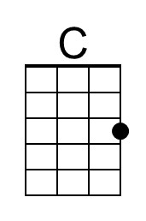 | 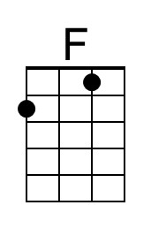 | 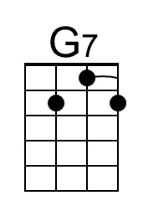 |  | Bari | 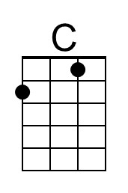 | 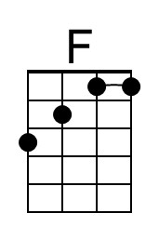 | 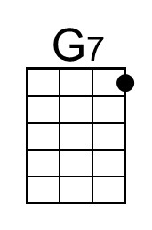

Down on the Corner (John Fogerty, 1969) (G)
Down on the Corner by Creedence Clearwater Revival

Intro Chords for verse

G D7 G
Early in the evenin' just about supper time,
D7 G
Over by the courthouse they're starting to unwind.
C G
Four kids on the corner trying to bring you up.
D7 G
Willy picks a tune out and he blows it on the harp.

Chorus
C G D7 G
Down on the corner, out in the street
C G
Willy and the Poorboys are playin'
D7 G
Bring a nickel; tap your feet.

G D7 G
Rooster hits the washboard and people just got to smile,
D7 G
Blinky, thumps the gut bass and solos for a while.
C G
Poorboy twangs the rhythm out on his kalamazoo.
D7 G
Willy goes into a dance and doubles on kazoo. Chorus (2x)

G D7 G
You don't need a penny just to hang around,
D7 G
But if you've got a nickel, won't you lay your money down?
C G
Over on the corner there's a happy noise.
D7 G
People come from all around to watch the magic boys. Chorus (3x)

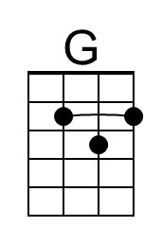 |  | 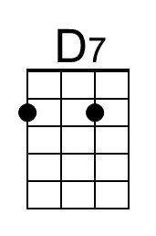 |  | Bari | 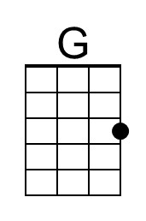 |  | 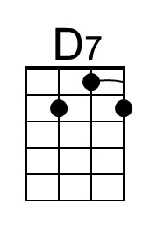

Down on the Corner (John Fogerty, 1969) (F)
Down on the Corner by Creedence Clearwater Revival

Intro Chords for verse

F C7 F
Early in the evenin' just about supper time,
C7 F
Over by the courthouse they're starting to un-wind.
B♭ F
Four kids on the corner trying to bring you up.
C7 F
Willy picks a tune out and he blows it on the harp.

Chorus
B♭ F C7 F
Down on the corner, out in the street
B♭ F
Willy and the Poorboys are playin'
C7 F
Bring a nickel; tap your feet.

F C7 F
Rooster hits the washboard and people just got to smile,
C7 F
Blinky, thumps the gut bass and solos for a while.
B♭ F
Poorboy twangs the rhythm out on his kalamazoo.
C7 F
Willy goes into a dance and doubles on ka-zoo. Chorus (2x)

F C7 F
You don't need a penny just to hang around,
C7 F
But if you've got a nickel, won't you lay your money down?
B♭ F
Over on the corner there's a happy noise.
C7 F
People come from all around to watch the magic boys. Chorus (3x)

 | 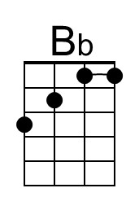 | 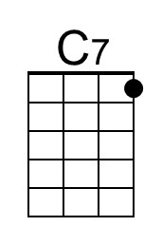 |  | Bari |  | 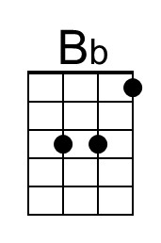 | 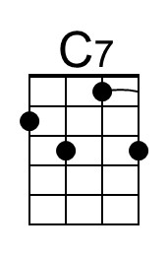

Down on the Corner (John Fogerty, 1969) (C)
Down on the Corner by Creedence Clearwater Revival

Intro Chords for verse

C G7 C
Early in the evenin' just about supper time,
G7 C
Over by the courthouse they're starting to unwind.
F C
Four kids on the corner trying to bring you up.
G7 C
Willy picks a tune out and he blows it on the harp.

Chorus
F C G7 C
Down on the corner, out in the street
F C
Willy and the Poorboys are playin'
G7 C
Bring a nickel; tap your feet.

C G7 C
Rooster hits the washboard and people just got to smile,
G7 C
Blinky, thumps the gut bass and solos for a while.
F C
Poorboy twangs the rhythm out on his kalamazoo.
G7 C
Willy goes into a dance and doubles on kazoo. Chorus (2x)

C G7 C
You don't need a penny just to hang around,
G7 C
But if you've got a nickel, won't you lay your money down?
F C
Over on the corner there's a happy noise.
G7 C
People come from all around to watch the magic boys. Chorus (3x)

Bari

This page is intentionally blank.

