Down The Ohio
Randy Sparks and Larry Ramos, 1963
As recorded by the New Christy Minstrels.
Cut Time (2/2). Key of C. "Fast." Ukulele.

GCEA  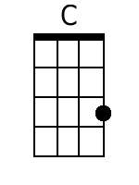  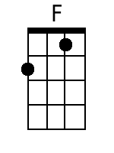  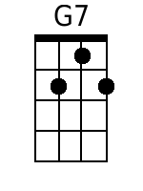  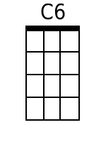  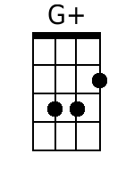  Bari  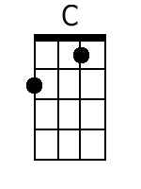  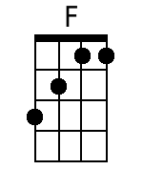  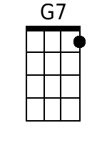  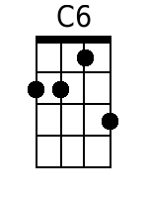  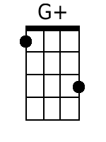 | Down The Ohio  Randy Sparks and Larry Ramos, 1963  Cut Time (2/4). Key of C (Original Key of G). "Fast." Ukulele.  Recorded by the New Christy Minstrels on their 1963 album Ramblin'.  Introduction - 20 Measures  Chorus:  C F C  Come 'long, children, and sing a happy song;  C G7  Play it on your old ban-jo.  C6 C F  Get on board, we're sailin' down the river;  C G7 C  Sailing down the O-hi-o.  Verses  C C G7 C  1. What d' we do on a Saturday night? Down the O-hi-o.  C C G7 C  Kiss the girls in the pale moonlight, Down the O-hi-o.  C C G7 C  I don' know, but I been told, Down the O-hi-o.  C C G7 C  All that glitters can't be gold, Down the O-hi-o. Chorus.  C C G7 C  2. If I die in Arkansas, Down the O-hi-o.  C C G7 C  Ship me "collect" to my mother-in-law, Down the O-hi-o.  Why don-cha... Chorus.  [16 Measure Instrumental]  Bridge  C  Dance, Liza, dance; dance, little Liza, dance.  C  Dance all night in the pale moonlight  C G7 C  And we'll all go home in the morning.  F  Hi! Ho! 'Way we go,  C  Sailin' down the river, on the Ohio  F  Hi! Ho! 'Way we go,  C G7 C  Sailin' down the river, on the O-hi-o.  F  Hi! Ho! 'Way we go,  C  Sailin' down the river, on the Ohio  F  Hi! Ho! 'Way we go,  C G7 C  Sailin' down the river, on the O-hi-o.
  C | C | C | C G7 C C
  C | C | C | C G7 C C
  C | C | C | G7
  F | F | C | C
  F | F | C | C G7 C C
  C | C | C | C G7 C C
  C | C | C | C G7 C C
  F | F | C | C
  F | F | C | C G7 C C
  C | G7 C | C | G+ C

