Down The Ohio
Randy Sparks and Larry Ramos, 1963
Cut Time (2/4). Original Key of G (1 Sharp). "Fast." Ukulele.
Recorded by the New Christy Minstrels on their 1963 album Ramblin'.

GCEA  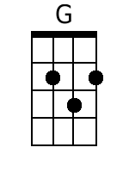  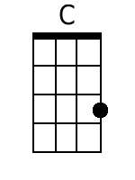  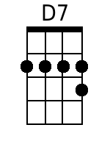  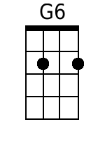  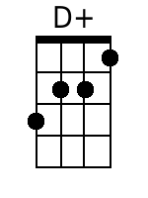  Bari  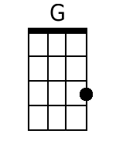  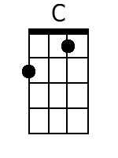  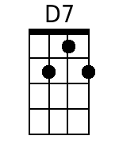  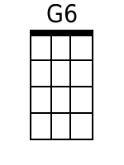  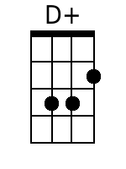 | Down The Ohio  Randy Sparks and Larry Ramos, 1963  Cut Time (2/4). Original Key of G (1 Sharp). "Fast." Ukulele.  Recorded by the New Christy Minstrels on their 1963 album Ramblin'.  Introduction - 20 Measures.  Chorus:  G C G  Come 'long, children, and sing a happy song;  G D7  Play it on your old ban-jo.  G6 G C  Get on board, we're sailin' down the river;  G D7 G  Sailing down the O-hi-o.  Verses  G G D7 G  1. What d' we do on a Saturday night? Down the O-hi-o.  G G D7 G  Kiss the girls in the pale moonlight, Down the O-hi-o.  G G D7 G  I don' know, but I been told, Down the O-hi-o.  G G D7 G  All that glitters can't be gold, Down the O-hi-o. Chorus.  G G D7 G  2. If I die in Arkansas, Down the O-hi-o.  G G D7 G  Ship me "collect" to my mother-in-law, Down the O-hi-o.  Why don-cha... Chorus.  [16 Measure Instrumental]  Bridge  G  Dance, Liza, dance; dance, little Liza, dance.  G  Dance all night in the pale moonlight  G D7 G  And we'll all go home in the morning.  C  Hi! Ho! 'Way we go,  G  Sailin' down the river, on the Ohio.  C  Hi! Ho! 'Way we go,  G D7 G  Sailin' down the river, on the O-hi-o.  [4 Measure Instrumental]  C  Hi! Ho! 'Way we go,  G  Sailin' down the river, on the Ohio.  C  Hi! Ho! 'Way we go,  G D7 G  Sailin' down the river, on the O-hi-o.
  G | G | G |  | G D7 G G
  G | G | G |  | G D7 G G
  G | G | G | D7 | G G7
  C | C | G |  | G
  C | C | G |  | G D7 G G
  G | G | G | G D7 G G
  G | G | G | G D7 G G
  C | C | G | G
  C | C | G | G D7 G G
  G | D7 G | G | D+ G

