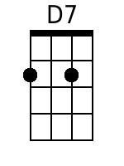
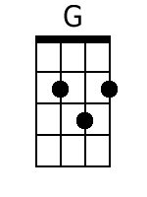
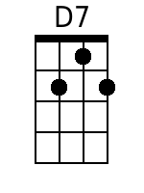
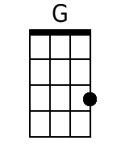
Dream Baby (Cindy Walker)
In A

Intro: D7 G (Last line of first verse)

A7
Sweet dream, baby, sweet dream, baby
D7 A7 D7
Sweet dream, baby, How long must I dream?

Verse
A7
Dream baby got me dreaming sweet dreams,

The whole day through.

Dream baby got me dreaming sweet dreams,

Night time too.
D7
I love you and I'm dreaming of you,

But that won't do.
A7
Dream baby make me stop my dreaming,
D7 (Bass Run)
You can make my dreams come true. [Second time through, jump to “Ending”]

Chorus:
A7
Sweet dream baby (sha-la-la-la, sha-la-la-la)

Sweet dream baby (sha-la-la-la, sha-la-la-la)
D7
Sweet dream baby (sha-la-la-la, sha-la-la-la)
A7 D7 (Bass Run)
How long must I dream?

(Repeat Verse)

Ending: (repeat to fade)
A7
Aww, Sweet dream baby, ah-huh-huh.

Yeah, yeah, swe-e-eet dream baby, ah-huh-huh.
G
Sweet dream baby, ah-huh-huh.
Baritone
D7 G (Bass Run)
How long must I dream?
A7
Sweet dream baby, ah-huh-huh.

Sweet dream baby, ah-huh-huh. (FADE)

