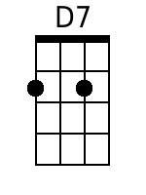
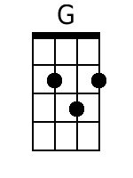
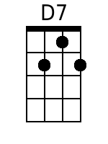
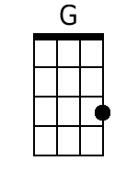
Dream Baby (Cindy Walker)
In D

Intro: D7 G (Last line of first verse)

D7
Sweet dream baby, sweet dream baby
G
Sweet dream baby
D7 G
How long must I dream

D7
Dream baby got me dreaming sweet dreams

The whole day through

Dream baby got me dreaming sweet dreams

Night time too
G
I love you and I'm dreaming of you

But that won't do
D7
Dream baby make me stop my dreaming
G
You can make my dreams come true

(Repeat entire song)

Ending: (repeat to fade)
D7
Sweet dream baby, sweet dream baby
G
Sweet dream baby
Baritone
D7 G
How long must I dream

