Dream Lover (Bobby Darin, 1959) (C)
503 C
Dream Lover by Bobby Darin (F) – C Tuning
2/2 – 132 BPM

Intro C | Am | C | Am |  C Am  __ Every night I hope and pray, __ a dream lover will come my way  C Am  __ A girl to hold in my arms __ and know the magic of her charms  C G7 C F  Because I want _ a girl _ to call _ my own  C Am F G C | G7  I want a _ dream lover so I don't have to dream a-lone.  C Am  __ Dream lover, where are you __ with a love oh so true,  C Am  __ And a hand that I can hold, __ to feel you near when I grow old?  C G7 C F  Because I want _ a girl _ to call _ my own  C Am F G C | C7  I want a dream lover so I don't have to dream a-lone.  Bridge  F C  __ Someday, I don't know how _ I hope she'll hear my plea  D7 G G7  __ Some way, I don't know how, __ She'll bring her love to me  C Am  __ Dream lover, until then, __ I'll go to sleep and dream again  C Am  __ That's the only thing to do, __ until my lovers dreams come true.  C G7 C F  Because I want _ a girl _ to call _ my own  C Am F G C | G#7  I want a dream lover so I don't have to dream a-lone.  C# A#m  __ Dream lover, until then, __ I'll go to sleep and dream again  C# A#m  __ That's the only thing to do, __ until my lovers dreams come true  C# G#7 C# F#  Because I want _ a girl _ to call my own  C# A#m F# G# C#  I want a dream lover so I don't have to dream a-lone.  A#m C# A#m C#  Please don't make me dream alone. I beg you don't make me dream alone.  A#m C# | ↓ ↓ ↓ C#  No, I don't wanna dream alone. (Hold) | 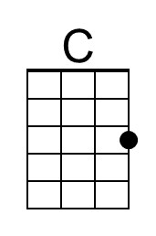 | 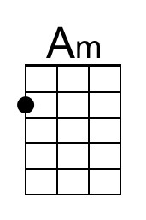
 | 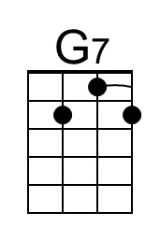 | 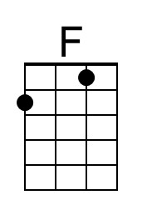
 | 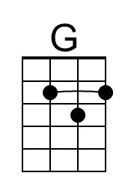 | 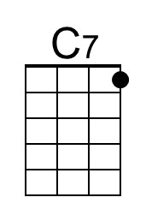
 | 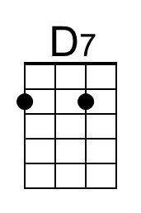 | 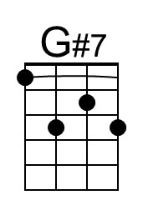
 | 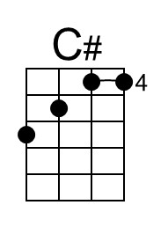 | 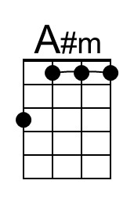
 | 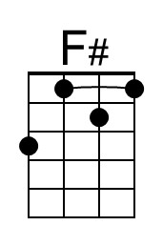 | 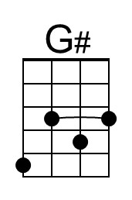

Dream Lover (Bobby Darin, 1959) (C)
503 C
Dream Lover by Bobby Darin (F) – G Tuning
2/2 – 132 BPM

Intro C | Am | C | Am |  C Am  __ Every night I hope and pray, __ a dream lover will come my way  C Am  __ A girl to hold in my arms __ and know the magic of her charms  C G7 C F  Because I want _ a girl _ to call _ my own  C Am F G C | G7  I want a _ dream lover so I don't have to dream a-lone.  C Am  __ Dream lover, where are you __ with a love oh so true,  C Am  __ And a hand that I can hold, __ to feel you near when I grow old?  C G7 C F  Because I want _ a girl _ to call _ my own  C Am F G C | C7  I want a dream lover so I don't have to dream a-lone.  Bridge  F C  __ Someday, I don't know how _ I hope she'll hear my plea  D7 G G7  __ Some way, I don't know how, __ She'll bring her love to me  C Am  __ Dream lover, until then, __ I'll go to sleep and dream again  C Am  __ That's the only thing to do, __ until my lovers dreams come true.  C G7 C F  Because I want _ a girl _ to call _ my own  C Am F G C | G#7  I want a dream lover so I don't have to dream a-lone.  C# A#m  __ Dream lover, until then, __ I'll go to sleep and dream again  C# A#m  __ That's the only thing to do, __ until my lovers dreams come true  C# G#7 C# F#  Because I want _ a girl _ to call _ my own  C# A#m F# G# C#  I want a dream lover so I don't have to dream a-lone.  A#m C# A#m C#  Please don't make me dream alone. I beg you don't make me dream alone.  A#m C# | ↓ ↓ ↓ C#  No, I don't wanna dream alone. (Hold) | 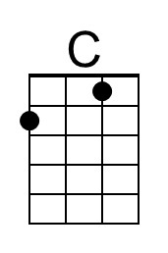 | 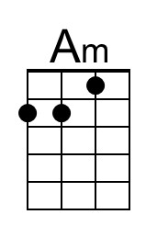
 | 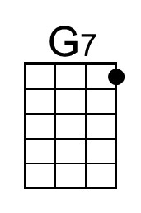 | 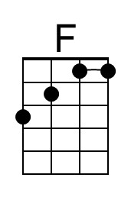
 | 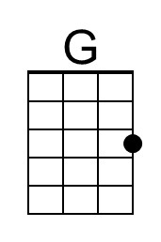 | 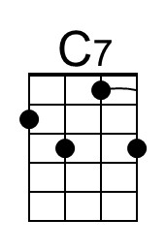
 | 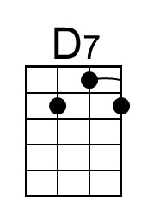 | 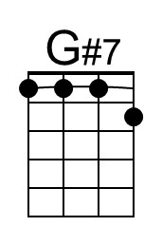
 | 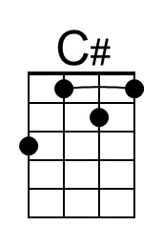 | 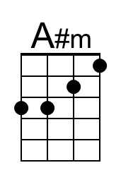
 | 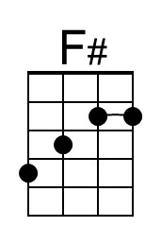 | 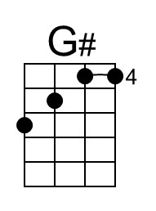

Dream Lover (Bobby Darin, 1959) (F)
503 F
Dream Lover by Bobby Darin (F - 132 BPM) – C Tuning
2/2 – 132 BPM

Intro F | Dm | F | Dm |  F Dm  __ Every night I hope and pray, __ a dream lover will come my way  F Dm  __ A girl to hold in my arms __ and know the magic of her charms  F C7 F Bb  Because I want _ a girl _ to call _ my own  F Dm Bb C F | C7  I want a _ dream lover so I don't have to dream a-lone.  F Dm  __ Dream lover, where are you __ with a love oh so true,  F Dm  __ And a hand that I can hold, __ to feel you near when I grow old?  F C7 F Bb  Because I want _ a girl _ to call _ my own  F Dm Bb C F | F7  I want a dream lover so I don't have to dream a-lone.  Bridge  Bb F  __ Someday, I don't know how _ I hope she'll hear my plea  G7 C C7  __ Some way, I don't know how, __ She'll bring her love to me  F Dm  __ Dream lover, until then, __ I'll go to sleep and dream again  F Dm  __ That's the only thing to do, __ until my lovers dreams come true.  F C7 F Bb  Because I want _ a girl _ to call _ my own  F Dm Bb C F | C#7  I want a dream lover so I don't have to dream a-lone.  F# D#m  __ Dream lover, until then, __ I'll go to sleep and dream again,  F# D#m  __ That's the only thing to do, __ until my lovers dreams come true.  F# C#7 F# B  Because I want _ a girl _ to call _ my own  F# D#m B C# F#  I want a dream lover so I don't have to dream a-lone.  D#m F# D#m F#  Please don't make me dream alone. I beg you don't make me dream alone.  D#m F# | ↓ ↓ ↓ F#  No, I don't wanna dream alone. (Hold) |  | 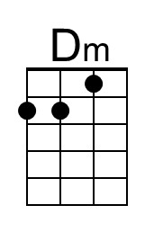
 |  | 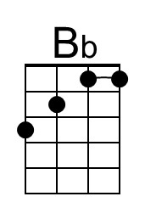
 |  | 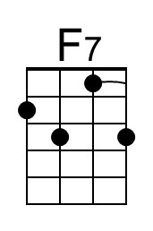
 |  | 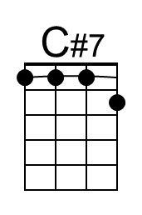
 |  | 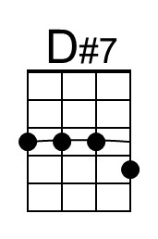
 | 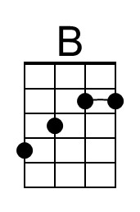

Dream Lover (Bobby Darin, 1959) (F)
503 F
Dream Lover by Bobby Darin (F - 132 BPM) – G Tuning
2/2 – 132 BPM

Intro F | Dm | F | Dm |  F Dm  __ Every night I hope and pray, __ a dream lover will come my way  F Dm  __ A girl to hold in my arms __ and know the magic of her charms  F C7 F Bb  Because I want _ a girl _ to call _ my own  F Dm Bb C F | C7  I want a _ dream lover so I don't have to dream a-lone.  F Dm  __ Dream lover, where are you __ with a love oh so true,  F Dm  __ And a hand that I can hold, __ to feel you near when I grow old?  F C7 F Bb  Because I want _ a girl _ to call _ my own  F Dm Bb C F | F7  I want a dream lover so I don't have to dream a-lone.  Bridge  Bb F  __ Someday, I don't know how _ I hope she'll hear my plea  G7 C C7  __ Some way, I don't know how, __ She'll bring her love to me  F Dm  __ Dream lover, until then, __ I'll go to sleep and dream again  F Dm  __ That's the only thing to do, __ until my lovers dreams come true.  F C7 F Bb  Because I want _ a girl _ to call _ my own  F Dm Bb C F | C#7  I want a dream lover so I don't have to dream a-lone.  F# D#m  __ Dream lover, until then, __ I'll go to sleep and dream again,  F# D#m  __ That's the only thing to do, __ until my lovers dreams come true.  F# C#7 F# B  Because I want _ a girl _ to call _ my own  F# D#m B C# F#  I want a dream lover so I don't have to dream a-lone.  D#m F# D#m F#  Please don't make me dream alone. I beg you don't make me dream alone.  D#m F# | ↓ ↓ ↓ F#  No, I don't wanna dream alone. (Hold) |  | 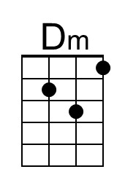
 |  | 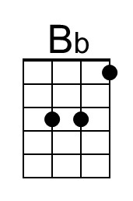
 |  | 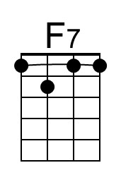
 |  | 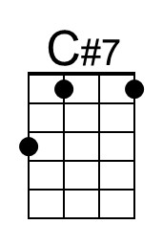
 |  | 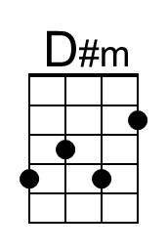
 | 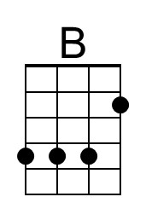

Dream Lover (Bobby Darin, 1959) (G)
503 G
Dream Lover by Bobby Darin (F - 132 BPM) – C Tuning
2/2 – 132 BPM

Intro G | Em | G | Em |  G Em  __ Every night I hope and pray, __ a dream lover will come my way  G Em  __ A girl to hold in my arms __ and know the magic of her charms  G D7 G C  Because I want _ a girl _ to call _ my own  G Em C D G | D7  I want a _ dream lover so I don't have to dream a-lone.  G Em  __ Dream lover, where are you __ with a love oh so true,  G Em  __ And a hand that I can hold, __ to feel you near when I grow old?  G D7 G C  Because I want _ a girl _ to call _ my own  G Em C D G | G7  I want a dream lover so I don't have to dream a-lone.  Bridge  C G  __ Someday, I don't know how _ I hope she'll hear my plea.  A7 D D7  __ Some way, I don't know how, __ She'll bring her love to me.  G Em  __ Dream lover, until then, __ I'll go to sleep and dream again  G Em  __ That's the only thing to do, __ until my lovers dreams come true.  G D7 G C  Because I want _ a girl _ to call _ my own  G Em C D G | D#7  I want a dream lover so I don't have to dream a-lone.  G# Fm  __ Dream lover, until then, __ I'll go to sleep and dream again  G# Fm  __ That's the only thing to do, __ until my lovers dreams come true  G# D#7 G# C#  Because I want _ a girl _ to call _ my own  G# Fm C# D# G#  I want a dream lover so I don't have to dream a-lone.  Fm G# Fm G#  Please don't make me dream alone. I beg you don't make me dream alone.  Fm G# | ↓ ↓ ↓ G#  No, I don't wanna dream alone. (Hold) |  | 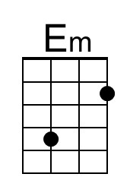
 | 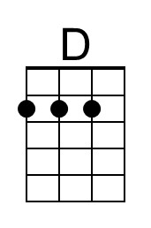
 | 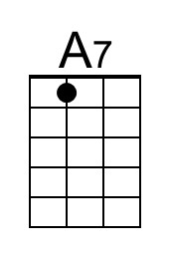
 |  | 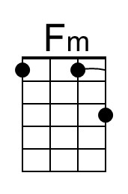
 |  | 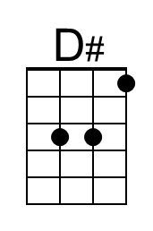

Dream Lover (Bobby Darin, 1959) (G)
503 G
Dream Lover by Bobby Darin (F - 132 BPM) – G Tuning
2/2 – 132 BPM

Intro G | Em | G | Em |  G Em  __ Every night I hope and pray, __ a dream lover will come my way  G Em  __ A girl to hold in my arms __ and know the magic of her charms  G D7 G C  Because I want _ a girl _ to call _ my own  G Em C D G | D7  I want a _ dream lover so I don't have to dream a-lone.  G Em  __ Dream lover, where are you __ with a love oh so true,  G Em  __ And a hand that I can hold, __ to feel you near when I grow old?  G D7 G C  Because I want _ a girl _ to call _ my own  G Em C D G | G7  I want a dream lover so I don't have to dream a-lone.  Bridge  C G  __ Someday, I don't know how _ I hope she'll hear my plea.  A7 D D7  __ Some way, I don't know how, __ She'll bring her love to me.  G Em  __ Dream lover, until then, __ I'll go to sleep and dream again  G Em  __ That's the only thing to do, __ until my lovers dreams come true.  G D7 G C  Because I want _ a girl _ to call _ my own  G Em C D G | D#7  I want a dream lover so I don't have to dream a-lone.  G# Fm  __ Dream lover, until then, __ I'll go to sleep and dream again  G# Fm  __ That's the only thing to do, __ until my lovers dreams come true  G# D#7 G# C#  Because I want _ a girl _ to call _ my own  G# Fm C# D# G#  I want a dream lover so I don't have to dream a-lone.  Fm G# Fm G#  Please don't make me dream alone. I beg you don't make me dream alone.  Fm G# | ↓ ↓ ↓ G#  No, I don't wanna dream alone. (Hold) |  | 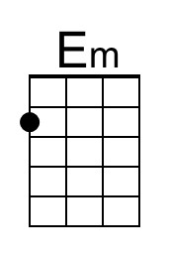
 | 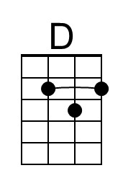
 | 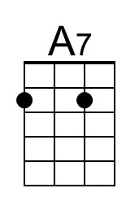 | 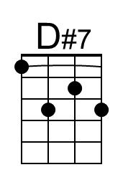
 |  | 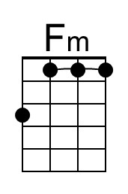
 |  | 